I have no words to say how I feel these days, every day I better feel different emotions, some happy days, other sad days and also more emotions.
What I don't like is that I can't see my friends or my family or anything, now in phase one I'm seeing my family a little more but I still don't see some family and friends. It is also a little sad to see the streets a little empty are not as usual. Another thing I don't like is that I can't go to school or see my classmates or teachers or anything. I just hope this is over quickly and we can go back to school, spend time with friends and family.

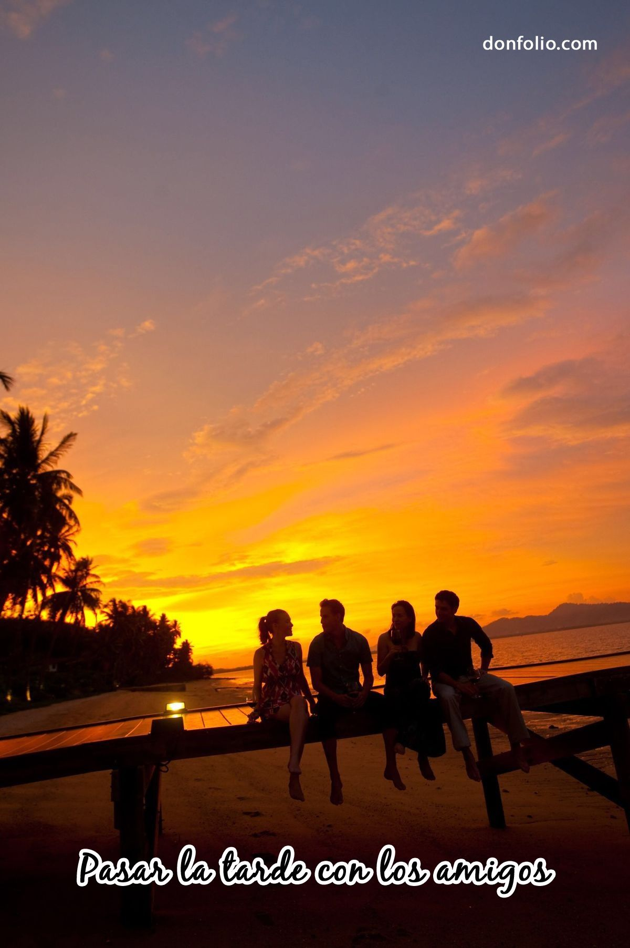

ANDREA NAVIO-1EsoB

