since 2010...

6 european projects
COMENIUS &
ERASMUS+

Comenius projects

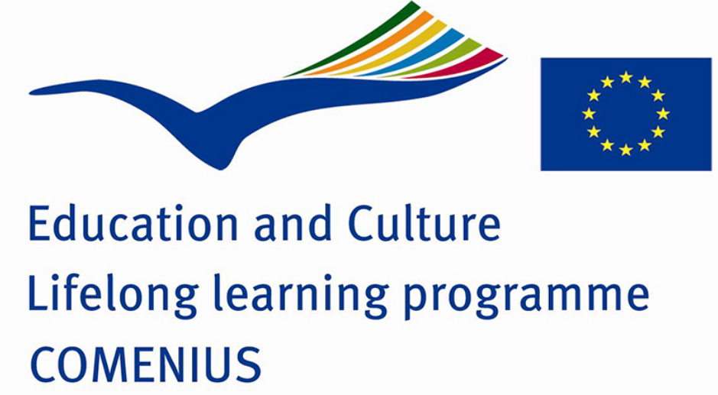

2010-12:

“ADDRESSING THE ENERGY CRUNCH; EVERY LITTLE ACTION COUNTS”

With Sweden and Lithuania

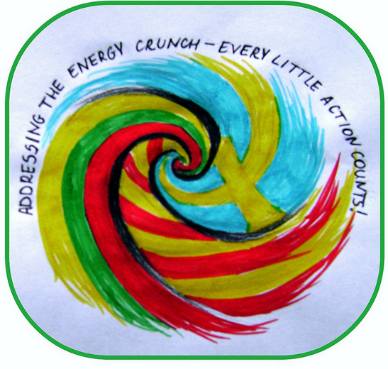

2012-14:

“EDUMEDIA: HOW CAN IT BE EFFICIENT IN EUROPEAN SCHOOLS ”

With Sweden, Itàly, Germany & Ireland

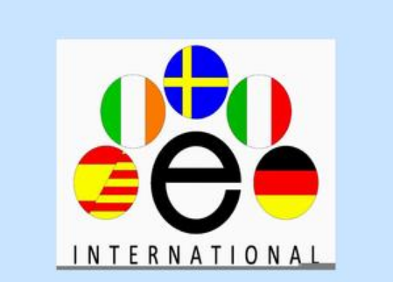

PROJECTS
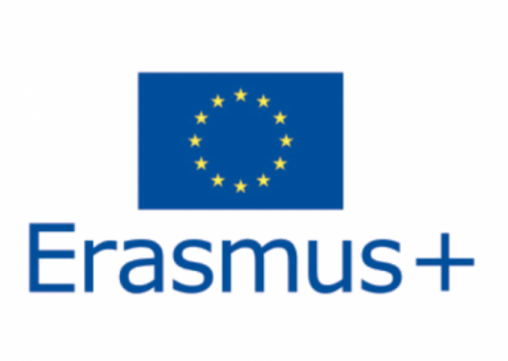

2015-17:

“MY WAY, YOUR WAY, OUR SHARED CULTURAL IDENTITIES”

With Bulgaria, Sweden and Italy

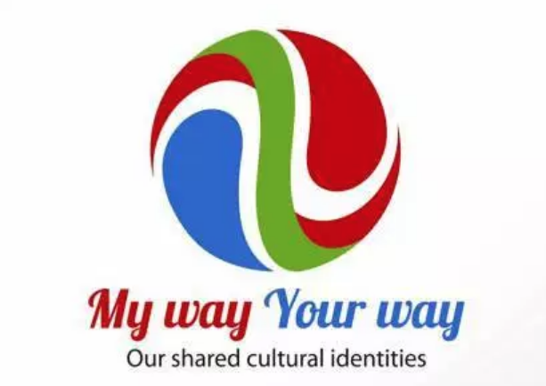

2017-19:

“FUTUREYEZING”

With Bulgaria, Sweden and Poland

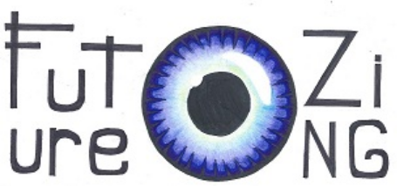

“JOBS, JOBS EVERYWHERE. WHICH ONE FOR ME?”

amb Italy, Ireland, Malta and Germany

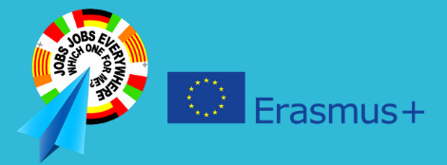

2019-21:

“ENVISIONING OUR EDUCATION IN THE FUTURE”
A KA1 PROJECT

Job-shadowing in Italy, Crete, Turkey, Cyprus, France
Training courses in Malta, Belgium and Ireland

