PREMIS CAMÍ- ENGLISH award

TERMS AND CONDITIONS
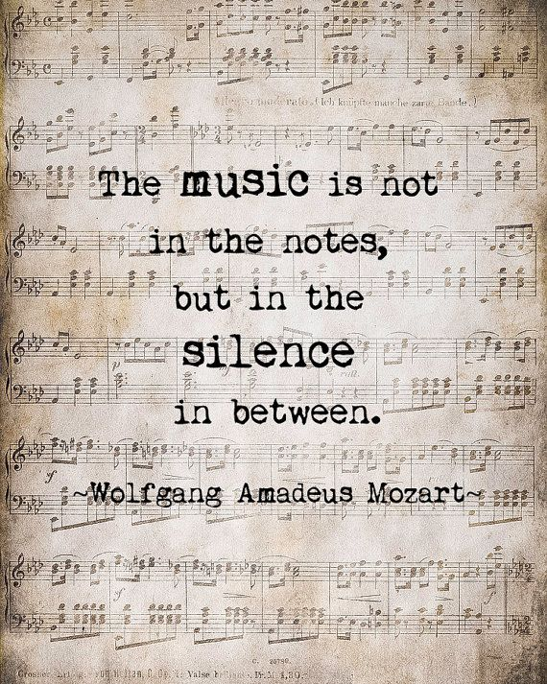
In the 2018-19 edition of the "Premis Camí" literary contest there will be an award for the texts written in English.
PLATO

- The text must be written in English, unpublished, original and inspired in one of the previous sentences.
- Each participant can only present a text: prose or poetry.
- The maximum length will be 150-200 words.
- The text will be written on the computer, on just one side, double spaced with 12-point font.
- Students must write their nickname and course on the reverse, and present it to their teacher before 18th March.
- They must also hand in an envelope with their nickname written outside and their real name inside.
- The jury will give only one award in this category. They will reserve the right to declare the contest void.
- The jury will be formed by the English teachers of the Foreign Languages Department.
- The awards will be given in a public act that will take place in the High School hall on 12th April 2018.
- The organizing team reserves the right to change the terms and conditions with previous announcement.
- Participating in the contest means accepting the terms and conditions.

