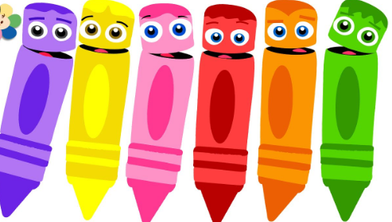
English
time!!

Hello boys and girls!!

This week we are going to review colours. Sure you know very well.
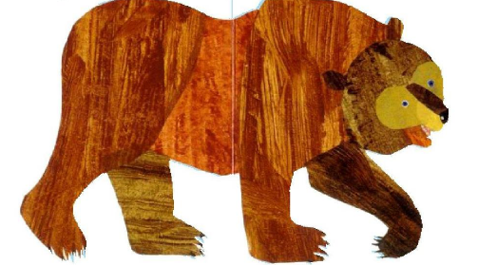
We are going to start with a nice story. Watch and enjoy!
https://youtu.be/WST-B8zQleM

And a song: What’s your favourite colour?
https://youtu.be/zxIpA5nF_LY

Alguns exercicis per practicar
http://www.koalatext.com/public/index.php/unitsv2/582
http://www.koalatext.com/public/index.php/unitsv2/579
Ara alguns exercicis per completar i enviar-me (no cal que els feu tots, però quants més millor)
https://www.liveworksheets.com/c?a=s&g=2nd&s=ENGLISH&t=82nj5yir47&l=as&i=dnfdox&r=nv
https://www.liveworksheets.com/c?a=s&g=2nd&s=ENGLISH&t=82nj5yir47&l=pu&i=tzfctc&r=ot
https://www.liveworksheets.com/c?a=s&g=2dn&s=ENGLISH&t=82nj5yir47&l=ir&i=ufdozs&r=rc
https://www.liveworksheets.com/c?a=s&g=2nd&s=ENGLISH&t=82nj5yir47&l=xk&i=xoxun&r=pd
https://www.liveworksheets.com/c?a=s&g=2nd&s=ENGLISH&t=82nj5yir47&l=ne&i=dzdnzc&r=eu

