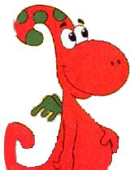
English time!!

Hello boys and girls!!
This week we are working about school objects. Do you remember? Sure.
We are going to start with a song
https://www.youtube.com/watch?v=BwBTozQisb4
and a video, do you remember Gogo?
https://youtu.be/h3QSXunkzhs

Alguns exercicis per practicar
http://www.koalatext.com/public/index.php/unitsv2/570
http://www.koalatext.com/public/index.php/unitsv2/571

Ara alguns exercicis per completar i enviar-me
https://www.liveworksheets.com/c?a=s&g=2nd&s=English&t=82nj5yir47&m=n&l=me&i=sscz&r=qy
https://www.liveworksheets.com/c?a=s&g=2nd&s=English&t=82nj5yir47&m=n&l=gr&i=oxftu&r=lm

