ENGLISH THIS IS MY BIKE

Write the different parts of the bike in the correct place.You can use a photo o picture.
https://drive.google.com/file/d/1aEkeCDfbhKmteBmPOVasPhMKD_COkBKU/view?usp=sharing

HANDLEBAR | PEDAL
BRAKE LEVER | CHAIN
WHEEL | SEAT

PARTS OF THE BIKE

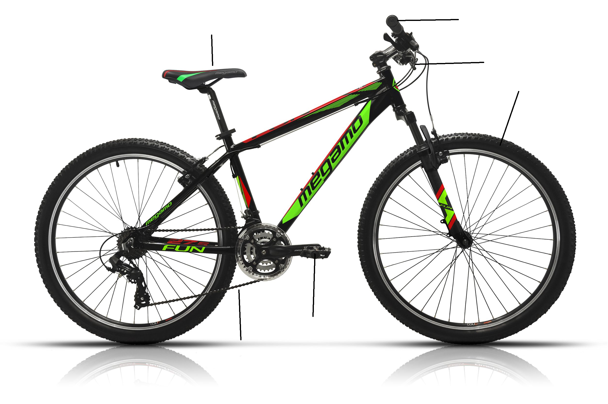

DESCRIBE YOUR BIKE

Llegeix les frases i tria. Escriu a sota la teva descripció.

My bike is …………. (colour)
My bike is (small/big )
I like riding my bike.
I don't like riding.
My bike is a urban / electric / road / mountain bike
I have got a helmet / I haven’t got a helmet
It’s……...

