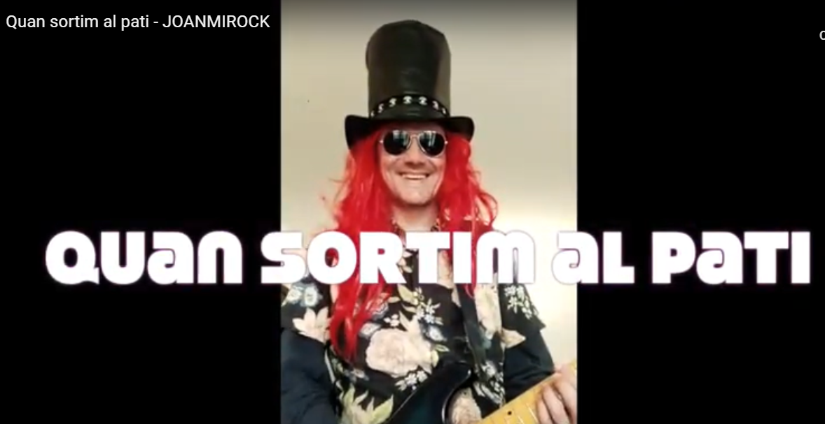

https://www.youtube.com/watch?time_continue=1&v=-V44-e2Hu2c&feature=emb_logo

