The Arctic Region

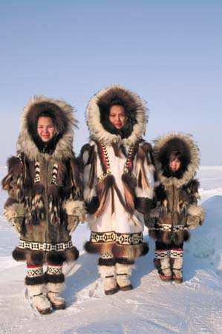
The Arctic region is a big area around the North Pole. It is opposite the Antarctic region around the South Pole. The Arctic region includes the very cold waters of the Arctic Ocean. Parts of Canada, Greenland, Alaska, Siberia and other Nordic territories are in the Arctic. Many parts of the region are covered with ice and snow.

The Arctic region is very big, but only about four million people live there.

People who live in the Arctic region have adapted their lives to the cold climate there. But today, many people, for example the Inuit of North America, do not live in igloos any more. They live in modern houses with electricity.

Arctic people use the natural resources they have to eat, to

make clothes, to decorate their houses, etc.
Seals, whales, polar bears, reindeer and salmon are very important for the Arctic people.

There are other natural resources in the Arctic region, for example oil, gas and
minerals.
People from other parts of the world want those resources. Will they destroy the
beautiful arctic region?

