P3
UN CAVALLET DE CARTRÓ
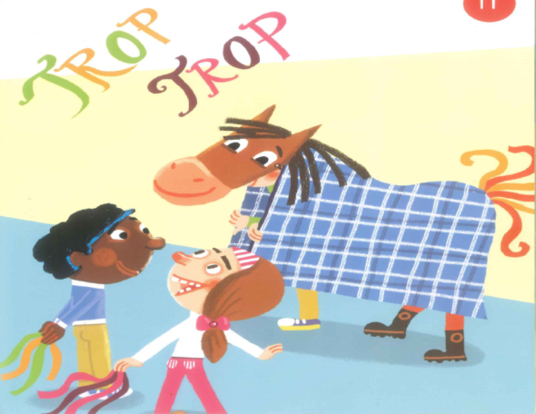
https://www.youtube.com/watch?v=5GqNR8i0Uio

UN CAVALLET DE CARTRÓ
MAI NO ES CANSA CORRE MOLT,
UN CAVALLET DE CARTRÓ
TROTA I TROTA SENSE POR
P4
EL MATÍ


https://www.youtube.com/watch?v=qmDOBB8EYIA
P5
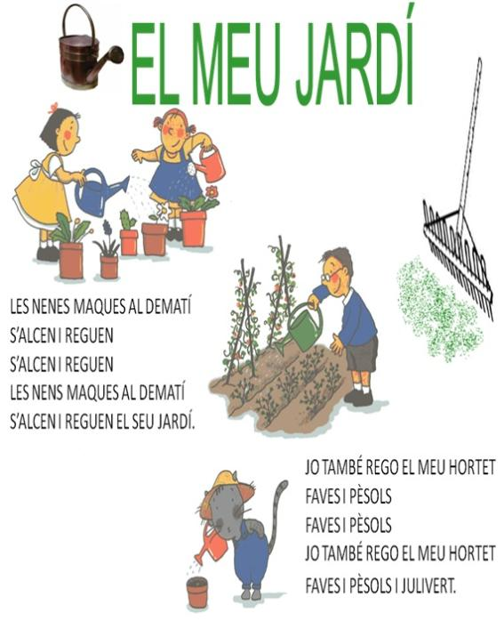

https://www.youtube.com/watch?v=vmrsacRNtKw
1R
A DINS D’UN BOSC
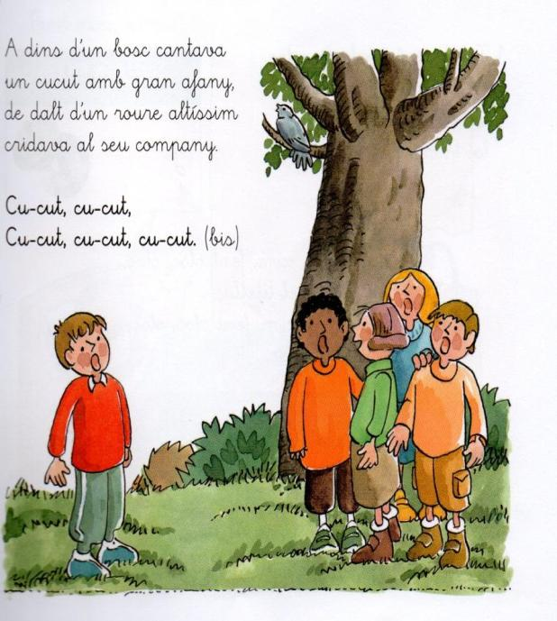
https://www.youtube.com/watch?v=rxChq65psJ8
2N
LA VACA DEL PASTOR
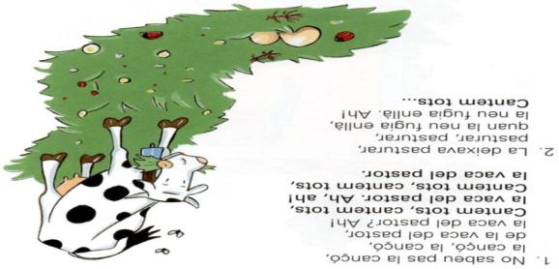
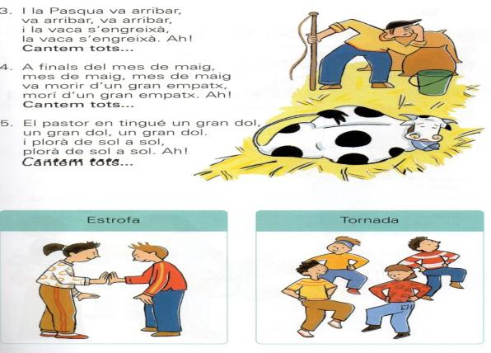
https://www.youtube.com/watch?v=XPAKa3bZkhk
3R
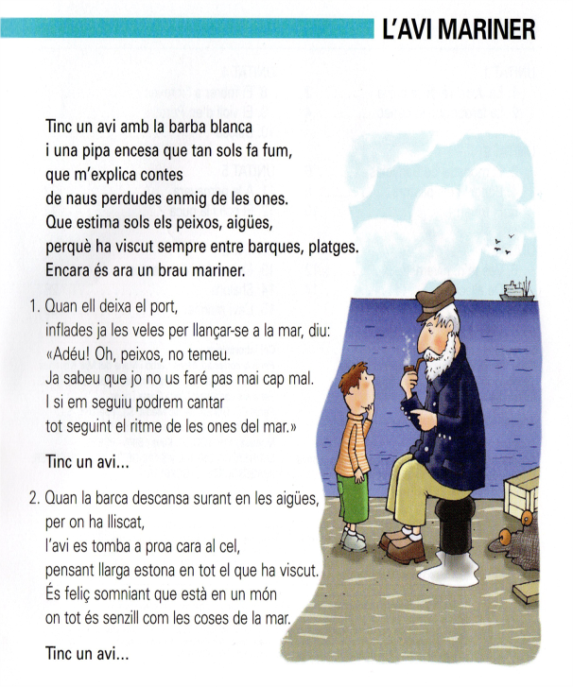
https://www.youtube.com/watch?v=zt7IuC3ewtA

4T


https://www.youtube.com/watch?v=Lw_Qlu4Y1dk

5è
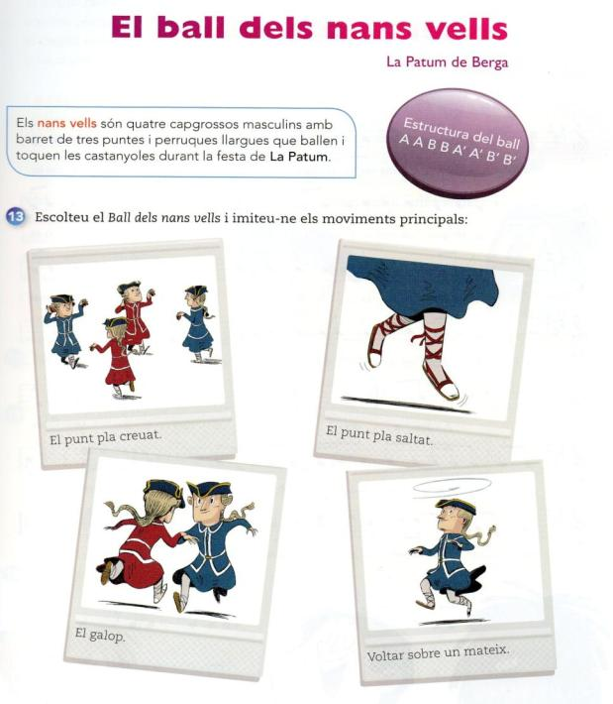
https://www.youtube.com/watch?v=J3ypOsIixzM
6è
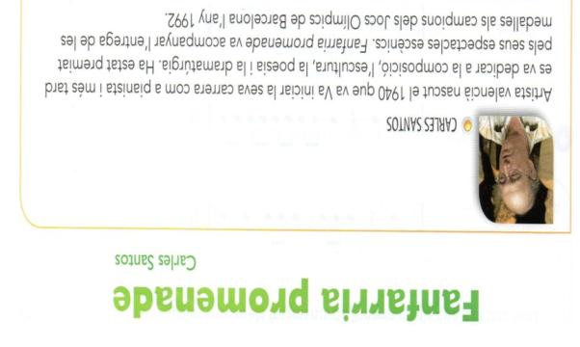
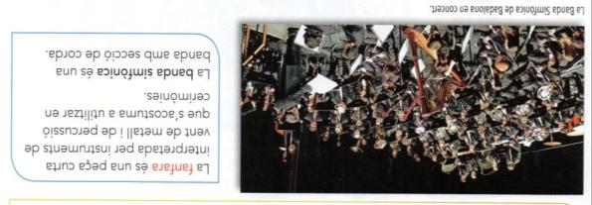
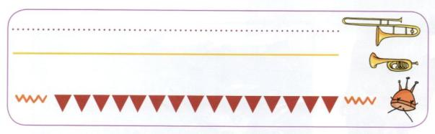
https://www.youtube.com/watch?v=XCMpg7SSPy8

