1r
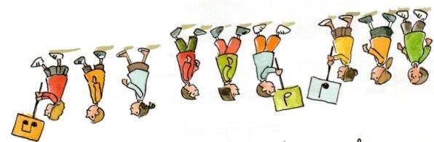

Poema amb ritme
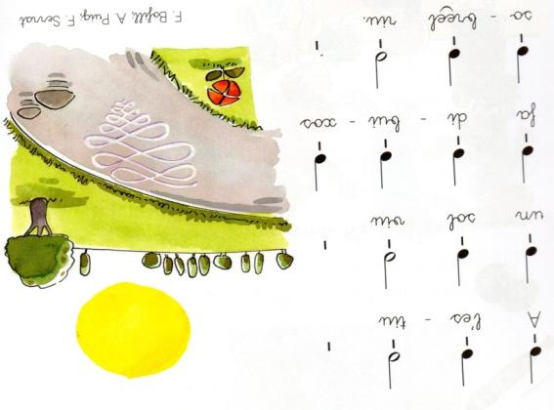

https://www.youtube.com/watch?v=rXEj80Clj0E
2n
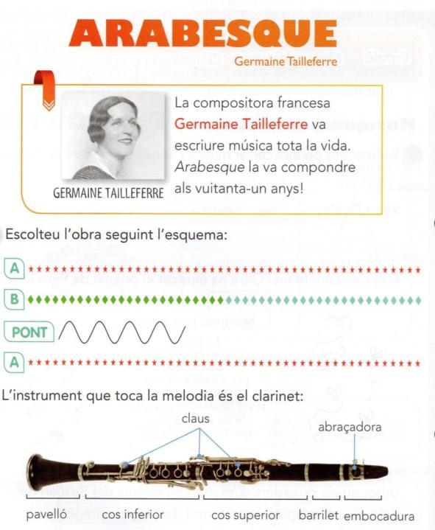

https://www.youtube.com/watch?v=L9XsbXSOkGs
3r
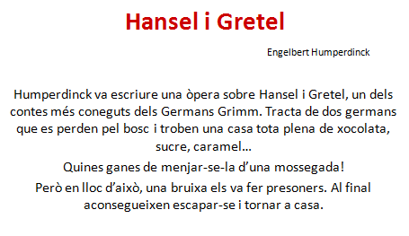
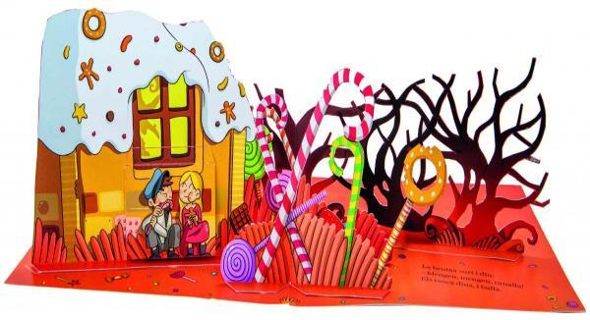
https://www.youtube.com/watch?v=cs4yV7QctFI

4t
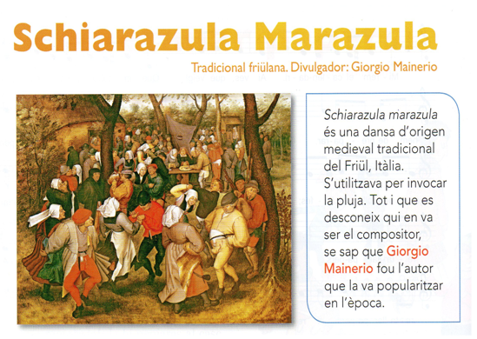
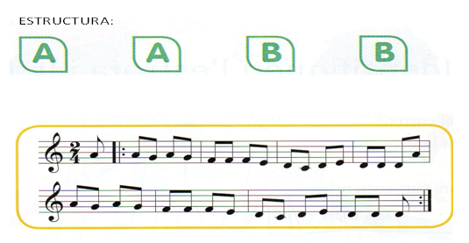
https://www.youtube.com/watch?v=LxBMCrrzN4s

5è
And I say
It's all right
Here comes the sun
Here comes the sun
And I say
It's all right

Sun, sun, sun, here it comes
Sun, sun, sun, here it comes
Sun, sun, sun, here it comes
Sun, sun, sun, here it comes
Sun, sun, sun, here it comes

Little darling
I feel that ice is slowly melting
Little darling
It seems like years since it's been clear

Here comes the sun
Here comes the sun
And I say
It's all right

Here comes the sun
Here comes the sun
Here comes the sun
And I say
It's all right

Little darling
It's been a long cold lonely winter
Little darling
It feels like years since it's been here

Here comes the sun
Here comes the sun
And I say
It's all right

Little darling
The smiles returning to the faces
Little darling
It seems like years since it's been here
Here comes the sun
Here comes the sun

Here comes the sun
Here comes the sun
And I say
It's all right

Little darling
It's been a long cold lonely winter
Little darling
It feels like years since it's been here

Here comes the sun
Here comes the sun
And I say
It's all right

Little darling
The smiles returning to the faces
Little darling
It seems like years since it's been here

https://www.youtube.com/watch?v=KQetemT1sWc

6è
https://www.youtube.com/watch?v=JjCre83iPjE

