1r
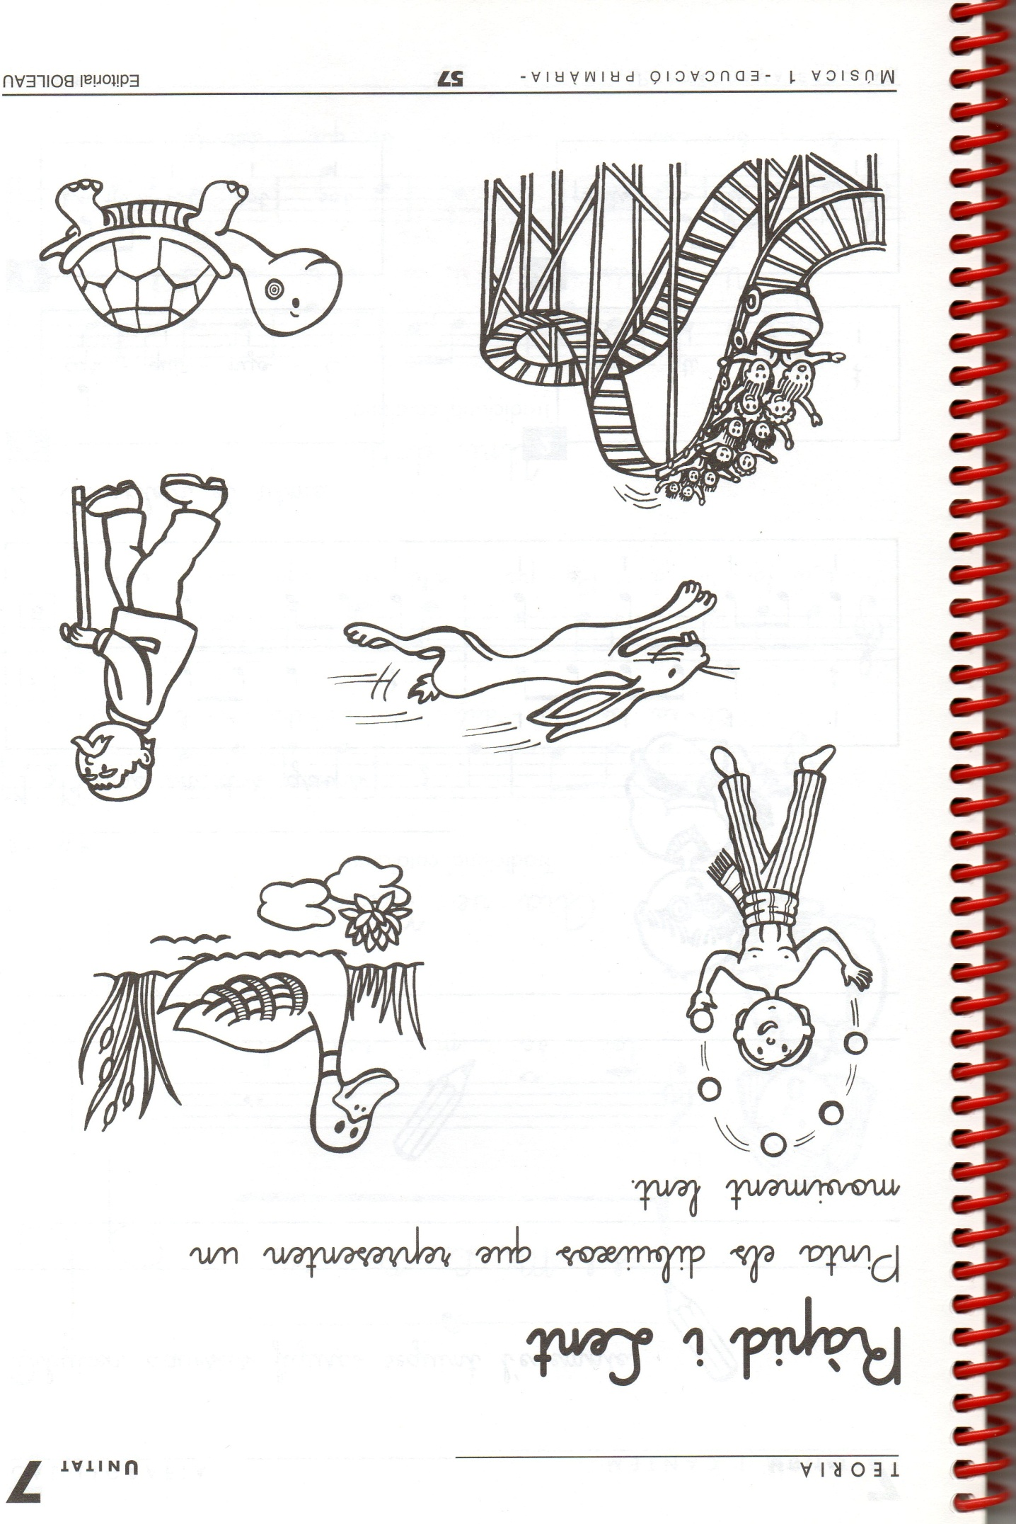
https://blocdemusicaelcasal.blogspot.com/2017/11/rapid-lent.html
2n
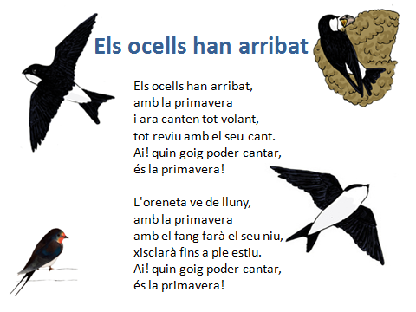
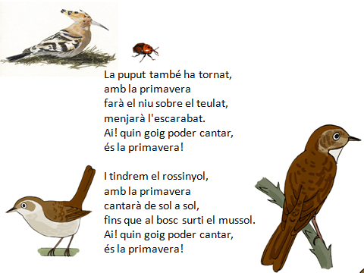
https://www.youtube.com/watch?v=8wbFnl2mcec
3r

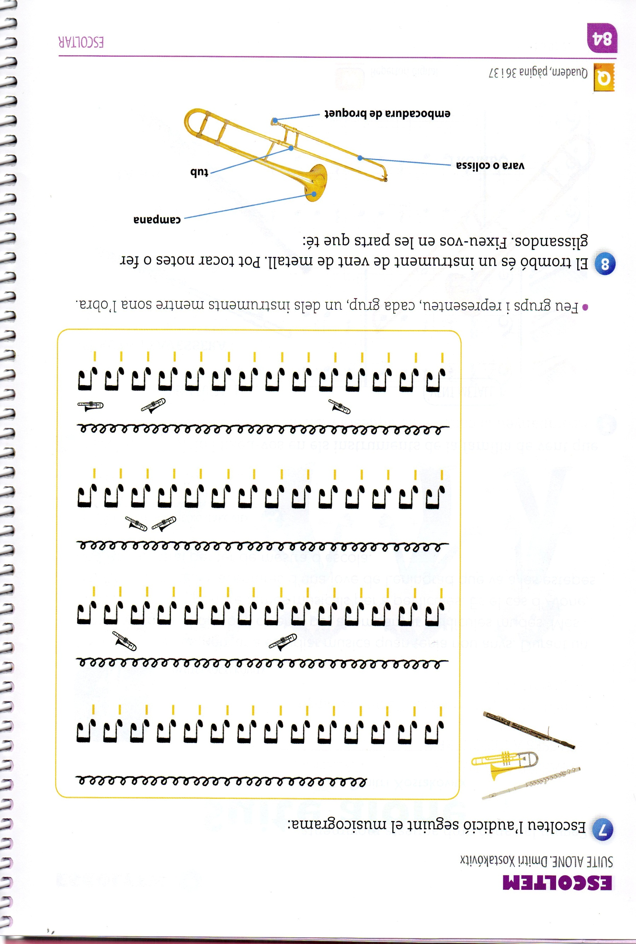
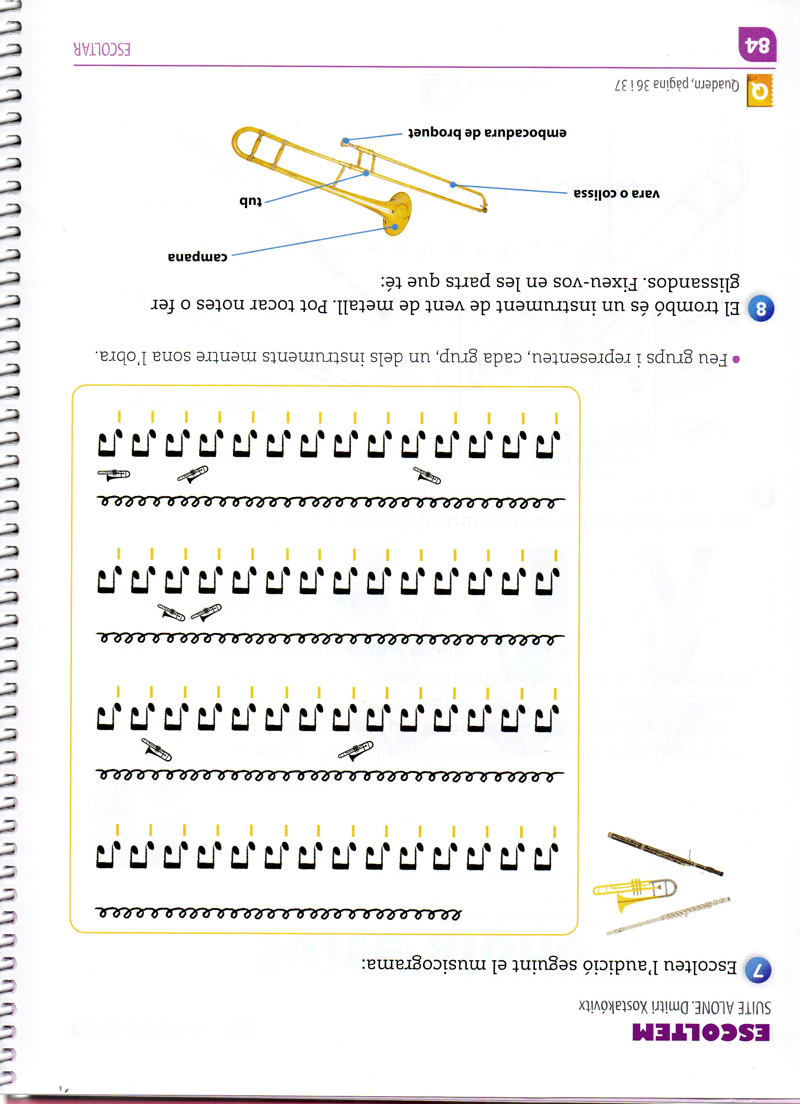
https://www.youtube.com/watch?v=lj0yuc8o9qQ
4t
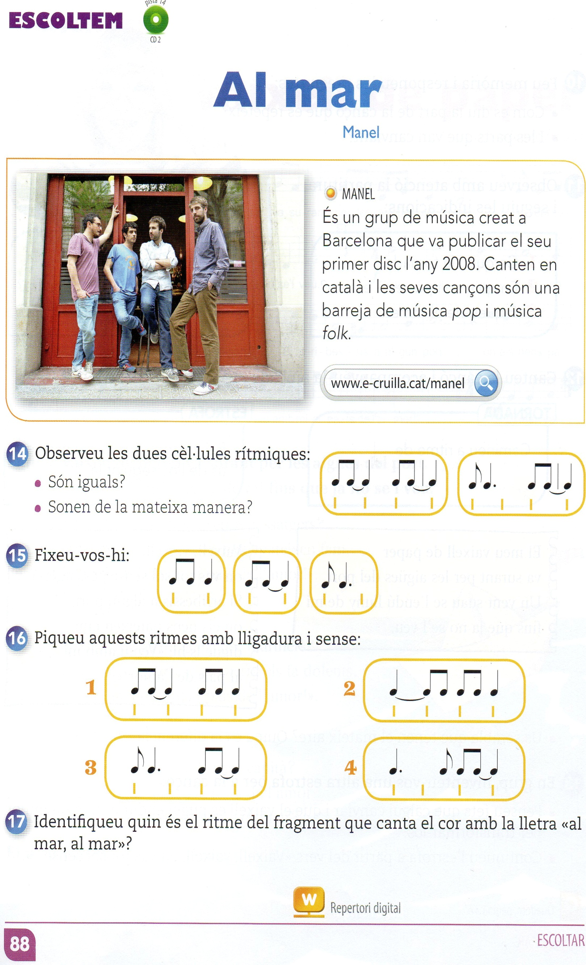
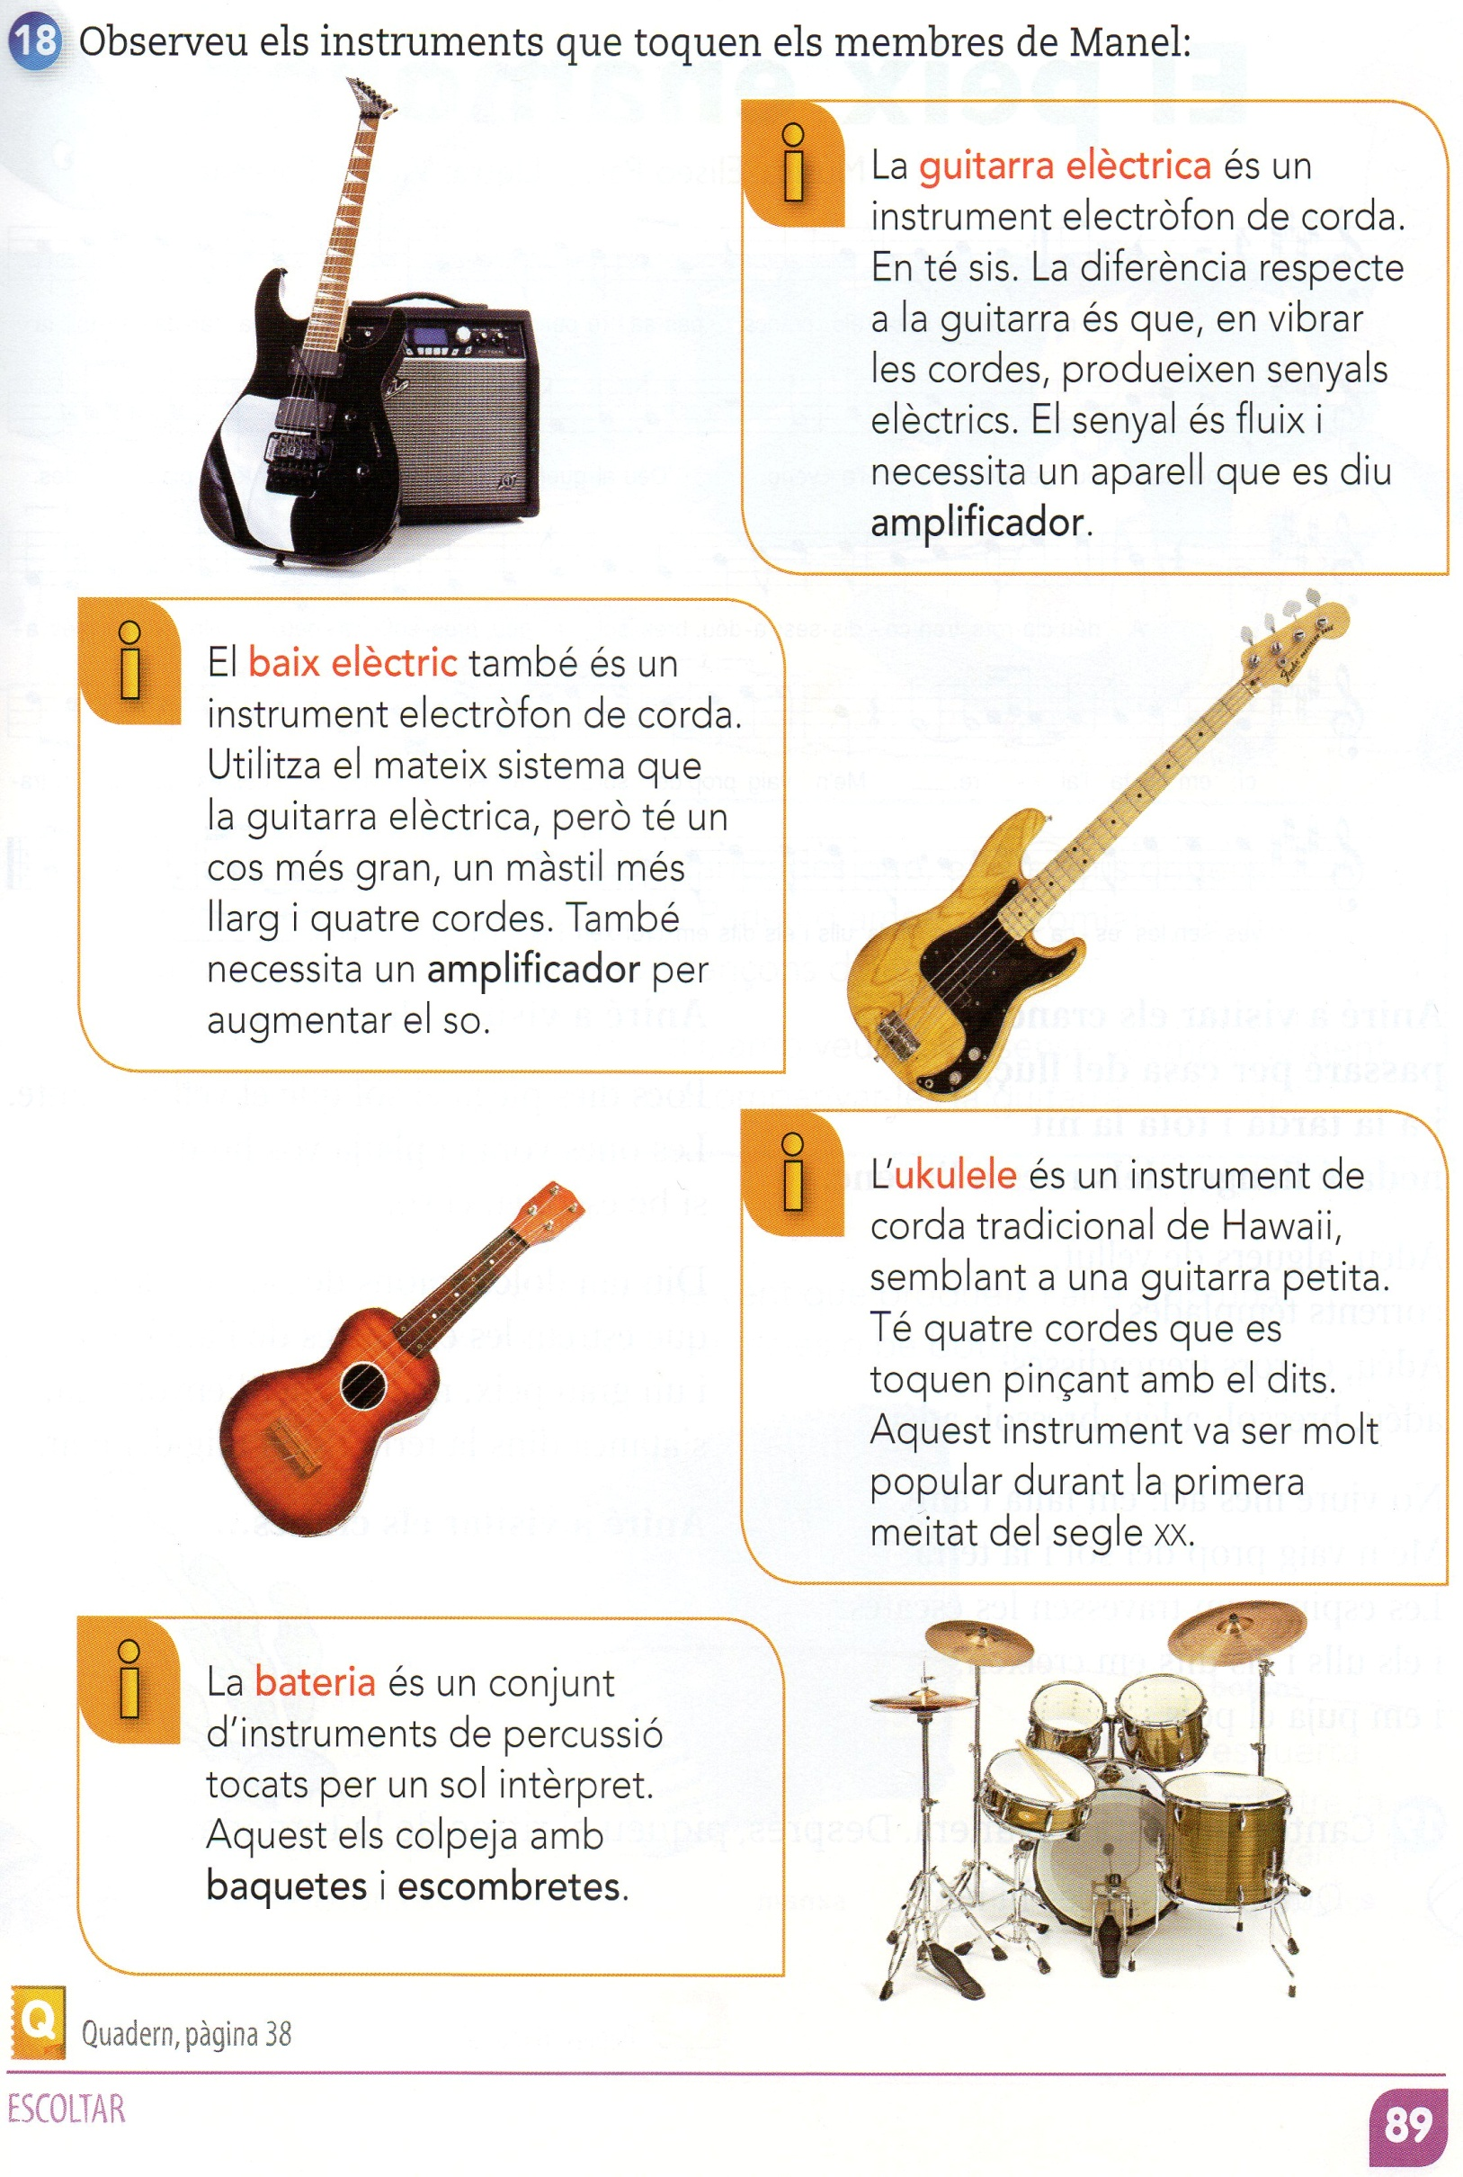
https://www.youtube.com/watch?v=iYUFx6CYd6M
5è
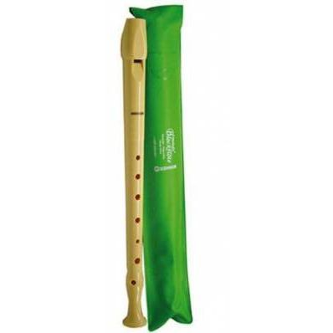
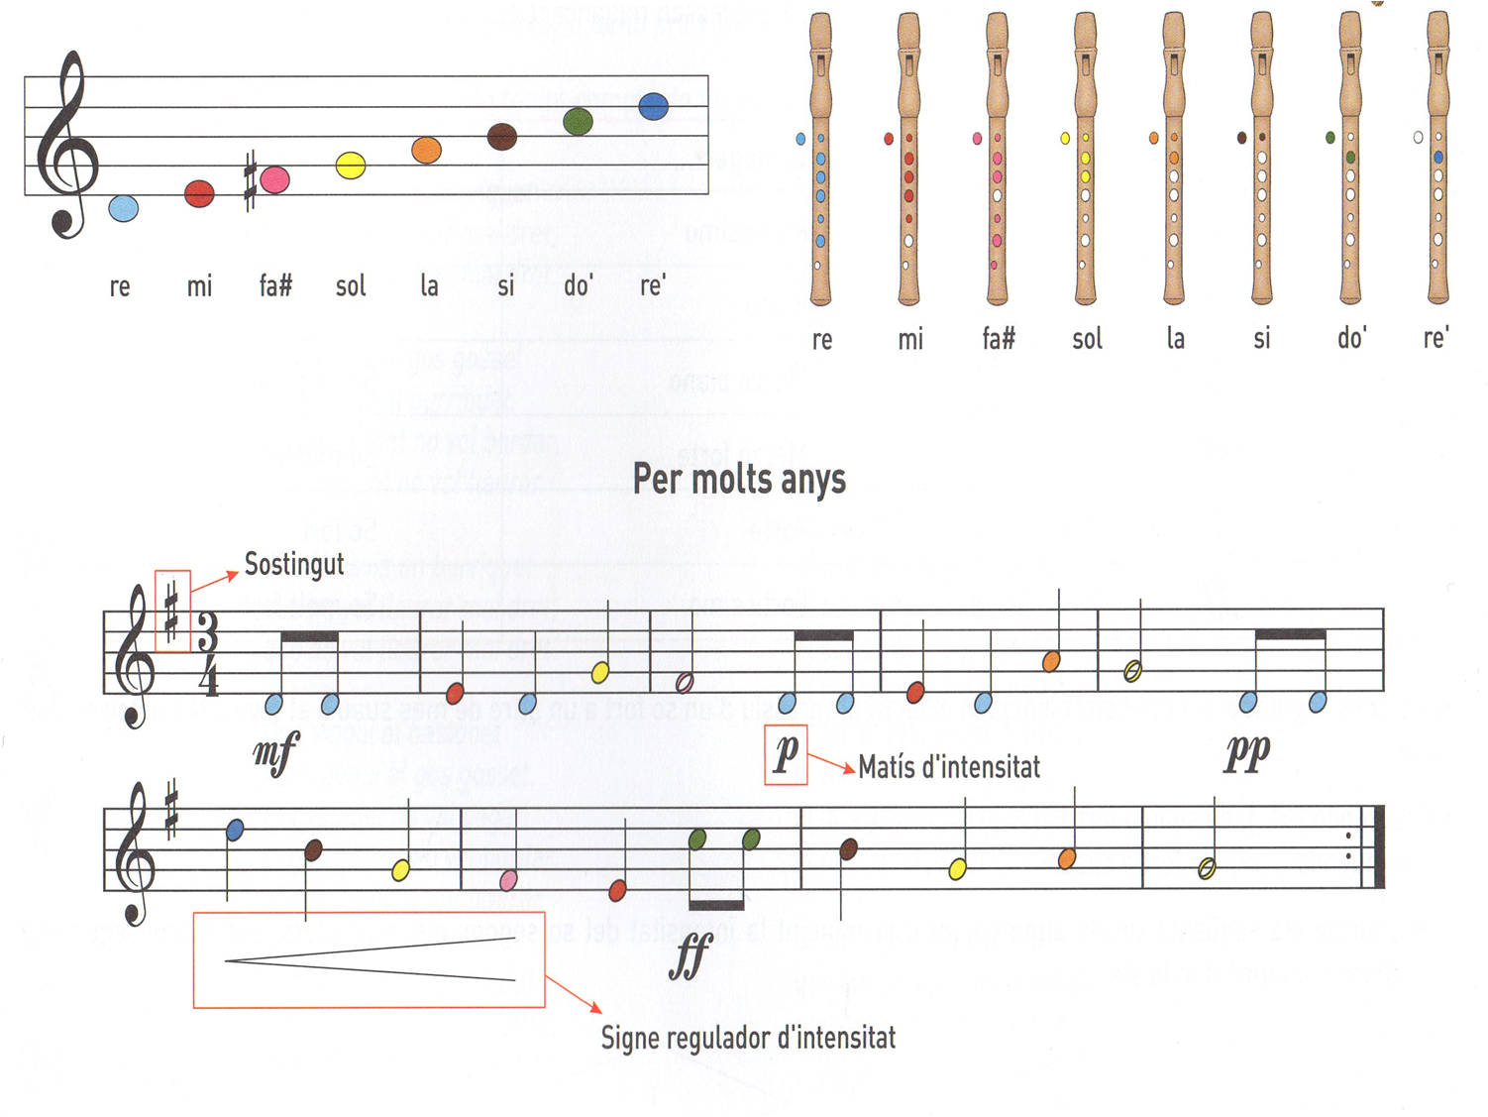
https://www.youtube.com/watch?v=UTEyw4dag3I

6è

ELS PICAPEDRA
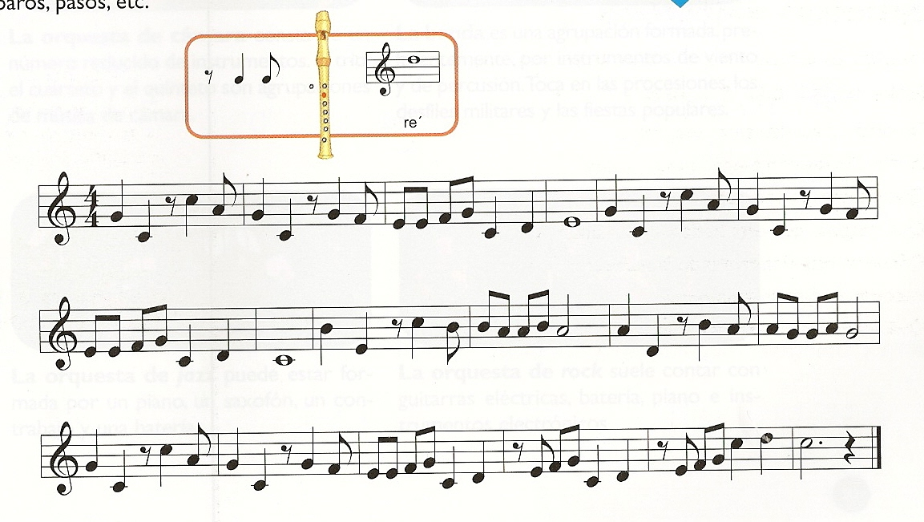

https://www.youtube.com/watch?v=UDavbZ6upUs

