1r 
LA SERENATA
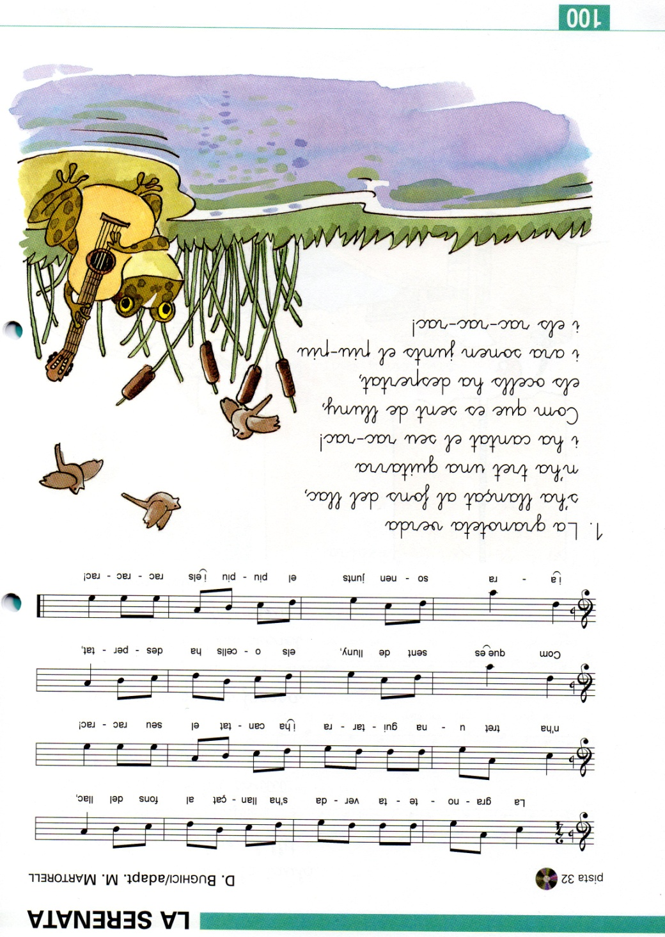
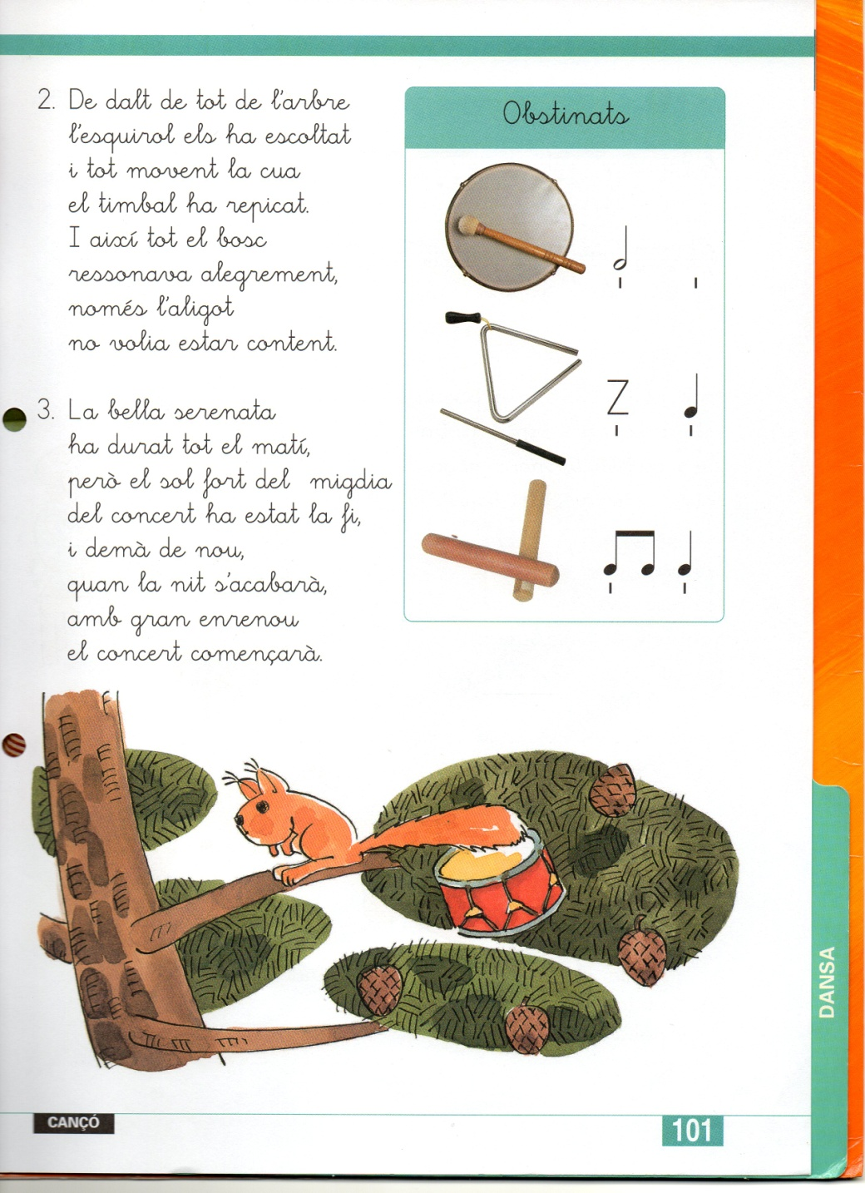
https://www.youtube.com/watch?v=XYWOv1q1rjA
2n 
Ballarem, ballarem i ballarem:

https://www.youtube.com/watch?v=jhssujWemqw

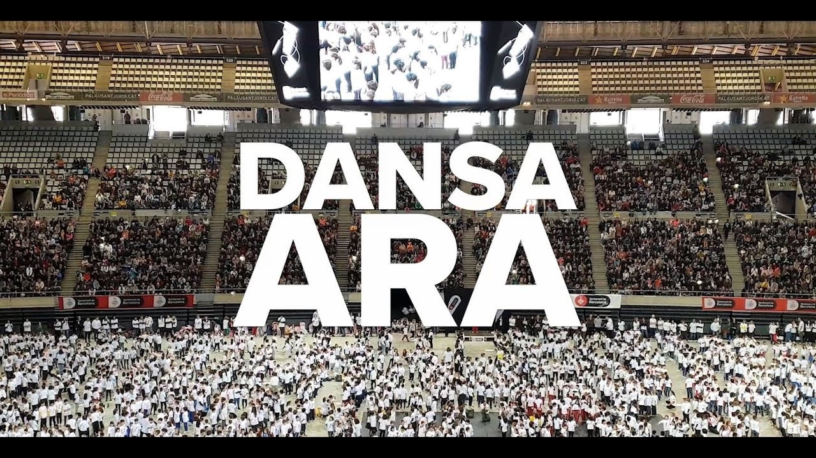

3r
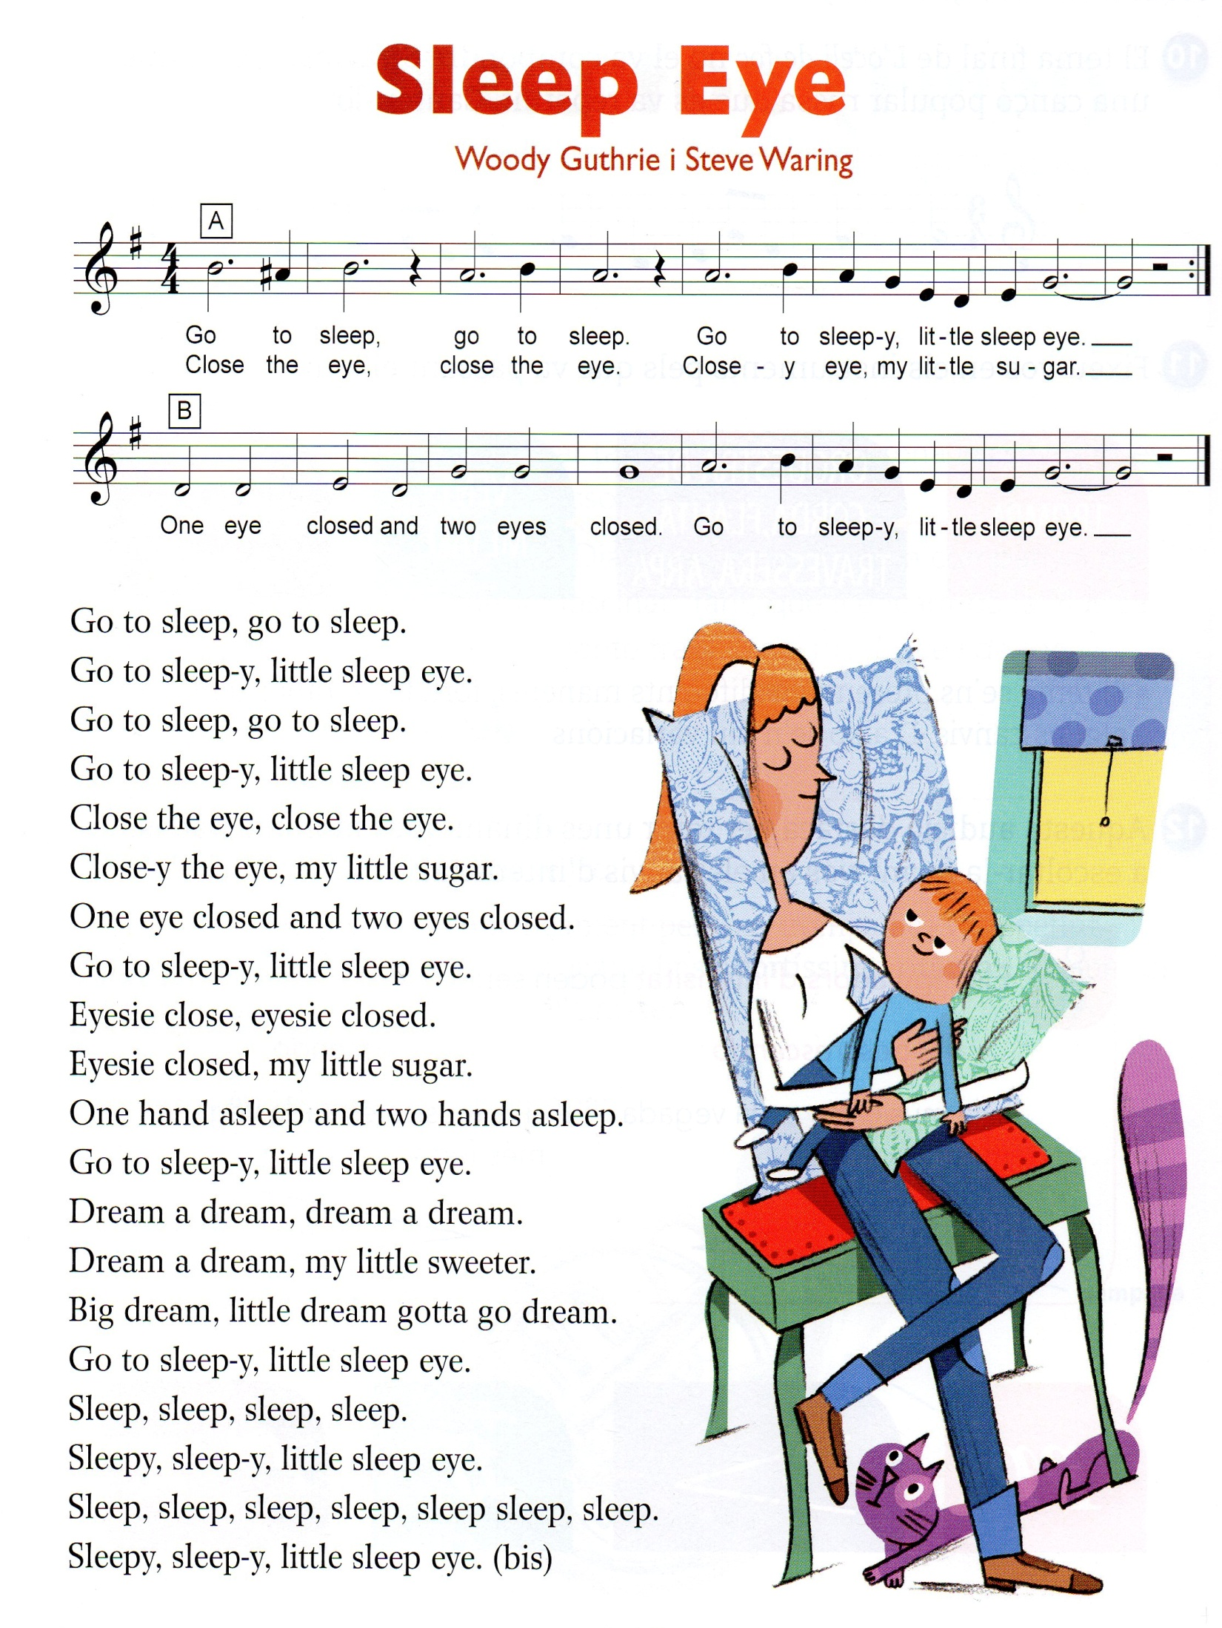
https://www.youtube.com/watch?v=rQf6iHrRhZU
4t

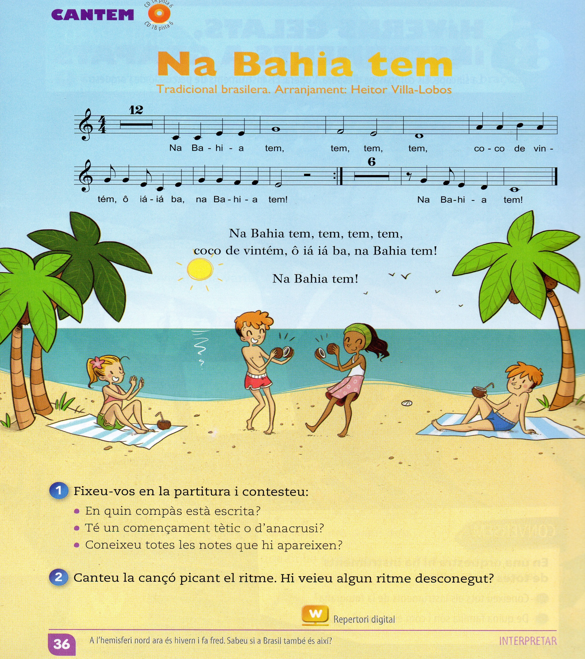
https://www.youtube.com/watch?v=MzeX8Y_n1s8
https://www.youtube.com/watch?v=yB1DS8mhXGM
5è



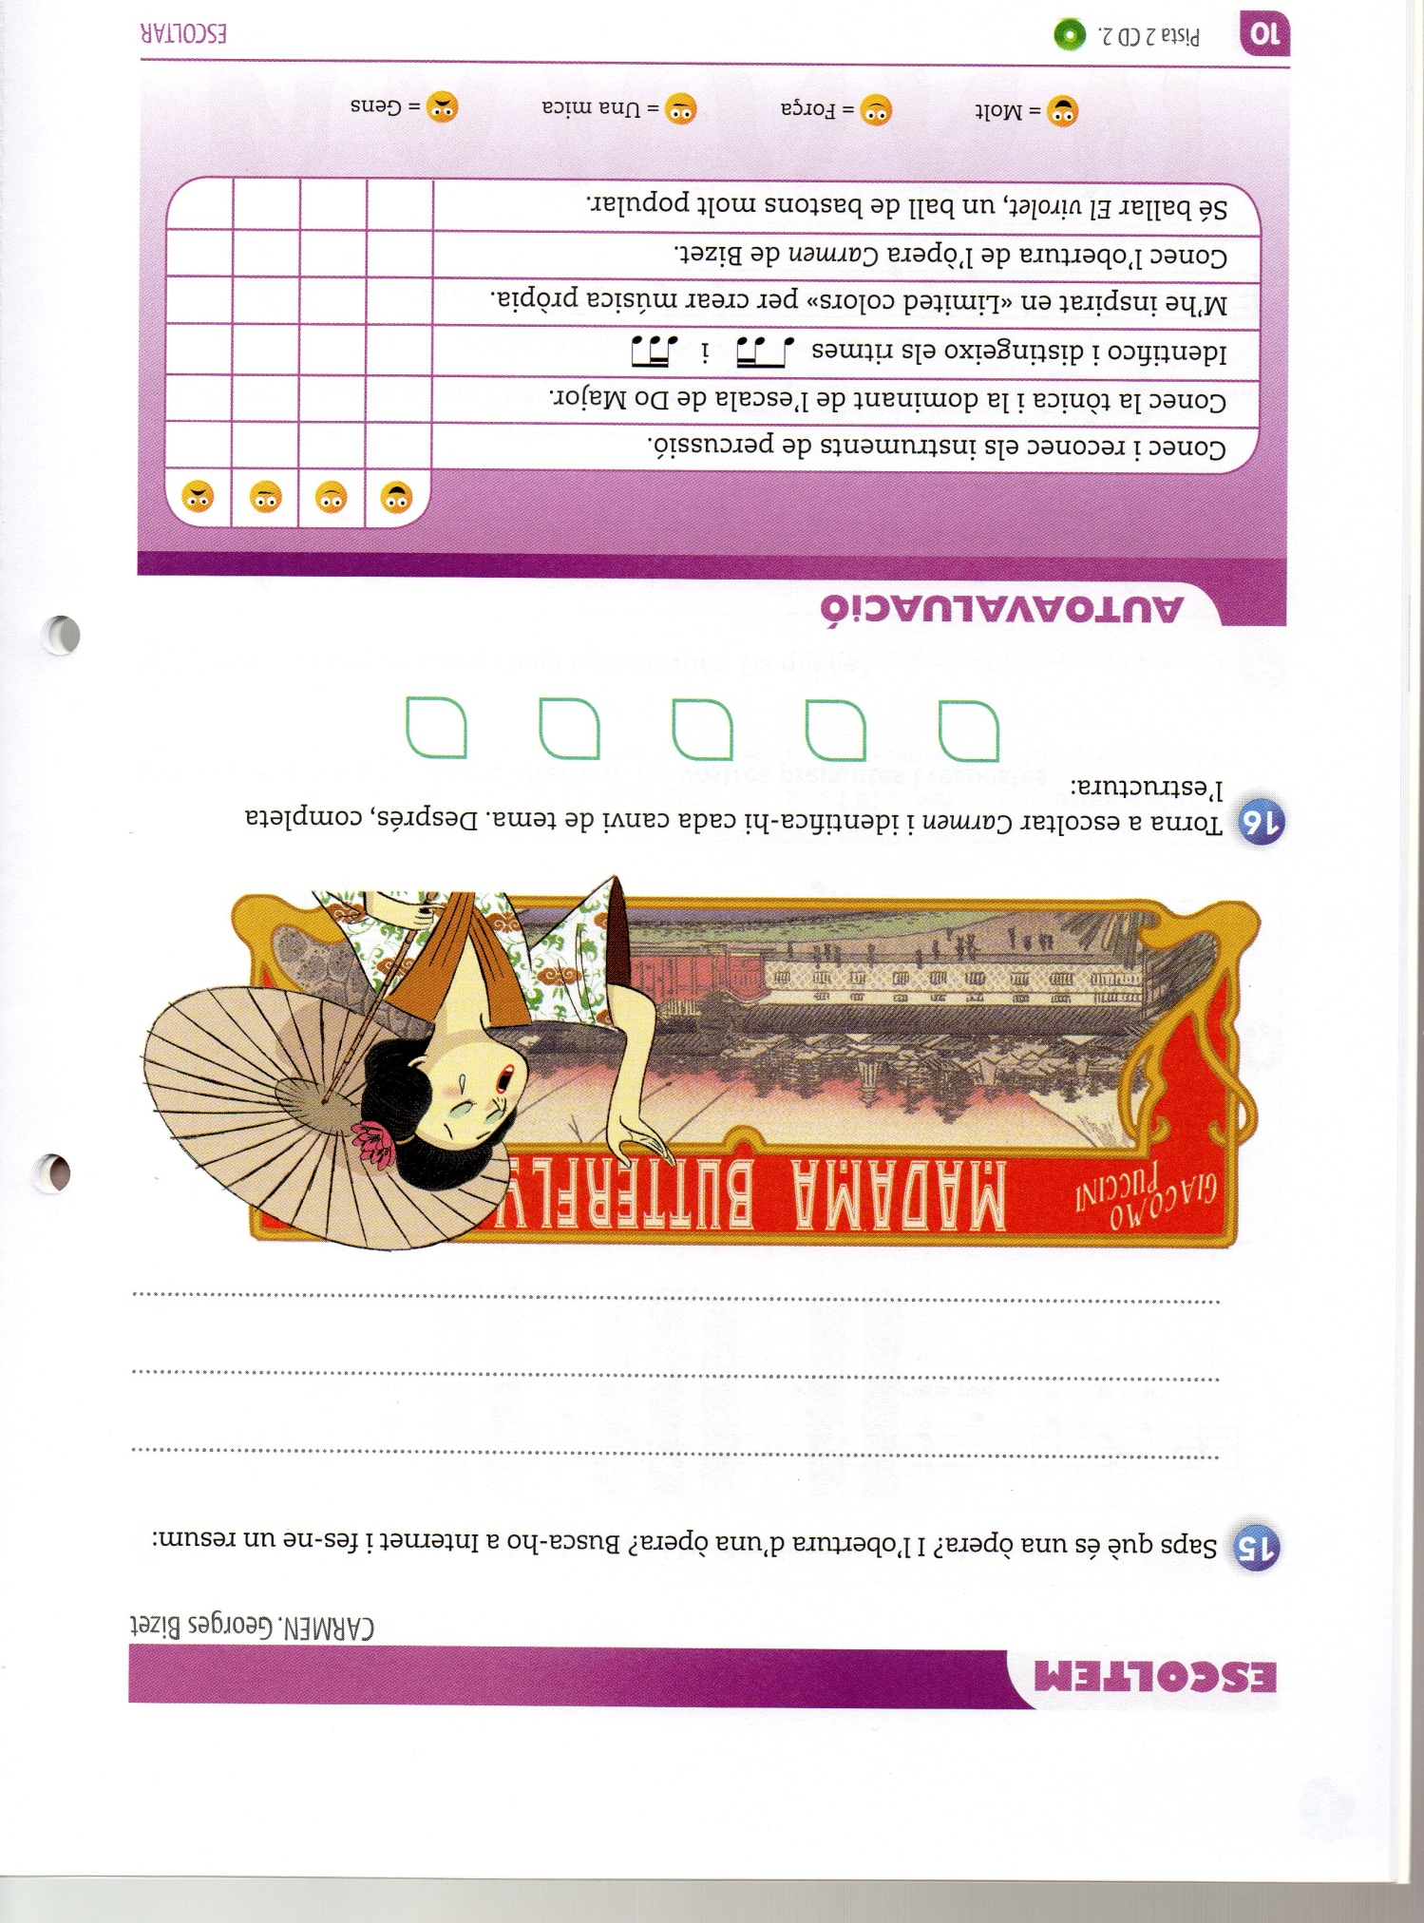
https://www.youtube.com/watch?v=OJe6reeG8_8
6è
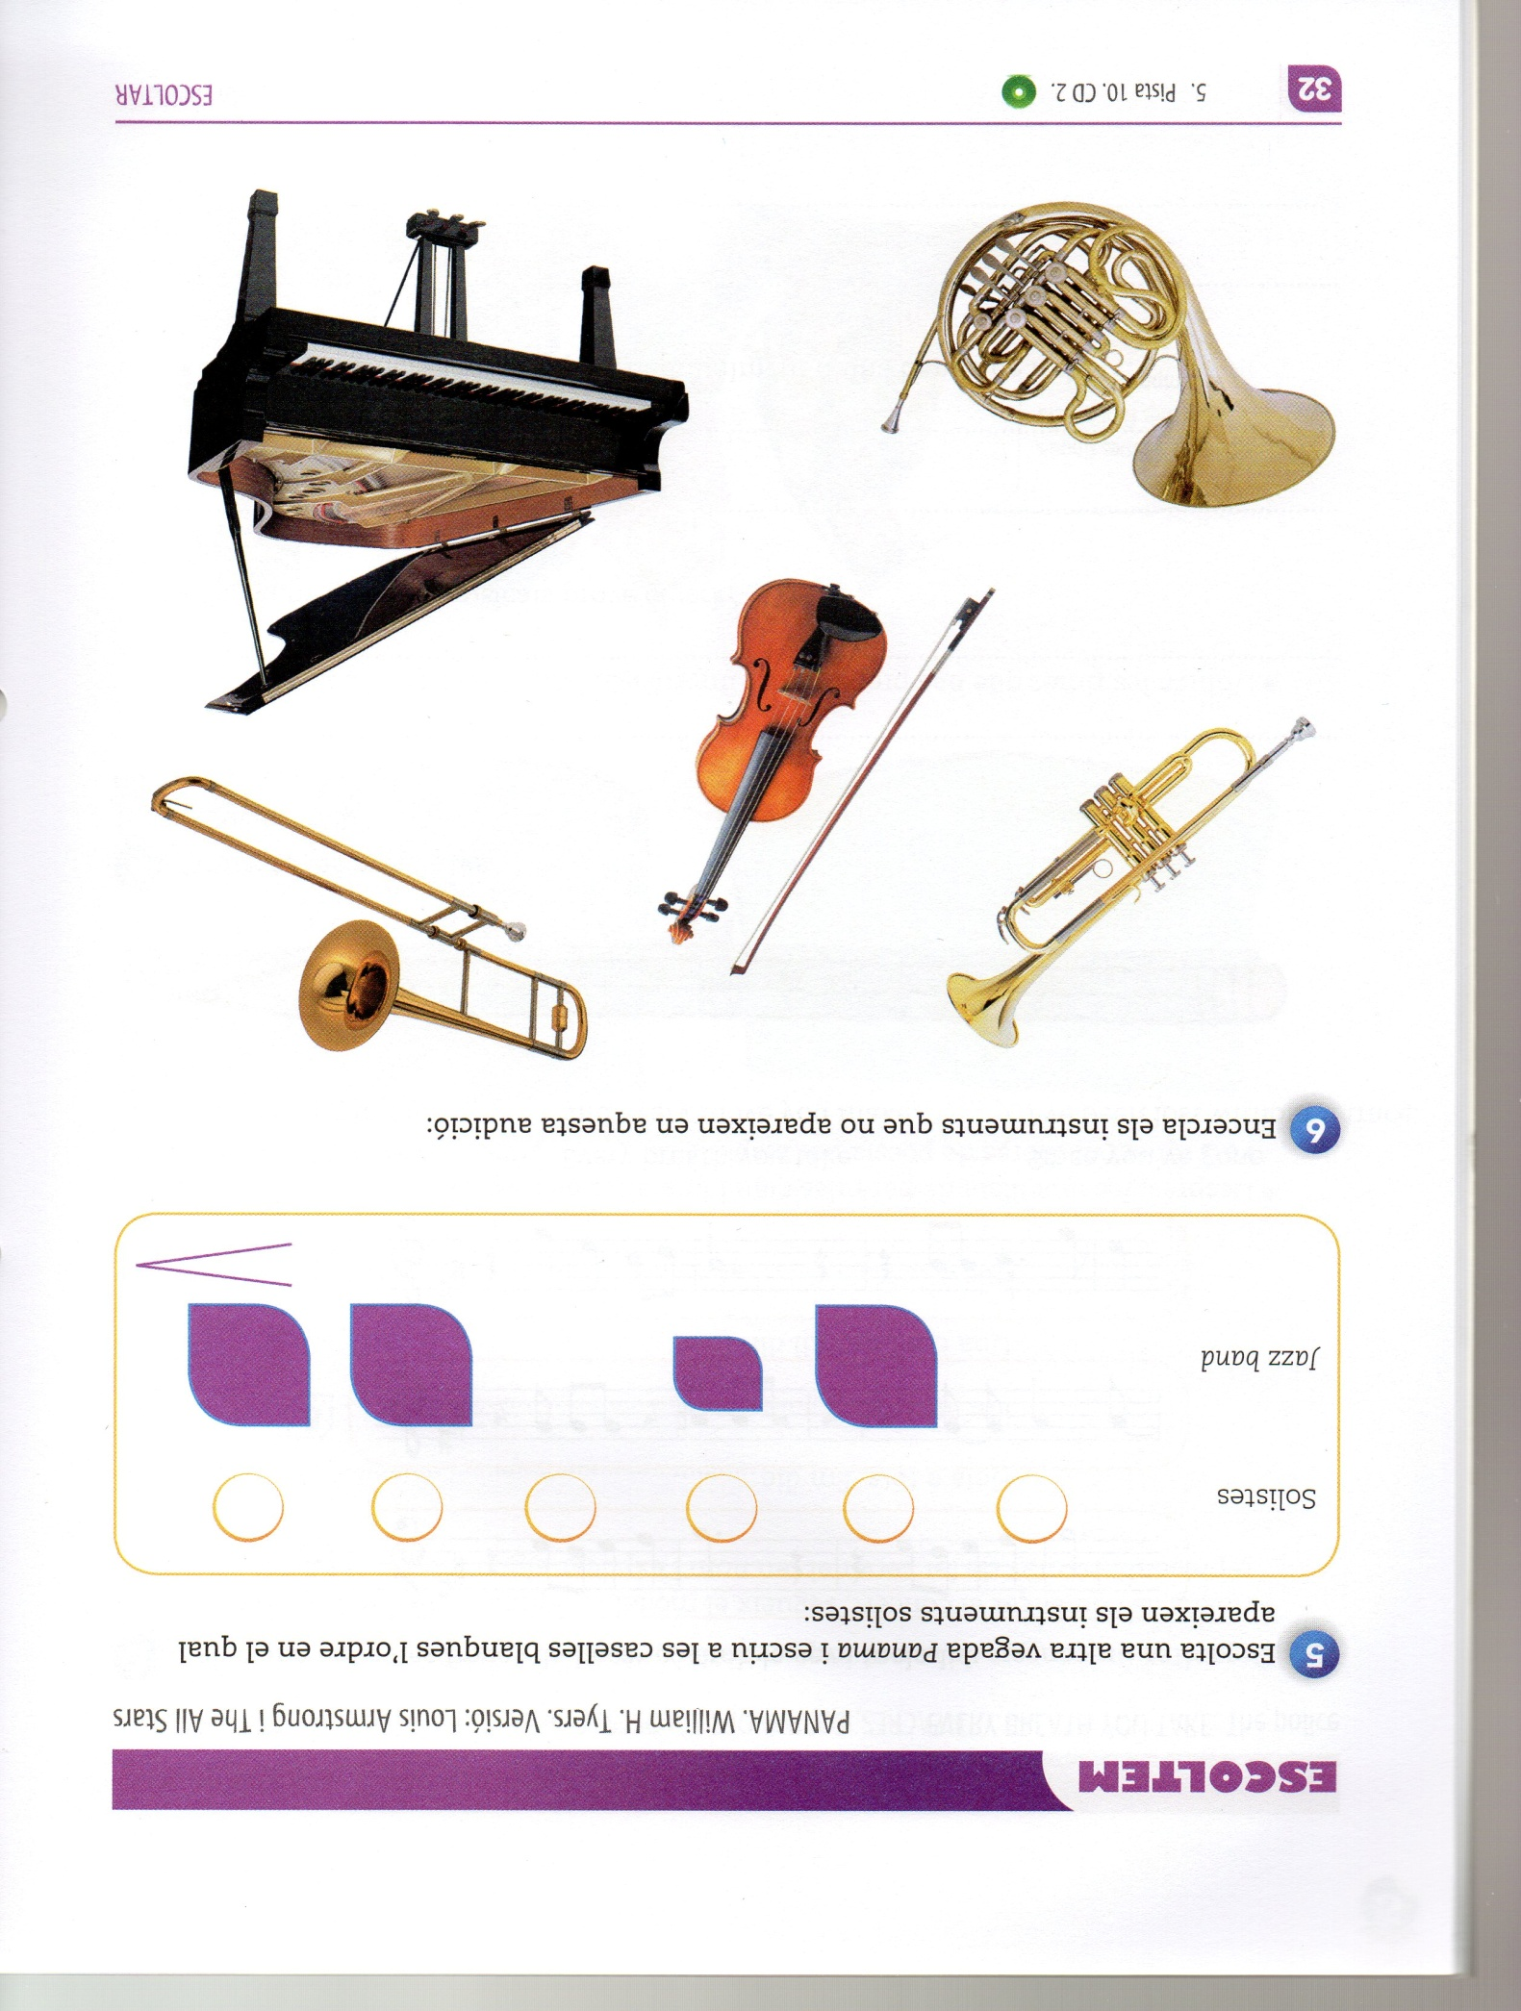
https://www.youtube.com/watch?v=nelDSJBBIf4

