P3
NOM:
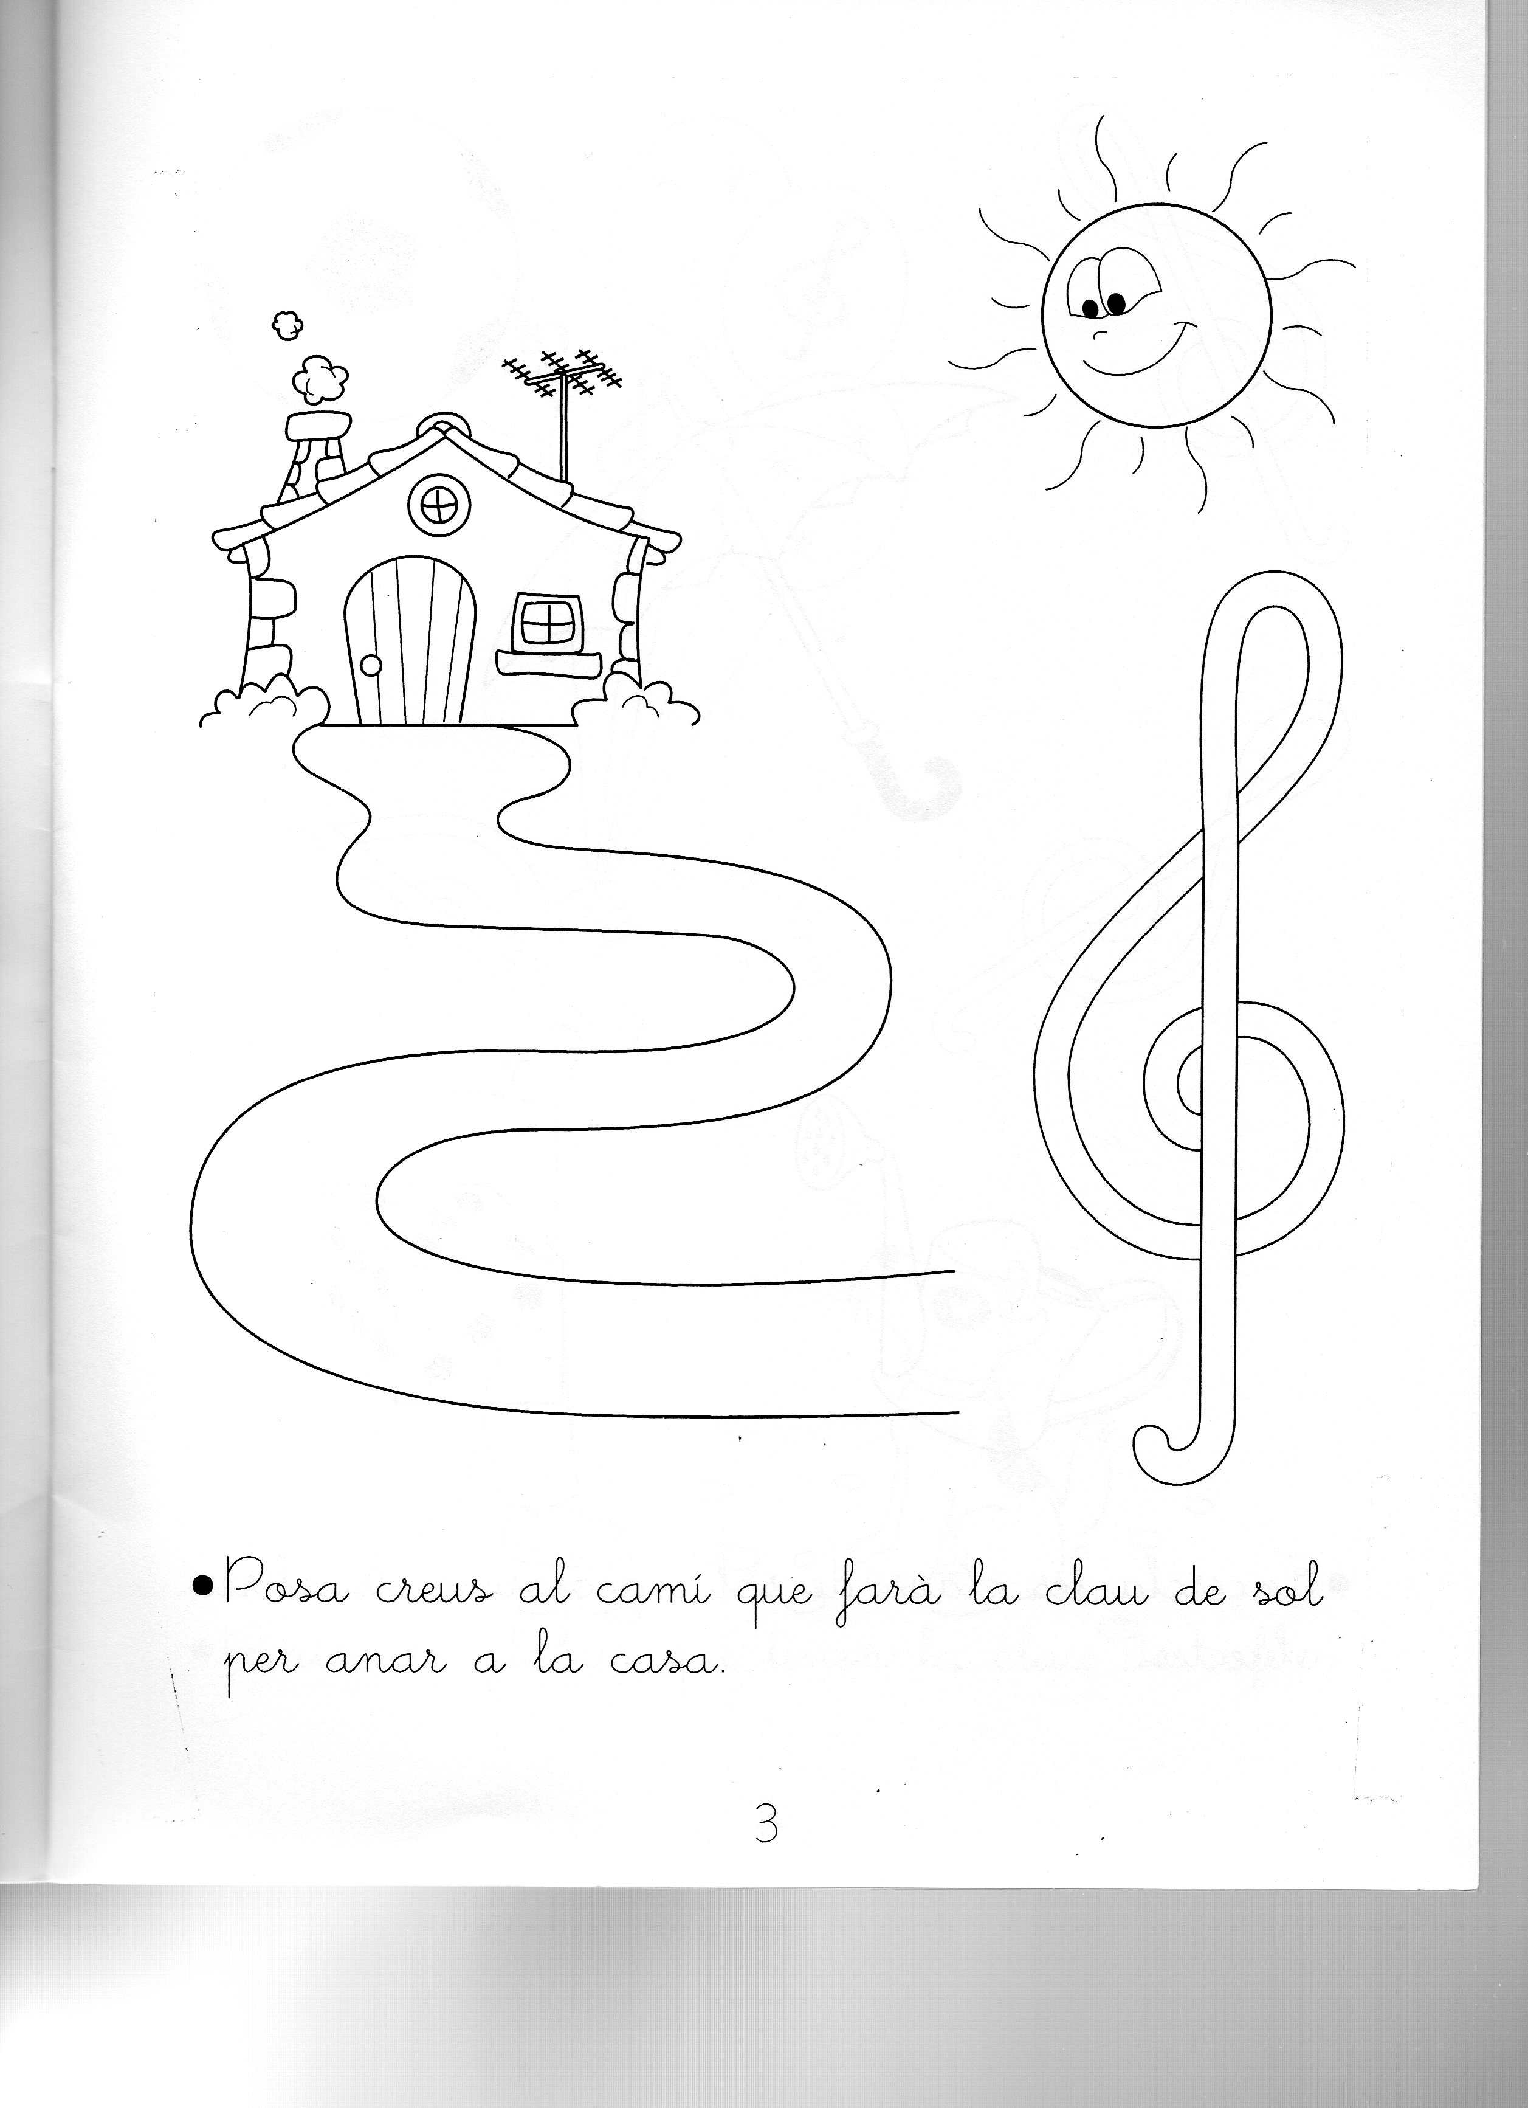
PER CANTAR I BALLAR: https://www.youtube.com/watch?v=ZQoi2uMrDMM
P4
NOM:
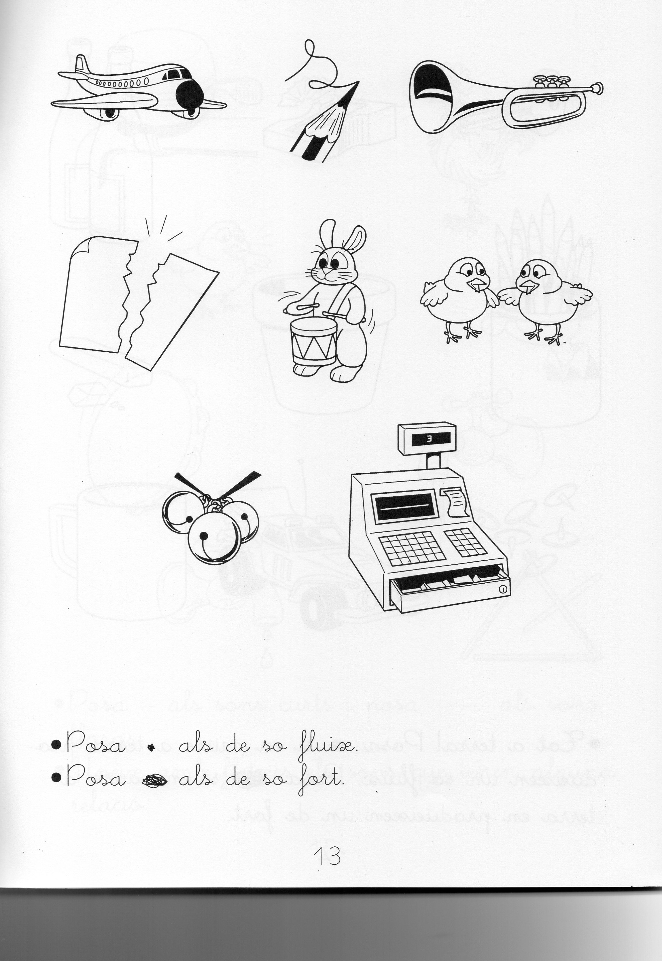
PER CANTAR I BALLAR:
https://www.youtube.com/watch?v=5sr4pbm5K9w
P5
NOM:
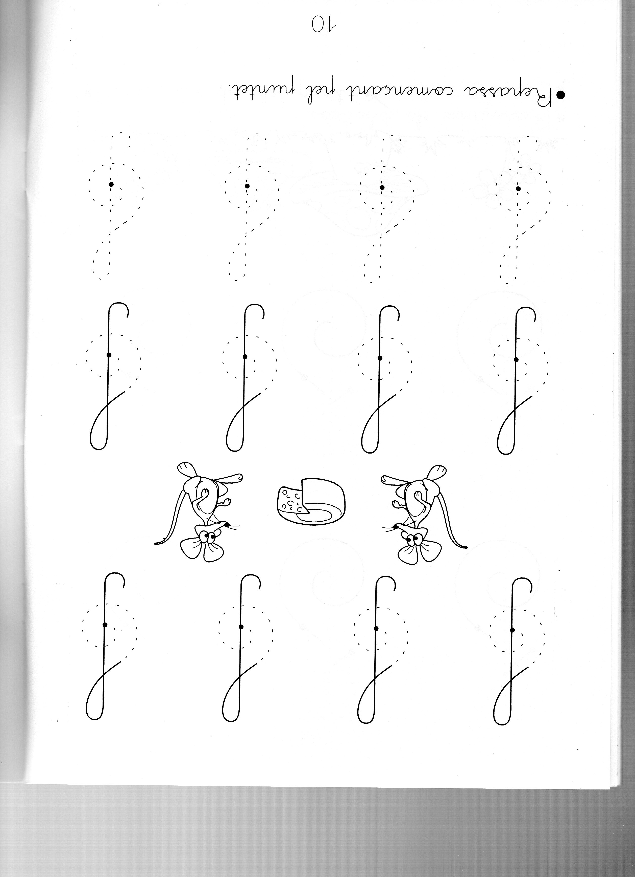
PER CANTAR I BALLAR:
https://www.youtube.com/watch?v=3pLZ-OyA4Y8
1r
NOM:
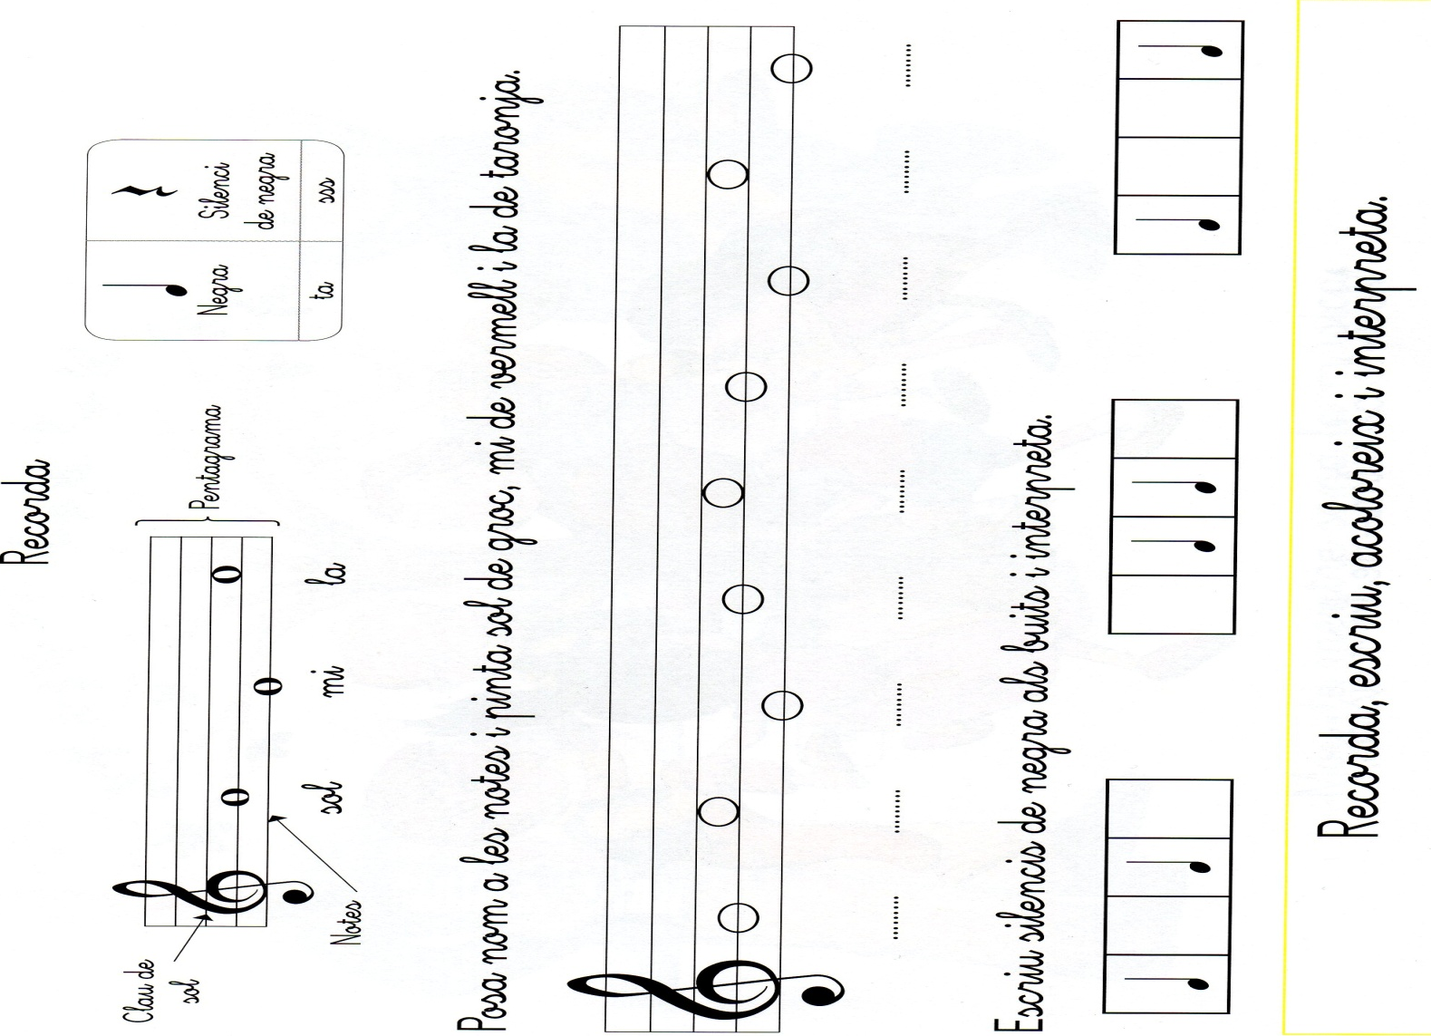
ENLLAÇ:
https://www.youtube.com/watch?v=wFzDz-g3MJw

2n
NOM:

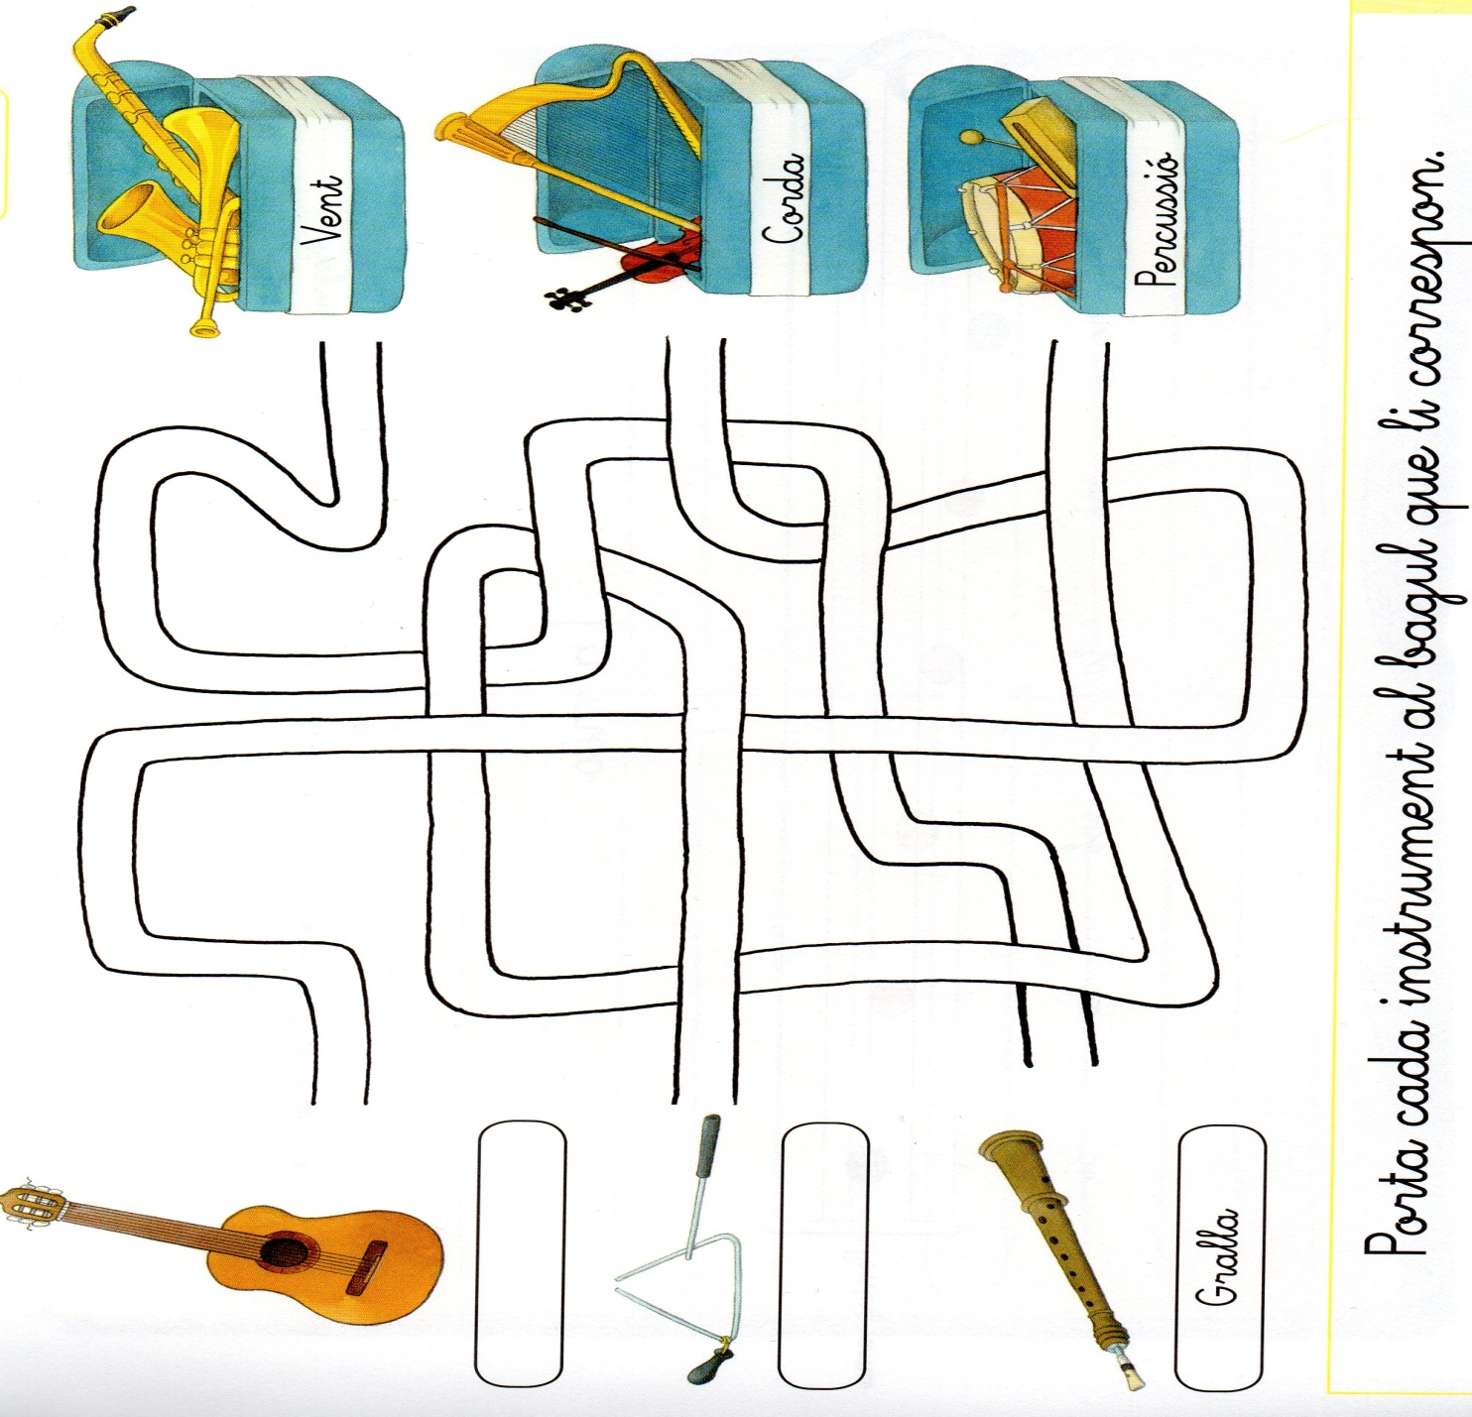
ENLLAÇ:
https://www.youtube.com/watch?v=cHad-I5AJT0

3r
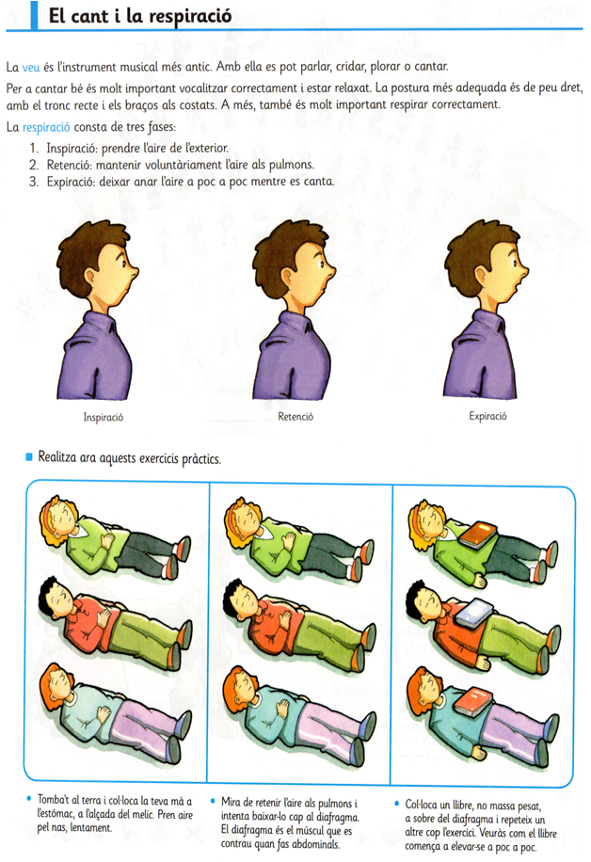ENLLAÇ:
https://www.youtube.com/watch?v=thUI3RfZUms
4t

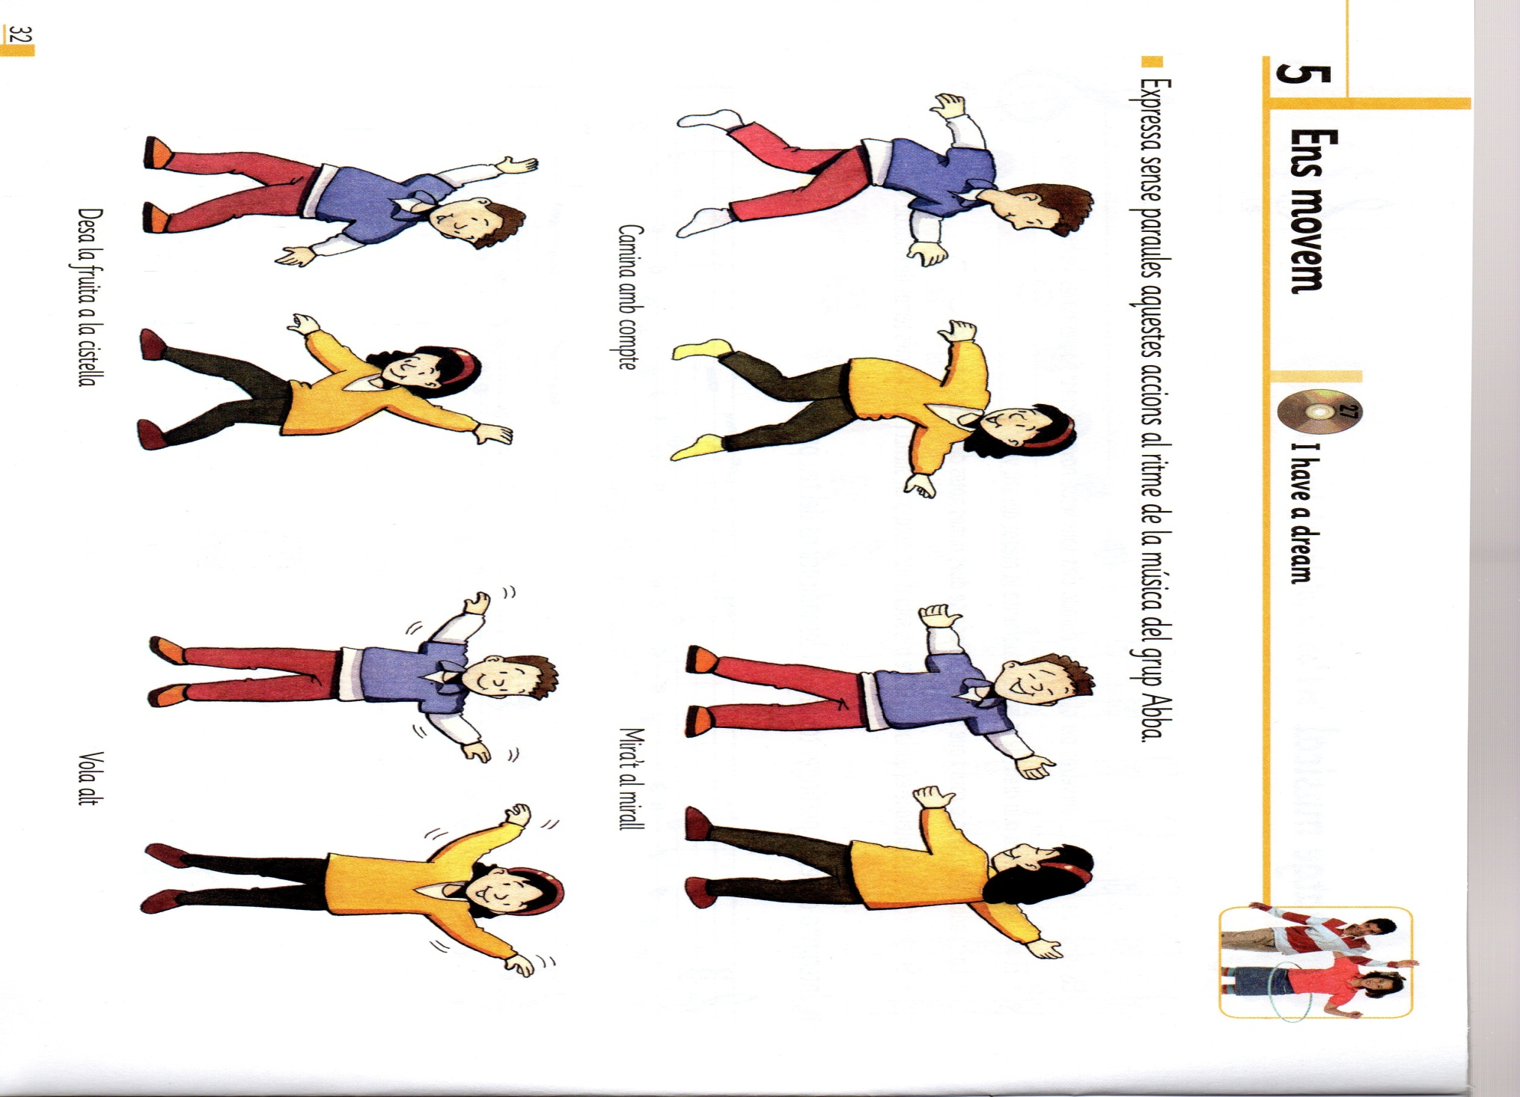

ENLLAÇ:
https://www.youtube.com/watch?v=_HMjOiHqE18
5è LA MÚSICA I LES SEVES FORMES
ENLLAÇ: https://www.youtube.com/watch?v=OFfYGoVstgc
6è AGRUPACIONS MUSICALS
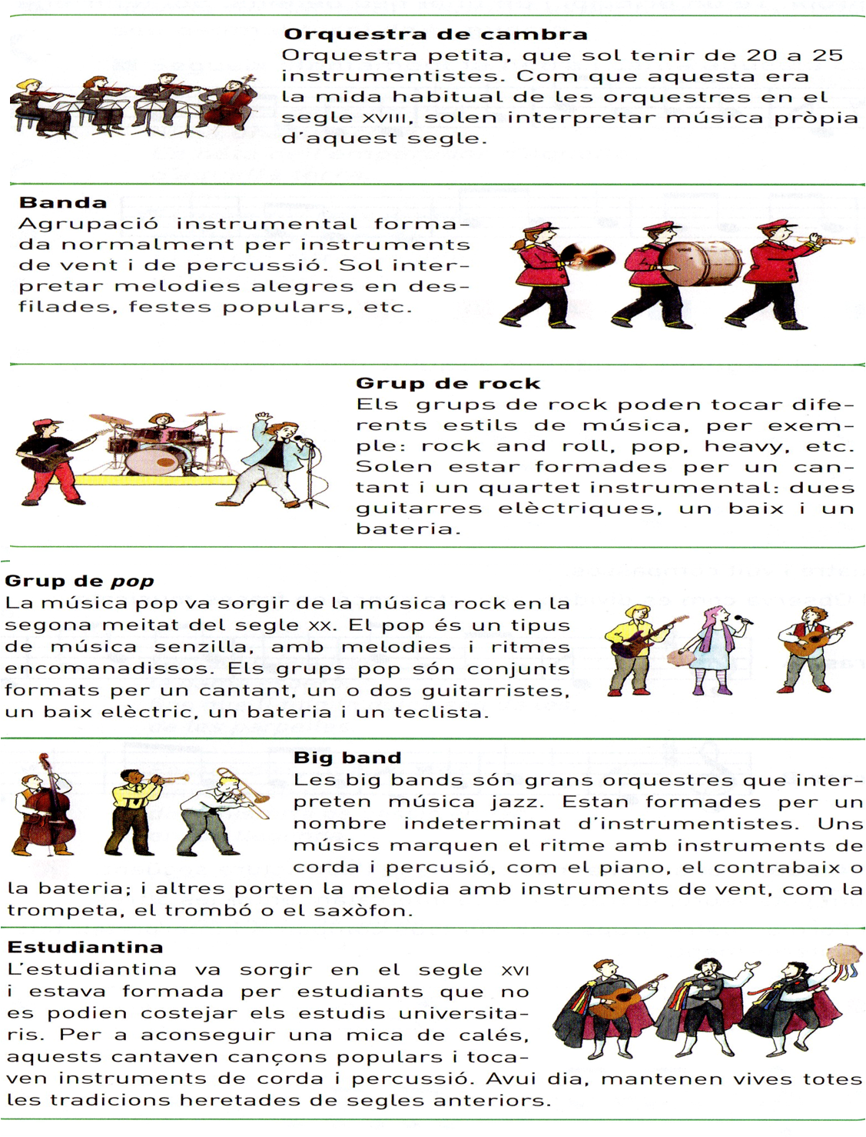
ENLLAÇOS 6È:
https://www.youtube.com/watch?v=0M0IfjSIdMs
https://www.youtube.com/watch?v=iSdBAiqOb3I
https://www.youtube.com/watch?v=79foFSDoOxY
https://www.youtube.com/watch?v=k14sntBb7jg
https://www.youtube.com/watch?v=oyI3EBFLO4c

