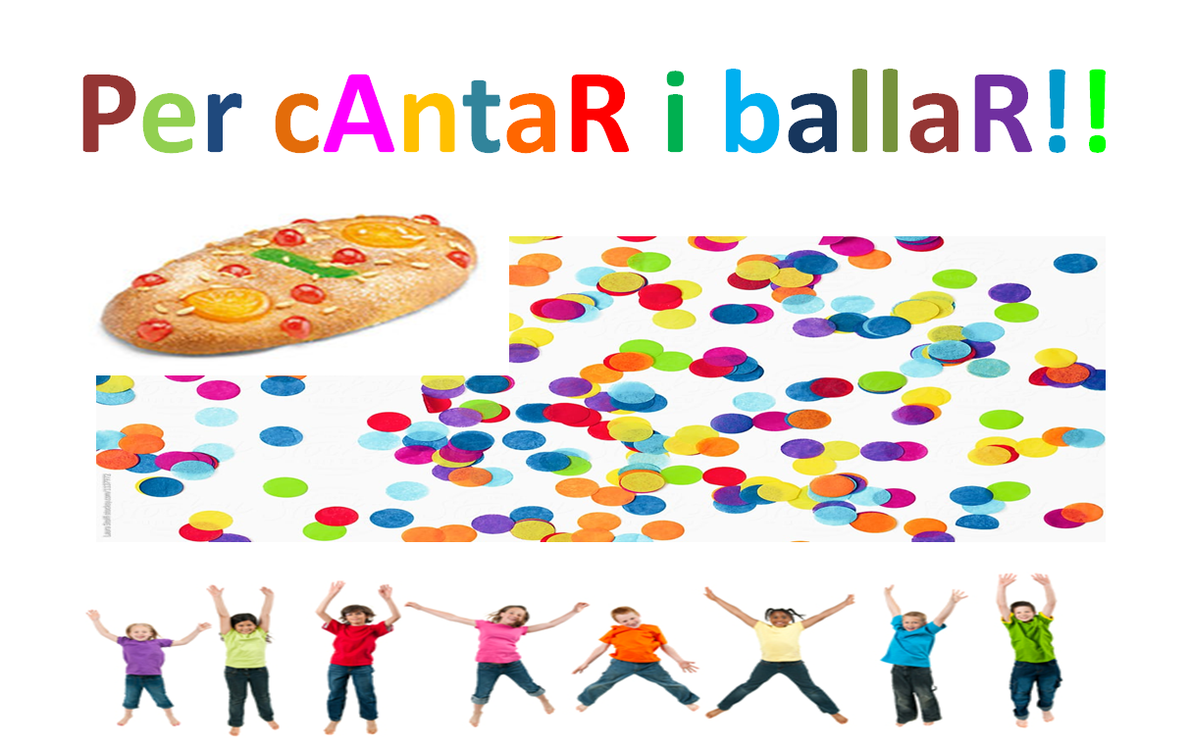
“Viu l’estiu”
https://www.youtube.com/watch?v=NC4A97nuZZY
“Ice cream”
https://www.youtube.com/watch?v=DaMhY8uvUWE
“I love Summertime”
https://www.youtube.com/watch?v=Xg5i9rxxuJM

