P3
NOM:
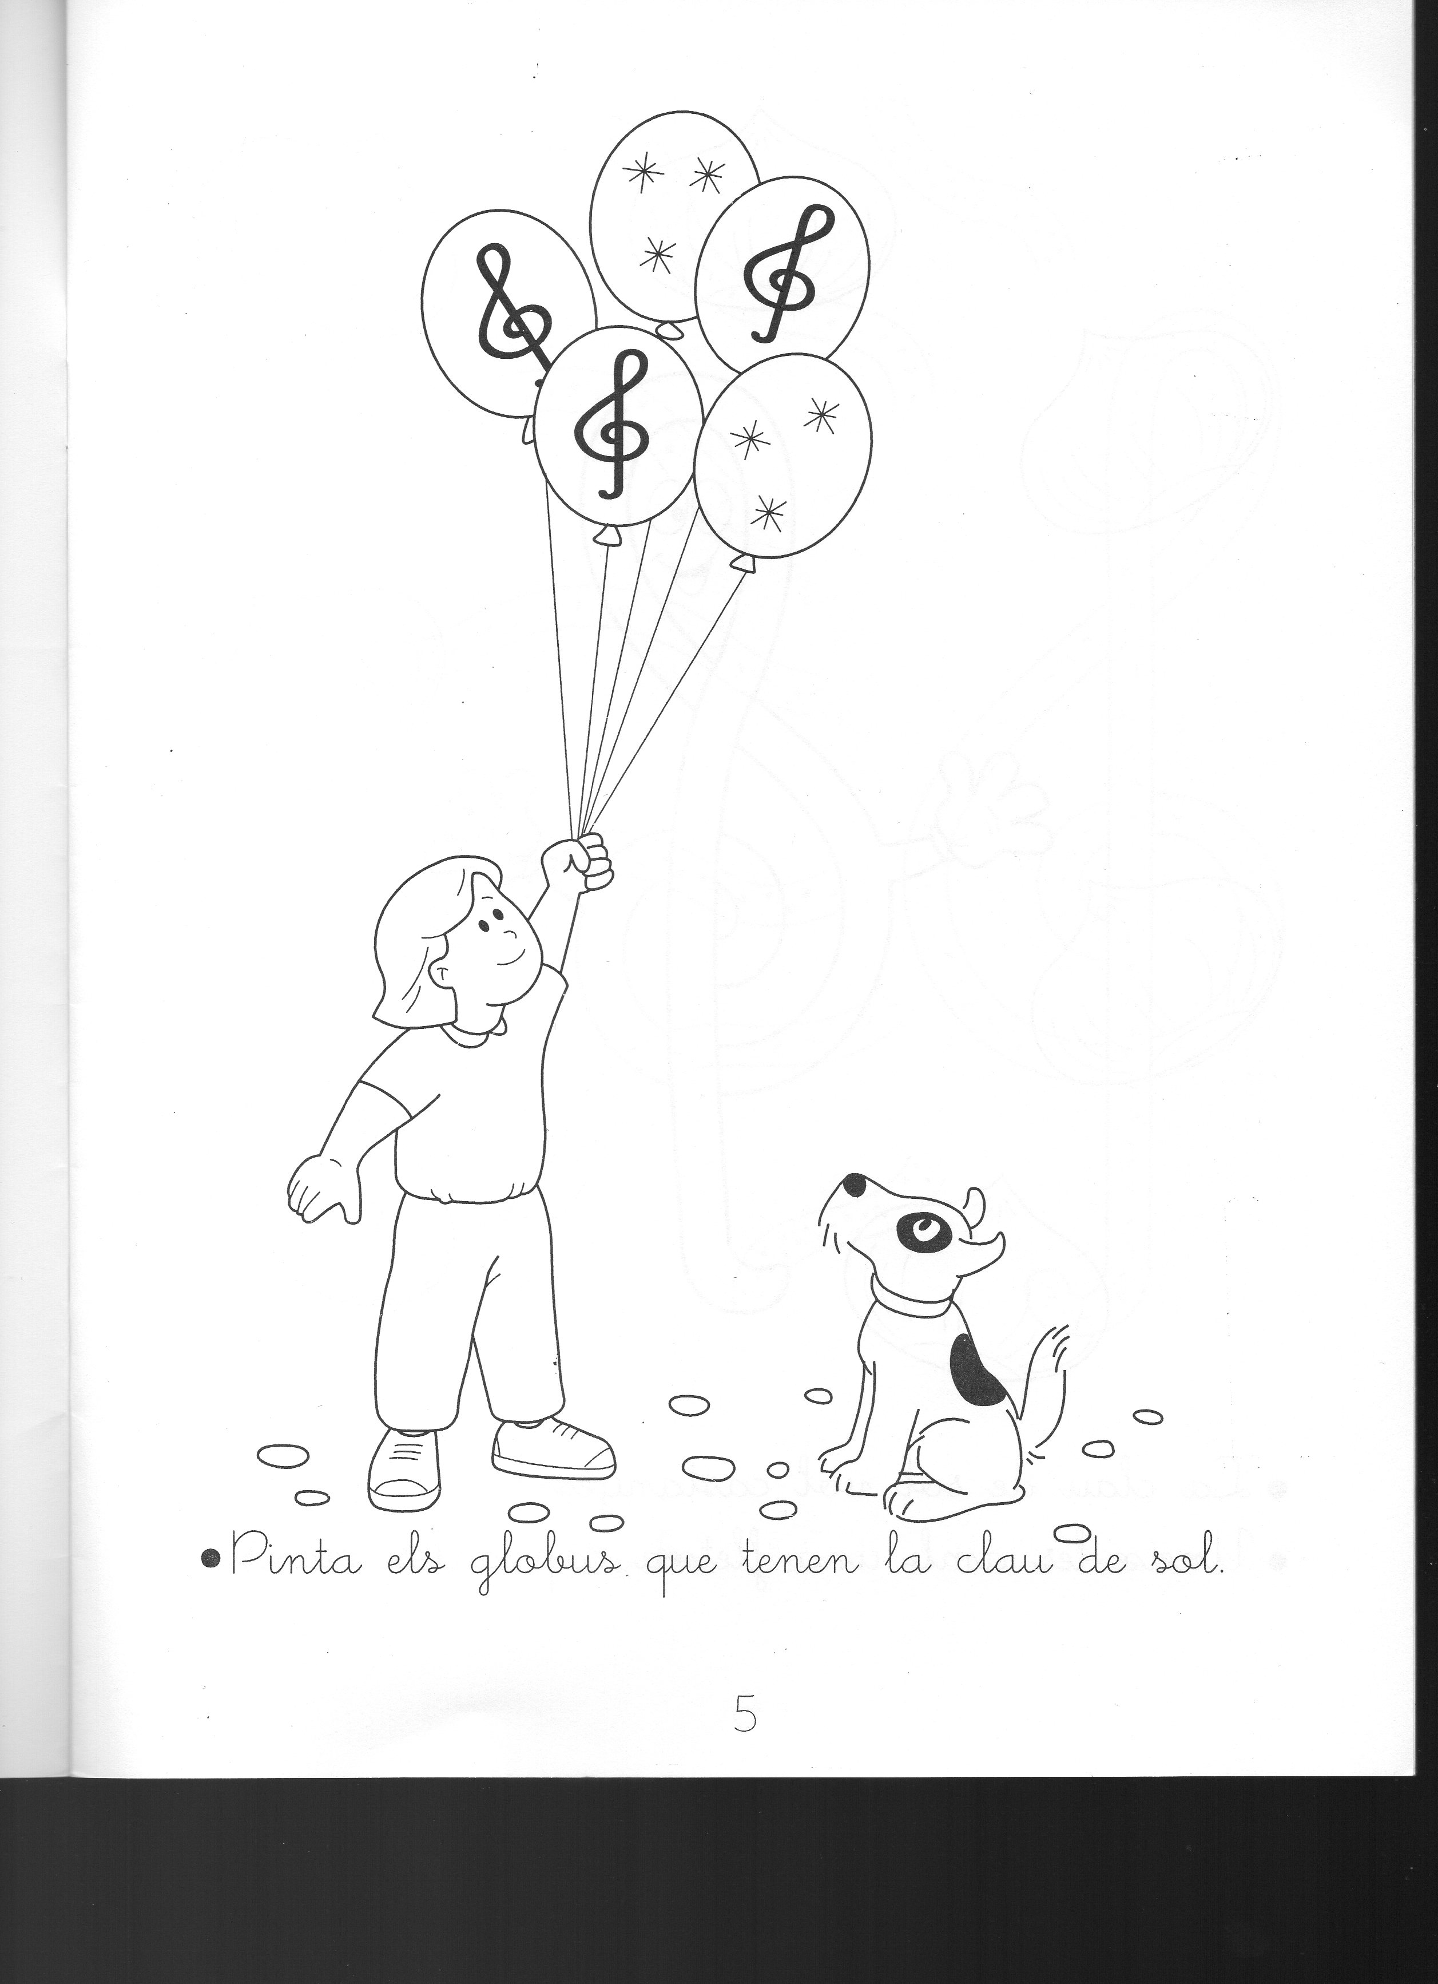
I PER BALLAR: https://www.youtube.com/watch?v=wII6FbAC_4Y
P4
NOM:
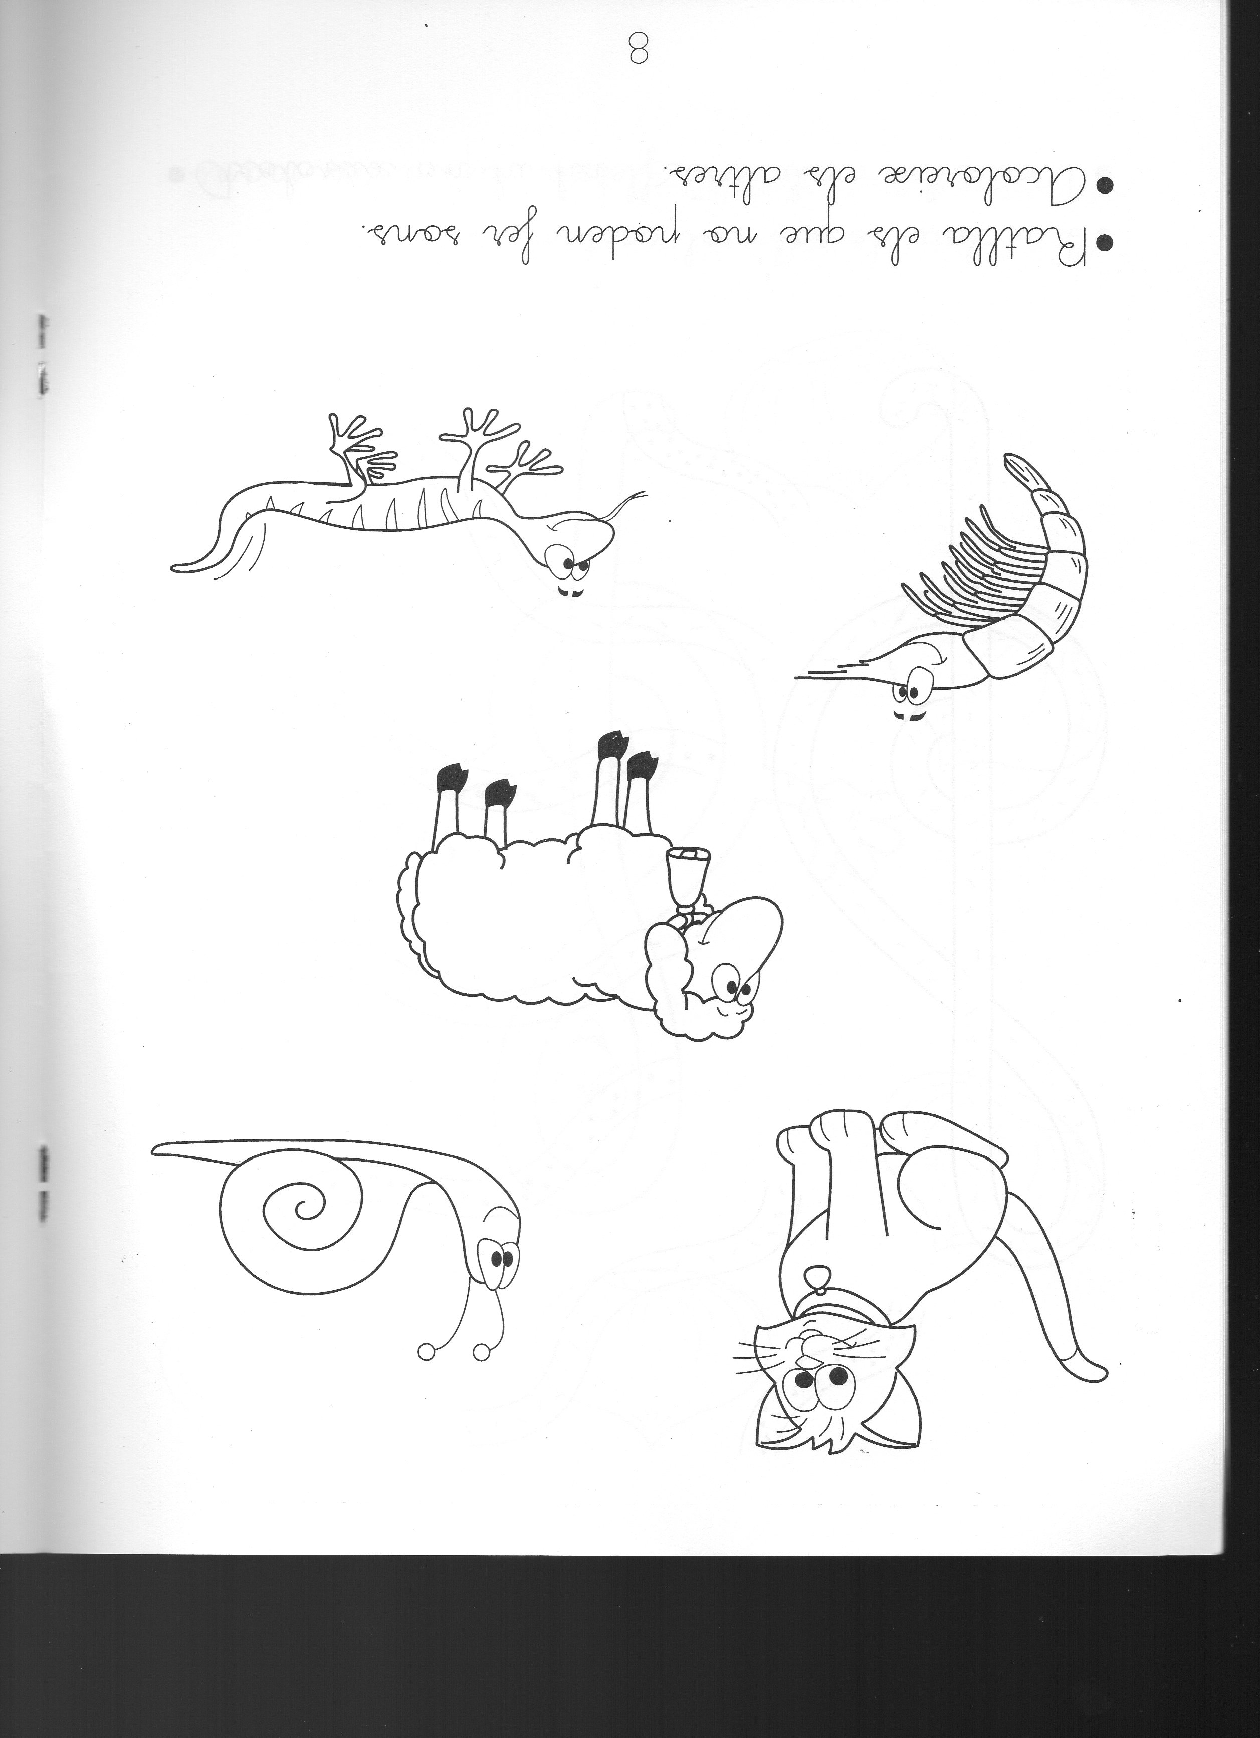
I PER BALLAR: https://www.youtube.com/watch?v=wII6FbAC_4Y
P5
NOM:
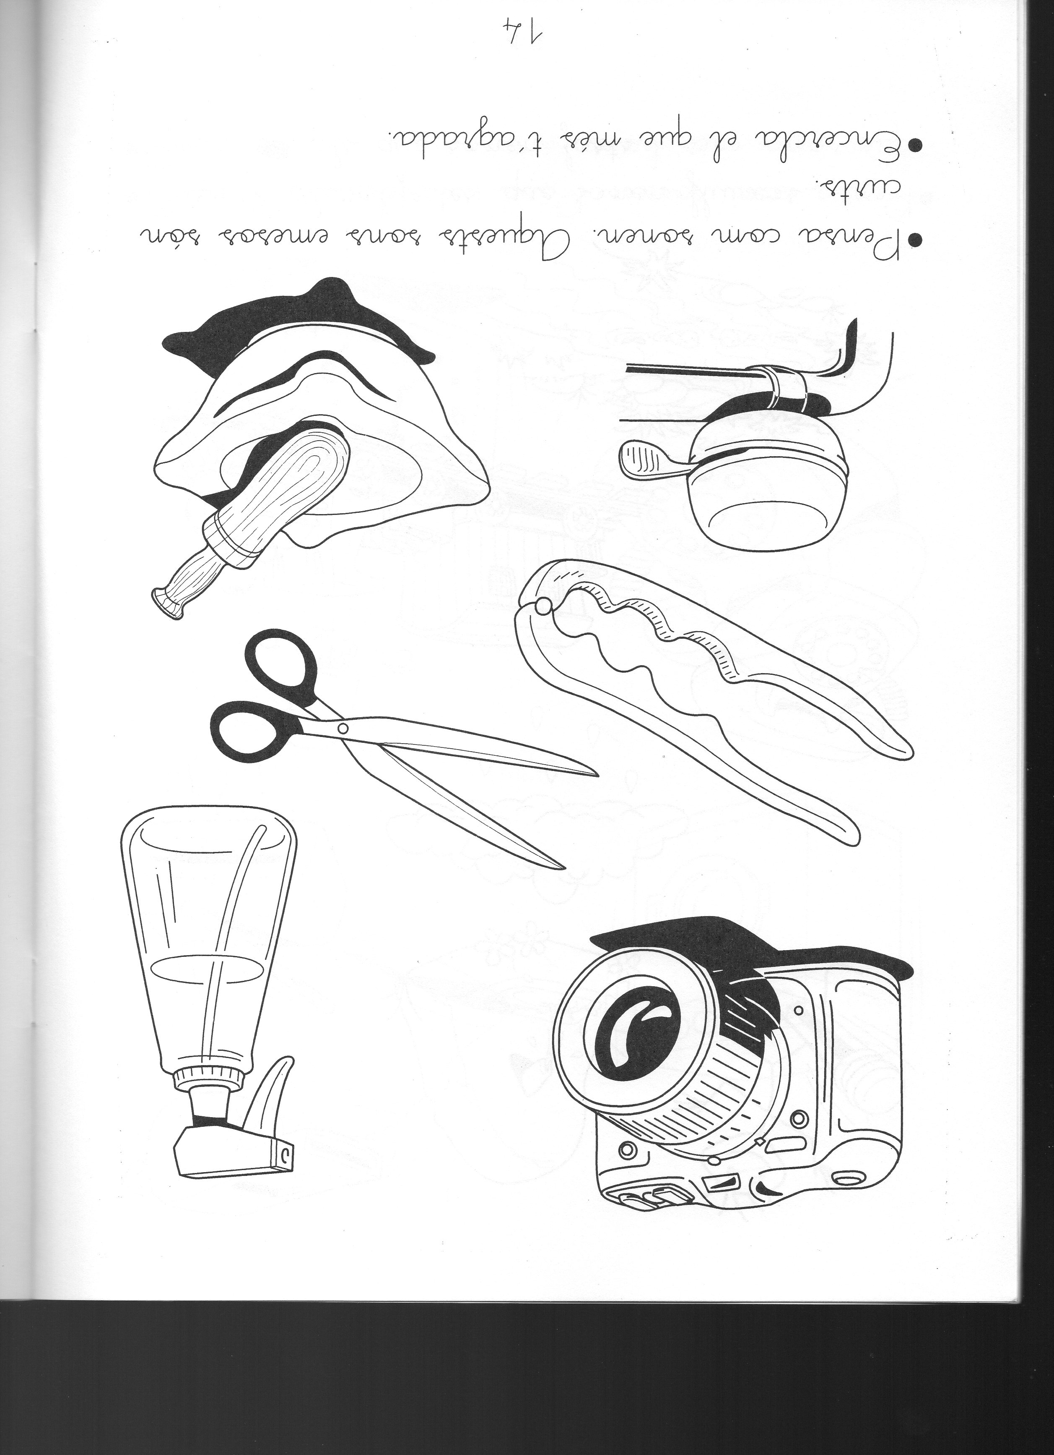
I PER BALLAR: https://www.youtube.com/watch?v=wII6FbAC_4Y

1r

https://www.youtube.com/watch?v=Q-AGyK8917I
EL SABATER
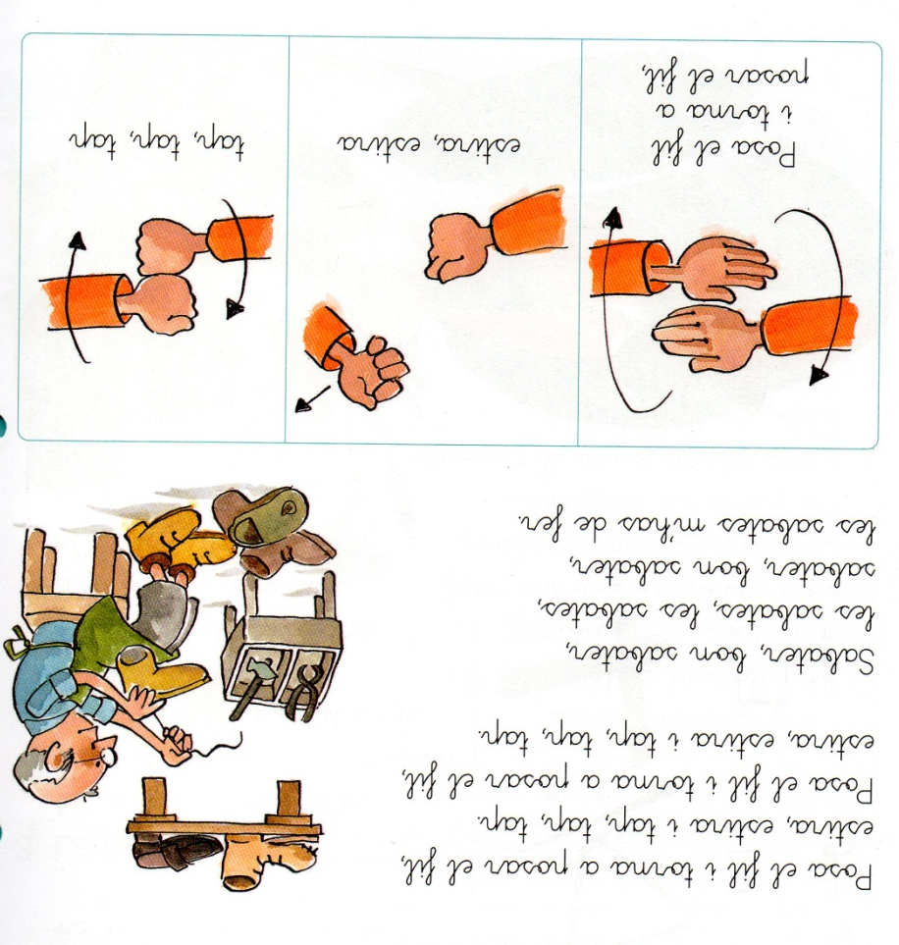
2n
https://www.youtube.com/watch?v=YN5vsSitLK0

3r
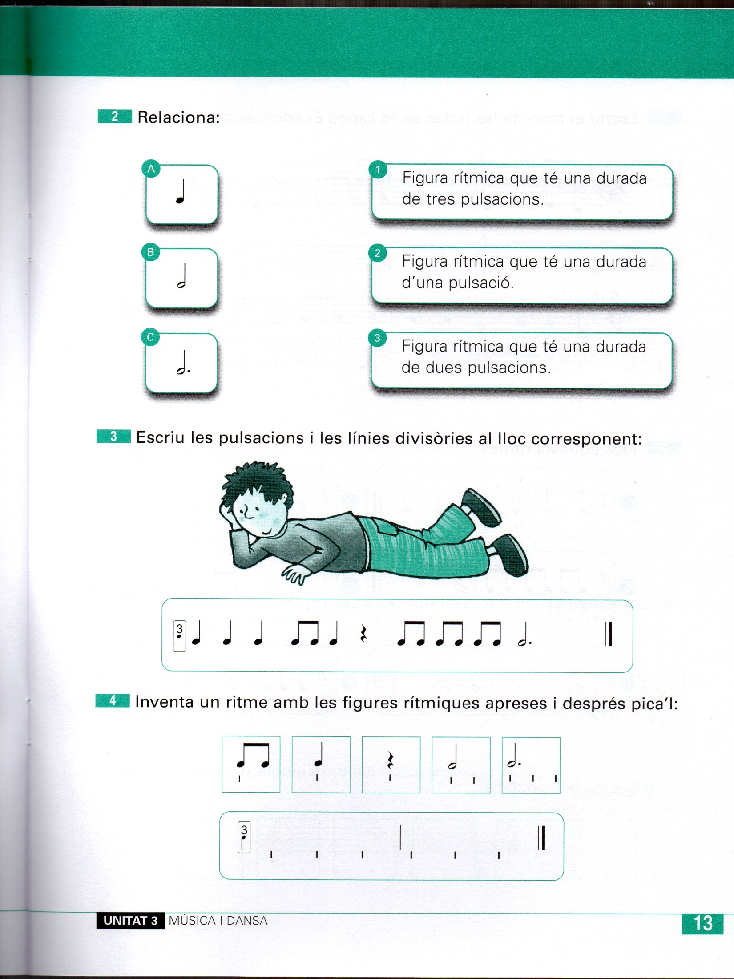

https://www.youtube.com/watch?v=4vZ5mlfZlgk
4t

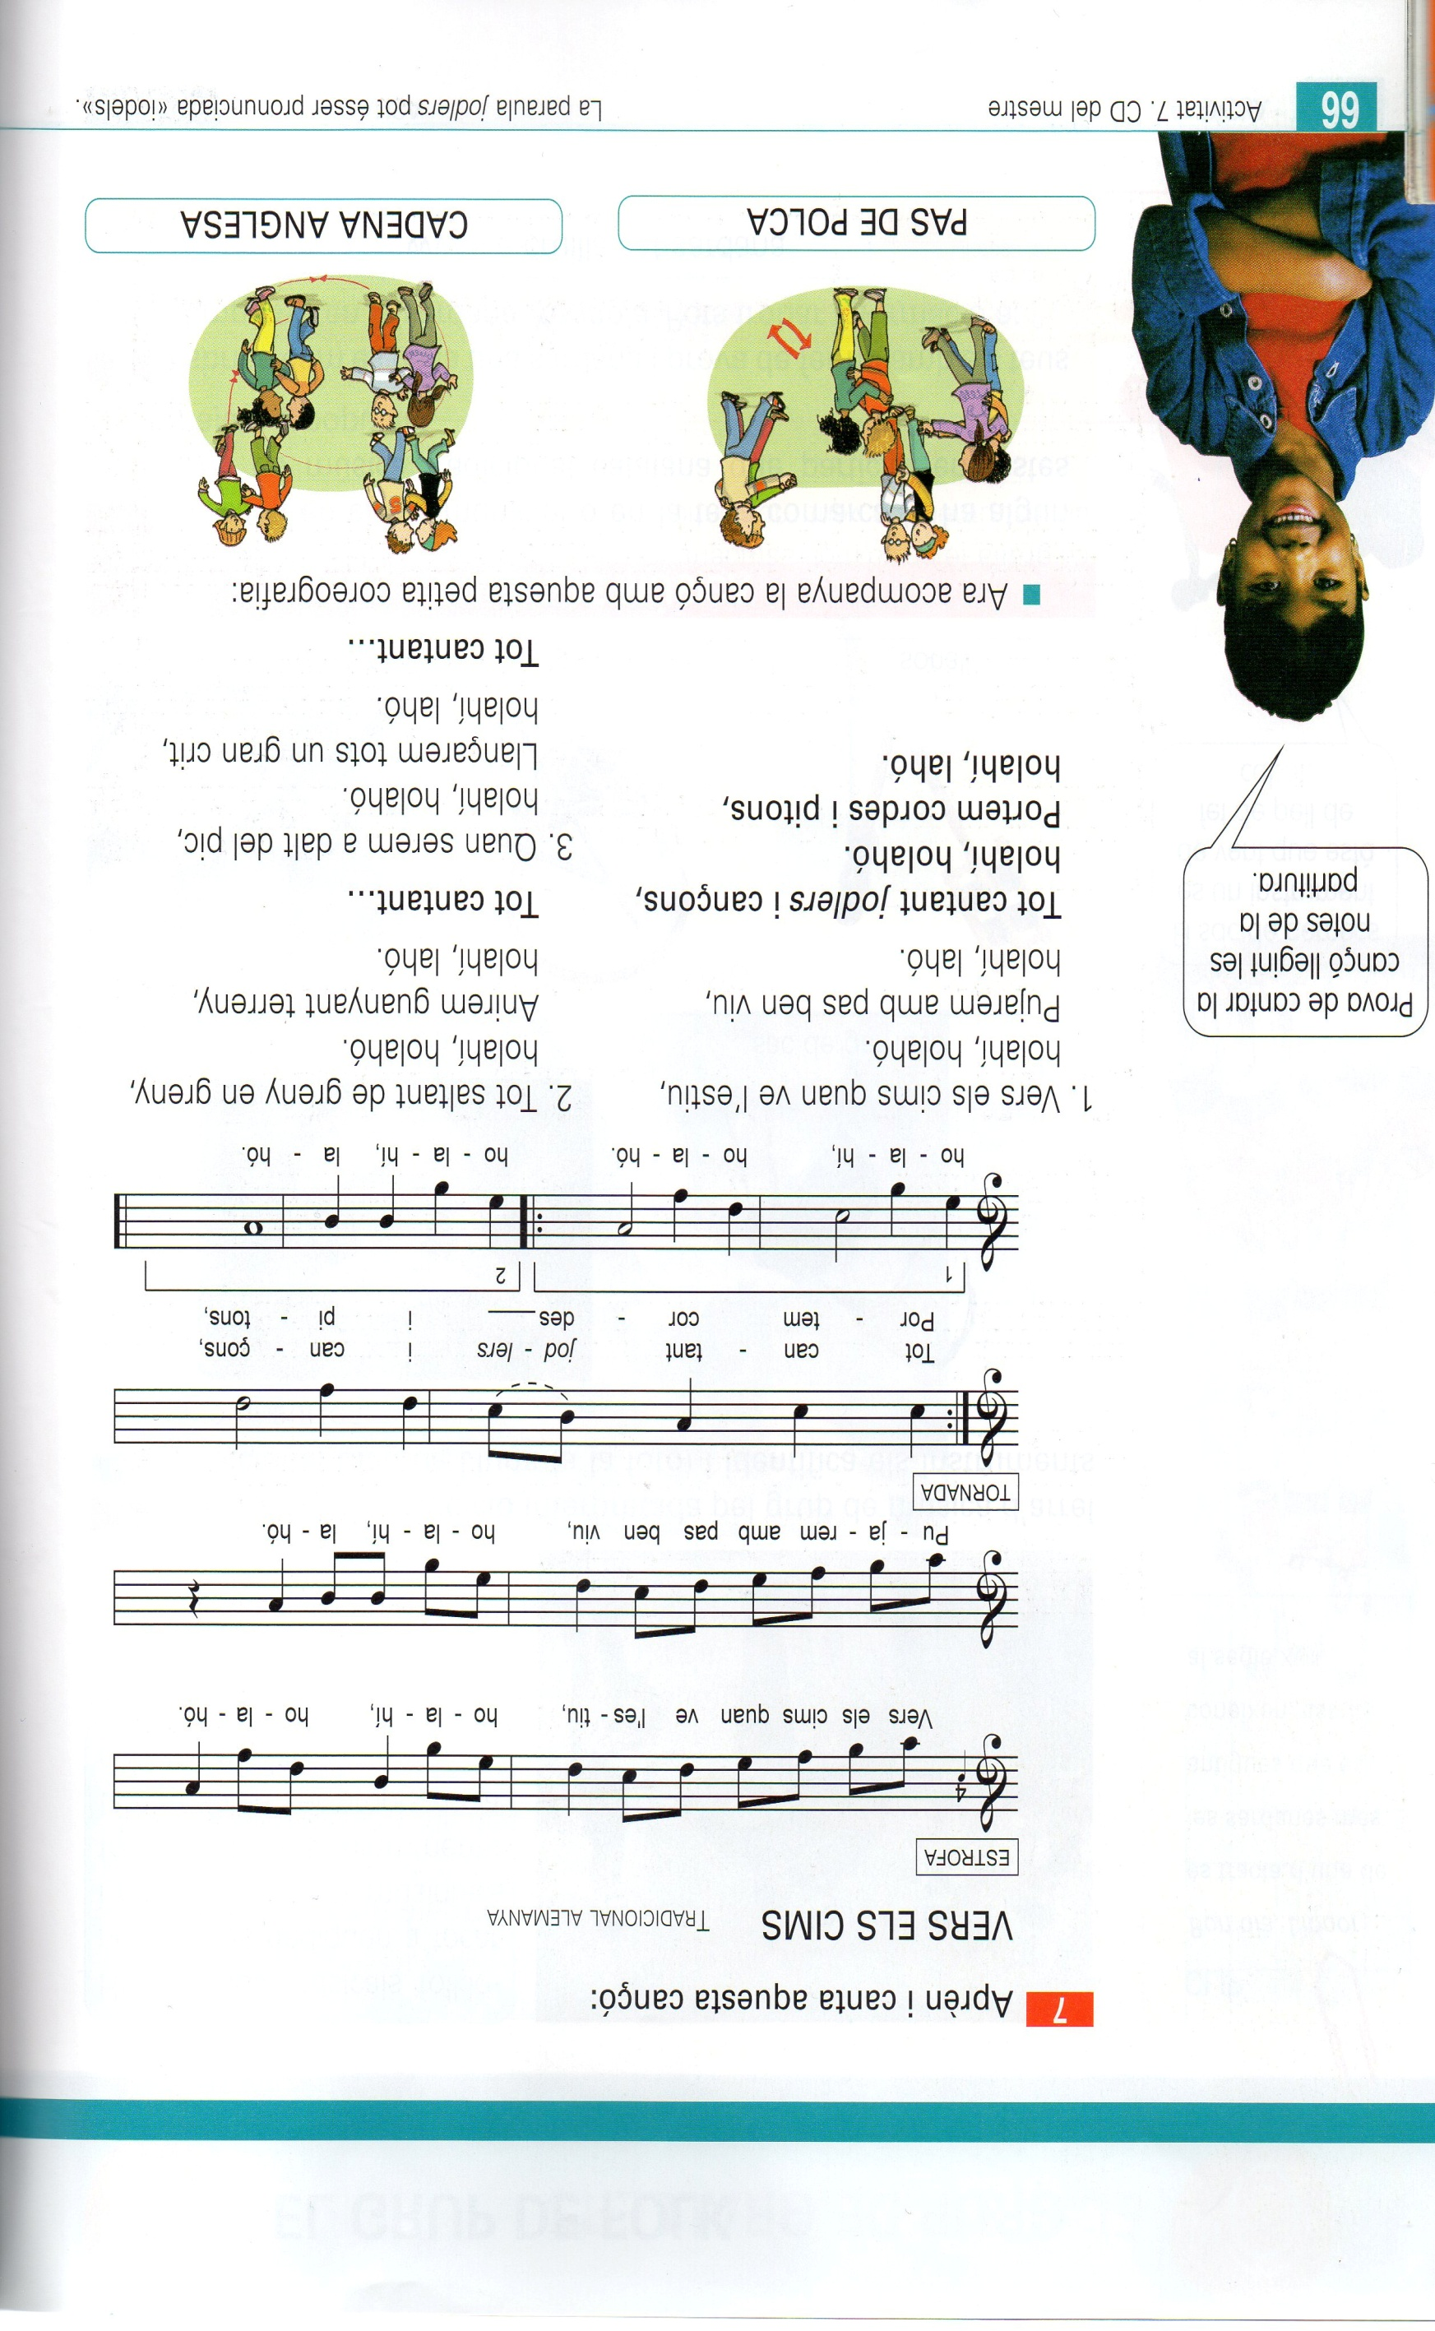

https://www.youtube.com/watch?v=t9y_w6AE6aE
5è

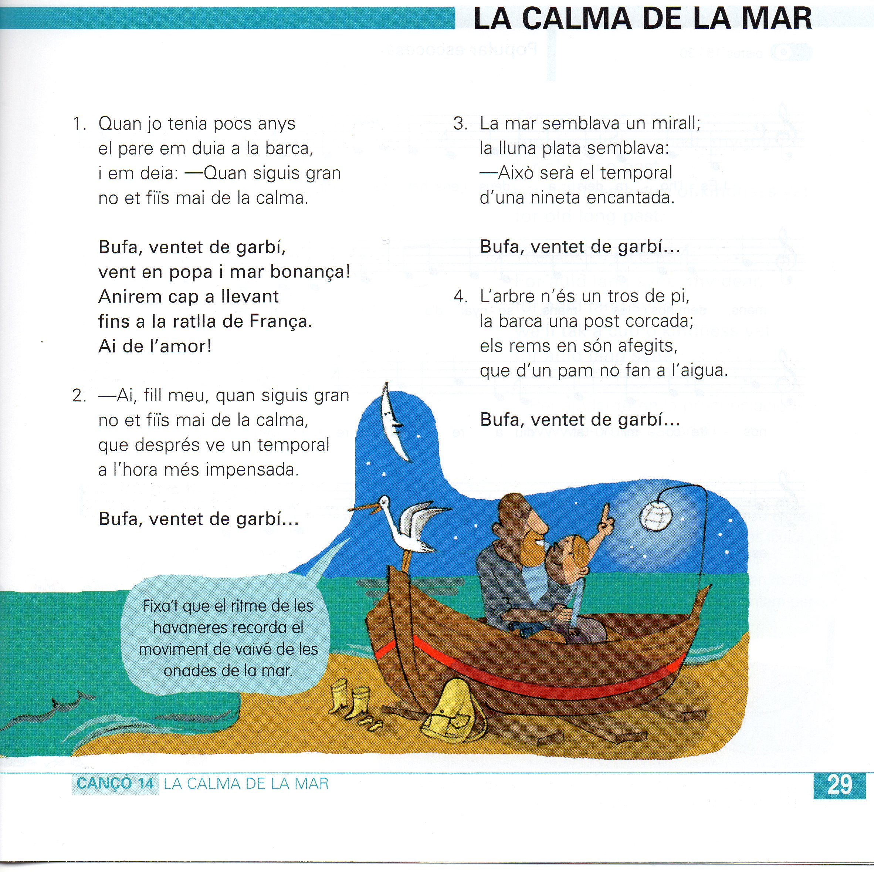

https://www.youtube.com/watch?v=nAcVgNcu2wg
6è
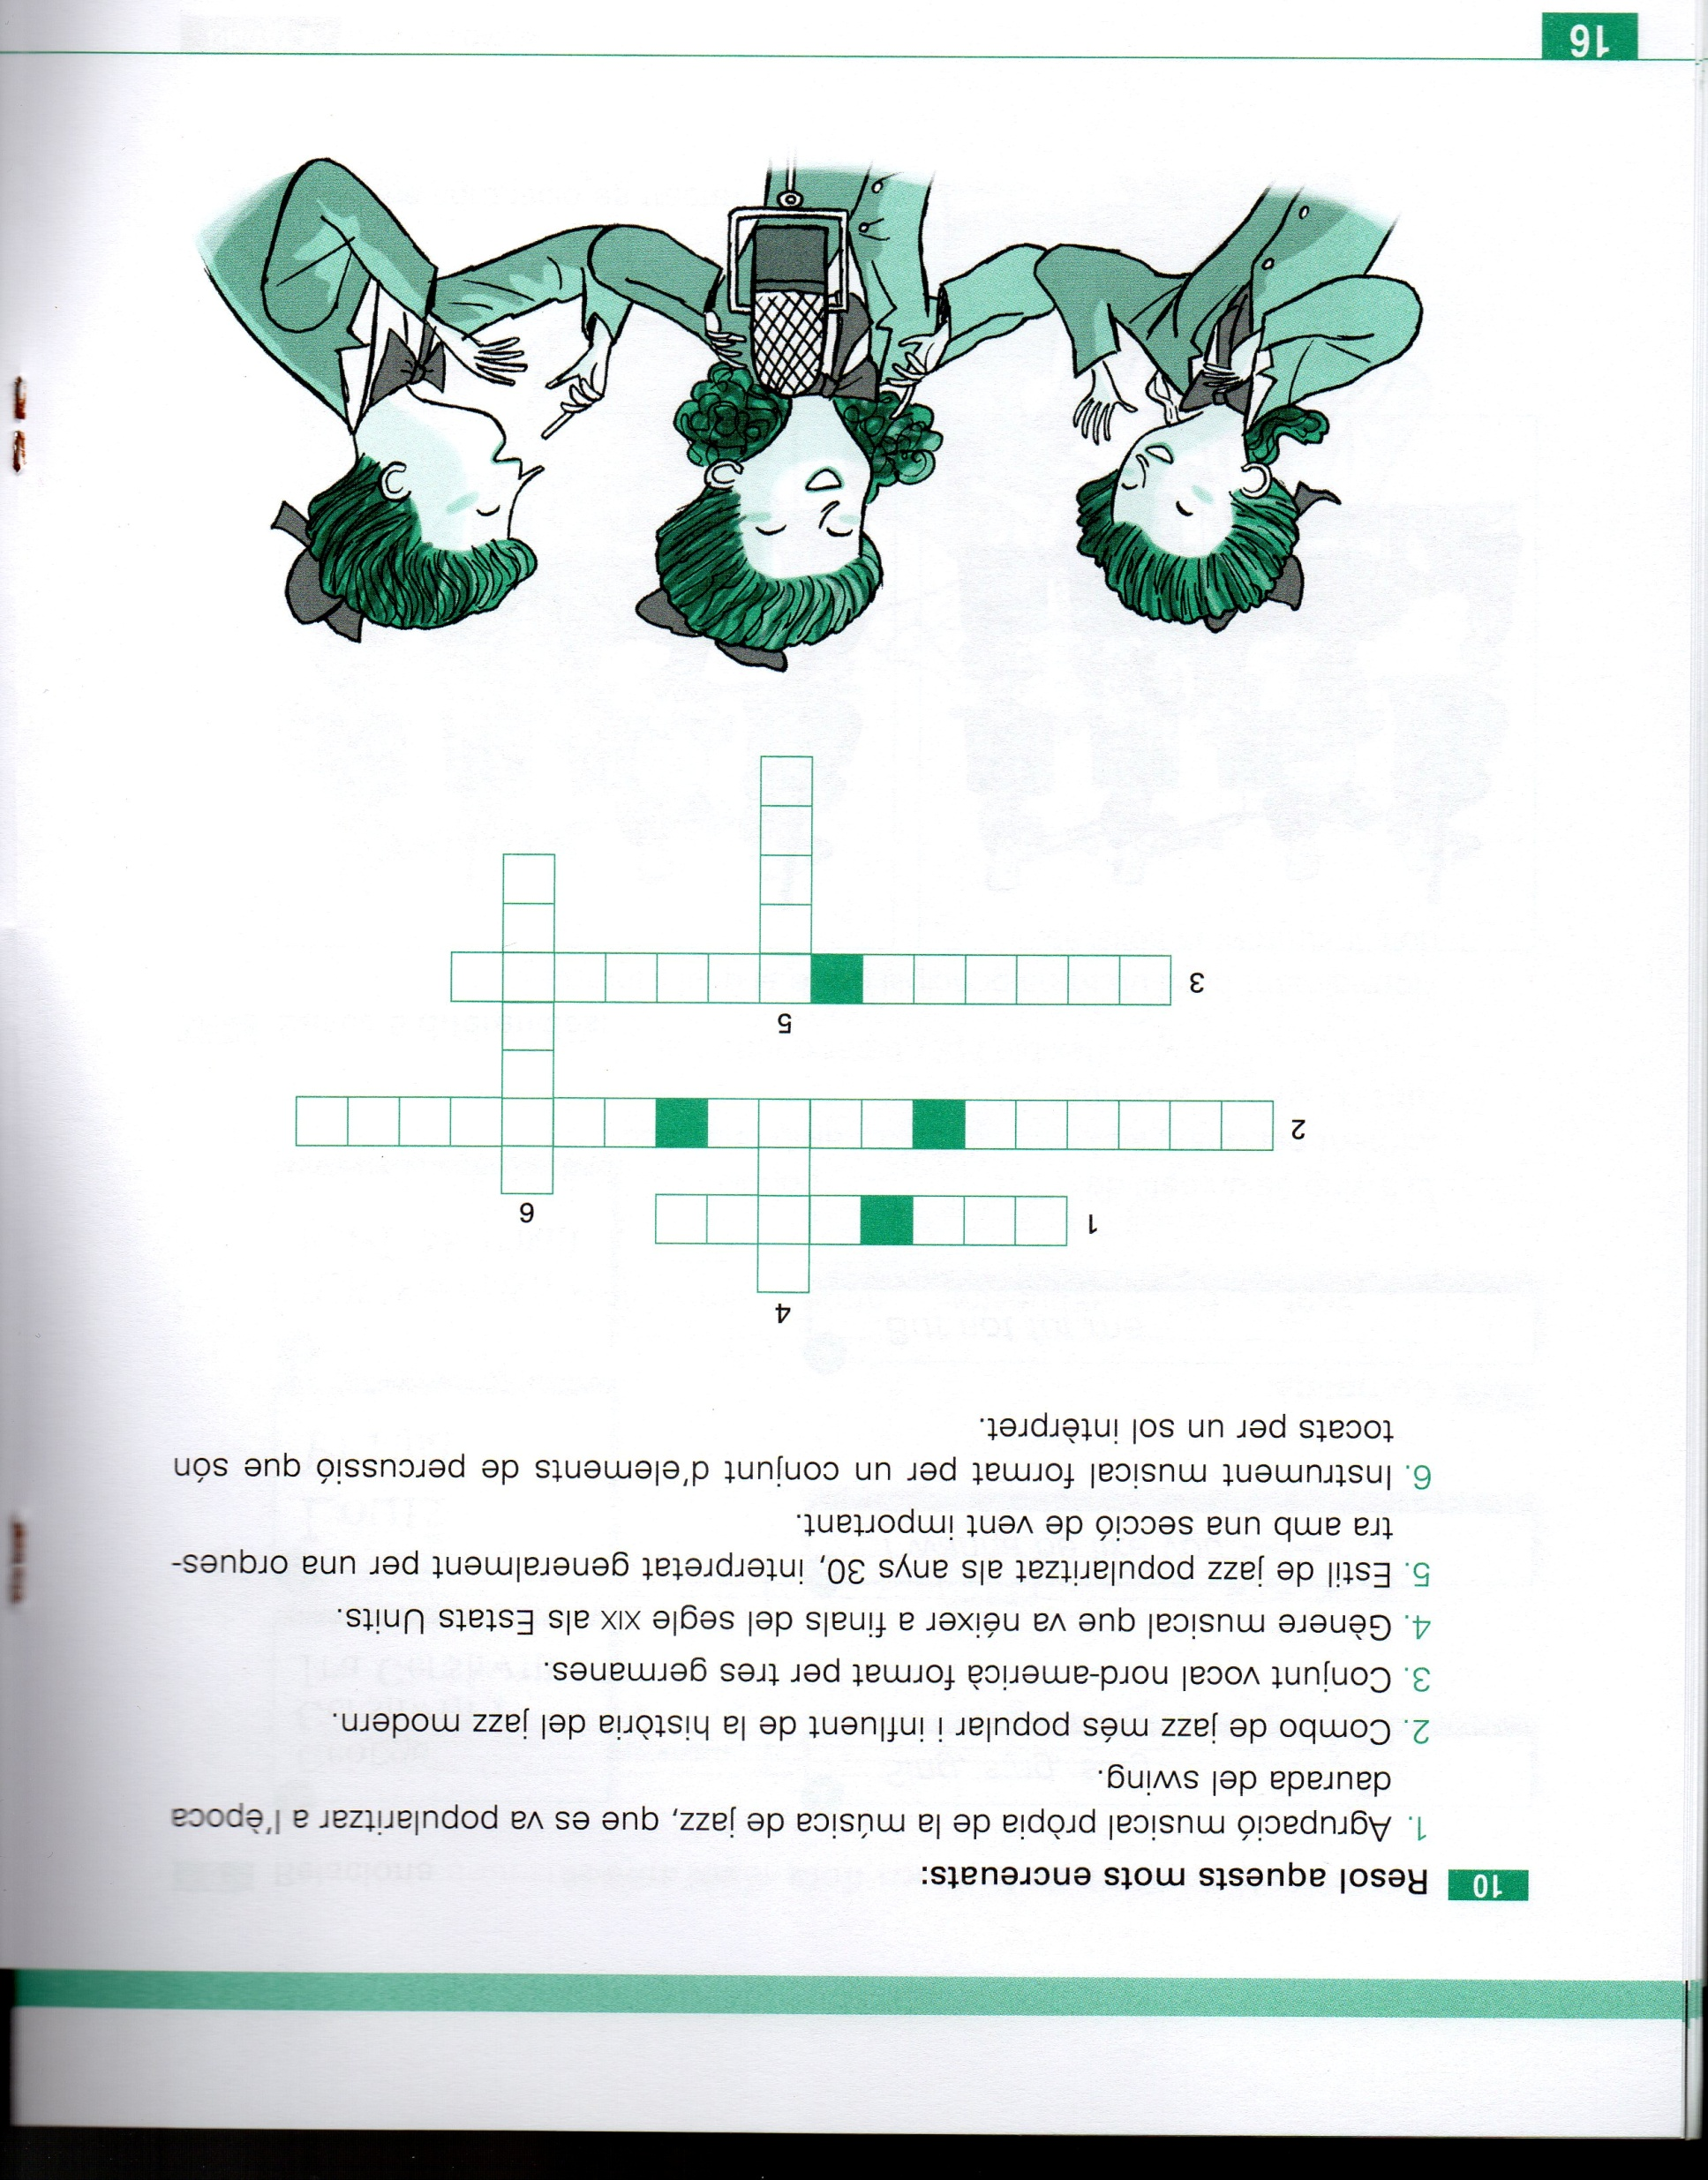
I PER CANTAR: https://www.youtube.com/watch?v=lqWQCWc_zCc

