1r
NOM:
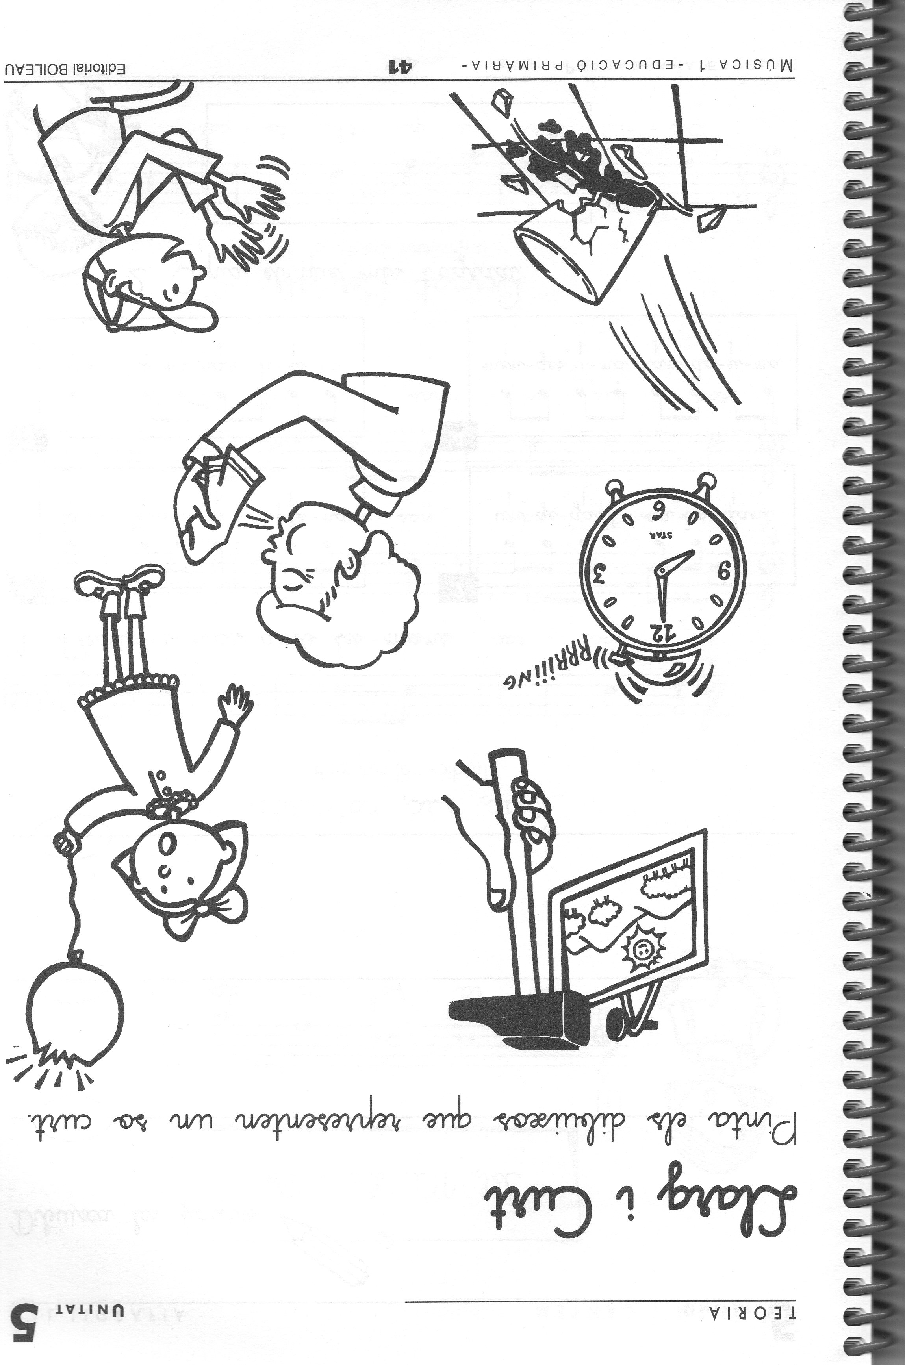

https://www.youtube.com/watch?v=RrX8lbttUzM
2n
NOM:
https://www.youtube.com/watch?v=387etfmuX5k
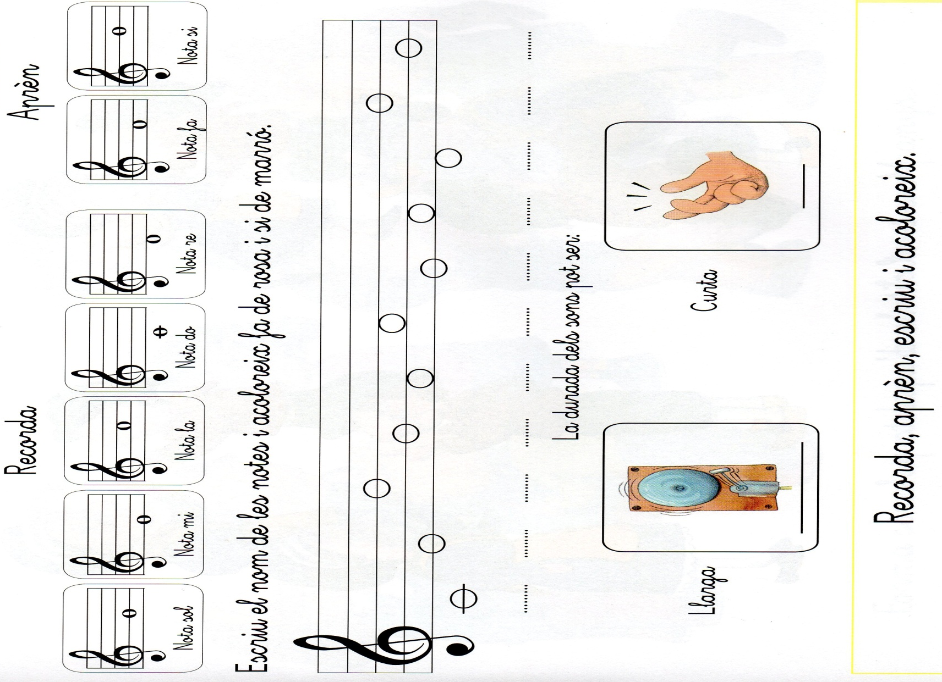

3r
NOM:

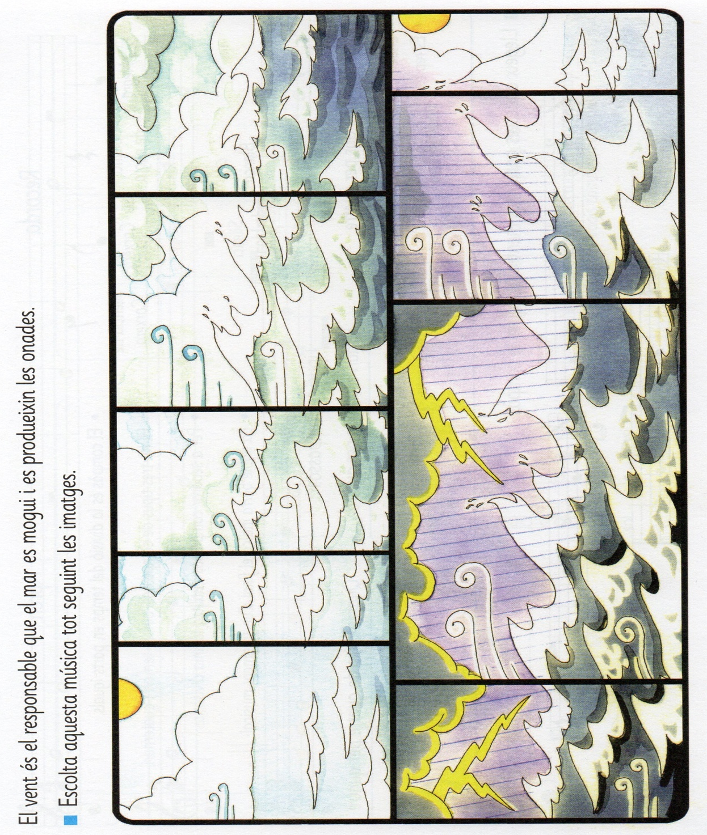
https://www.youtube.com/watch?v=E5rAN3efQ-8

4t
NOM:

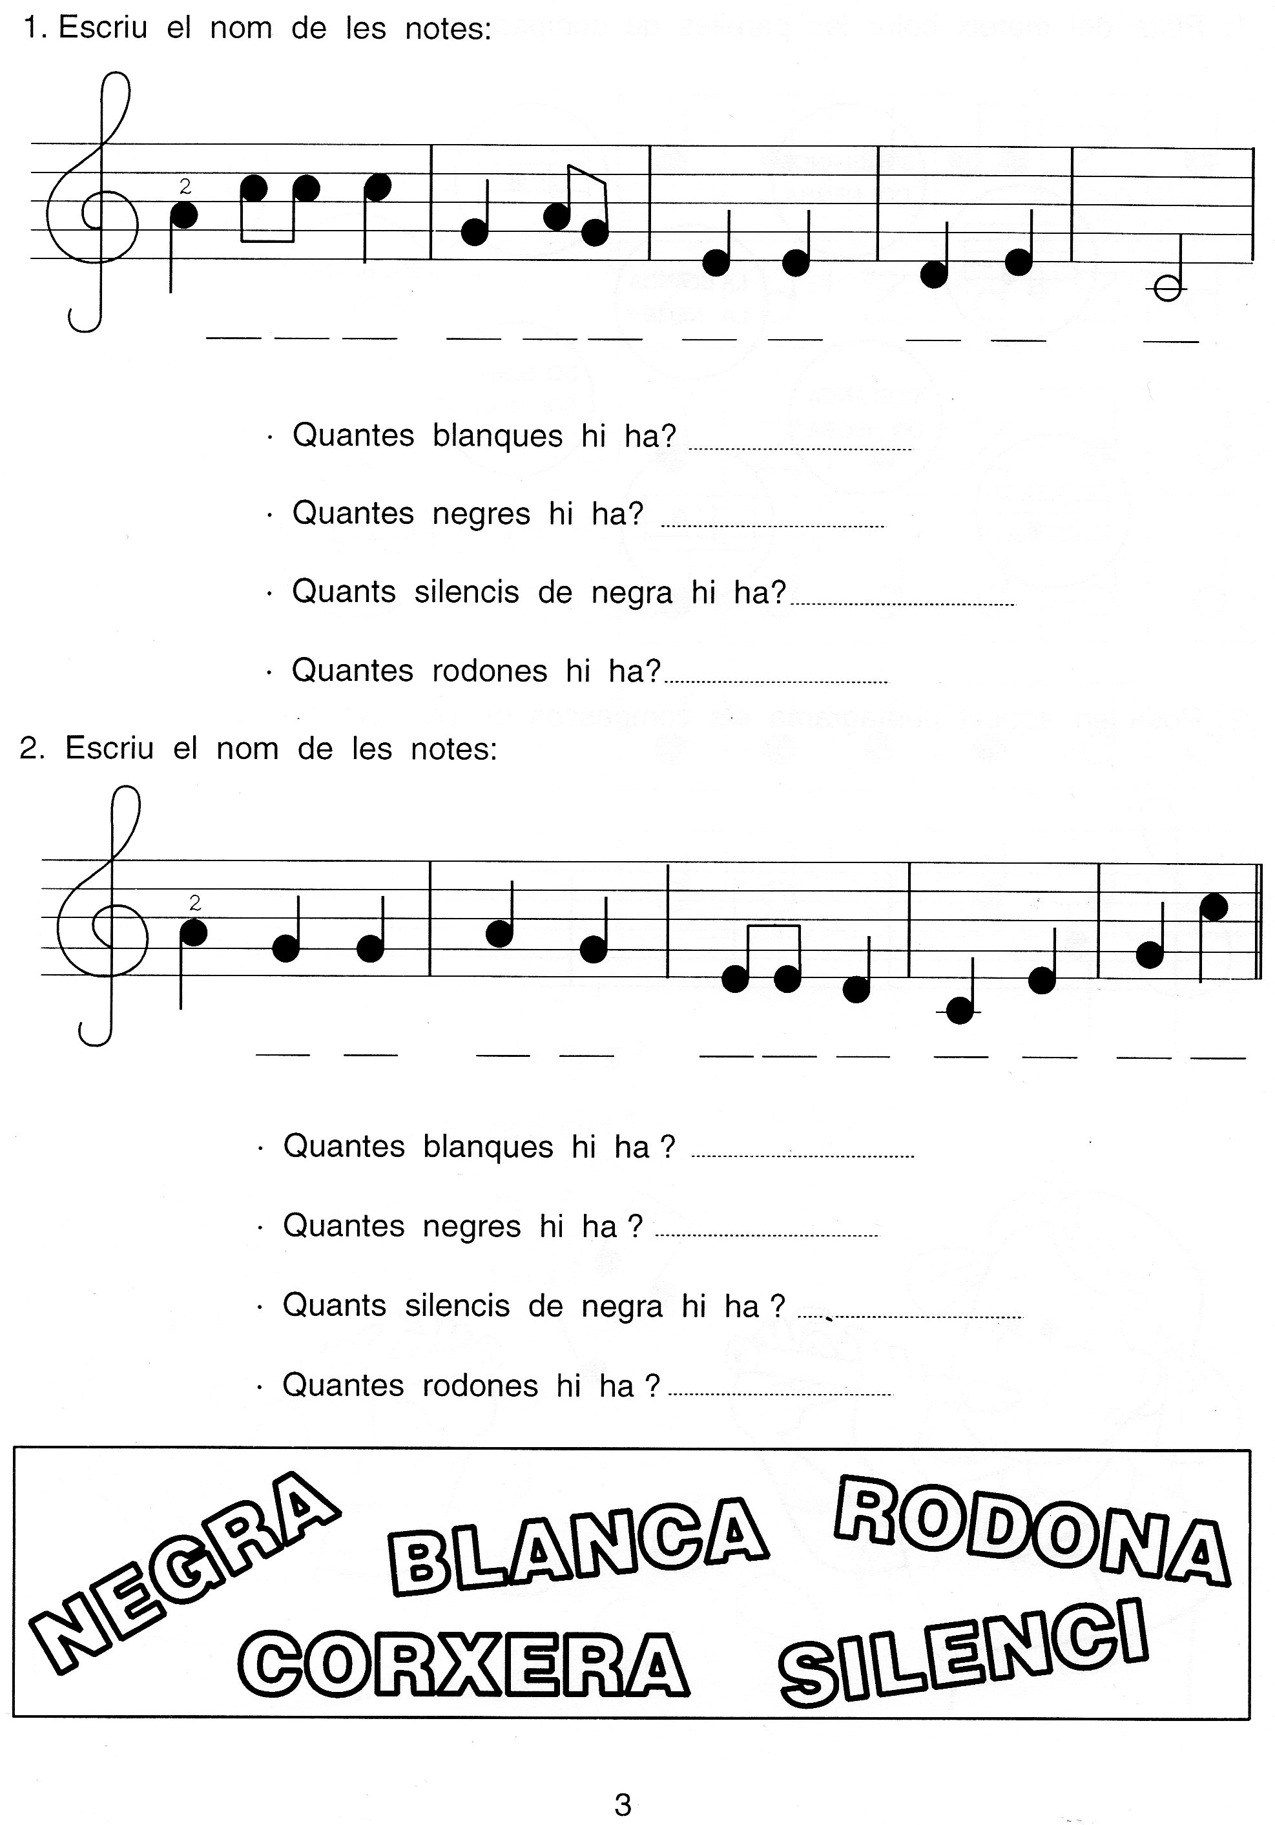
5è
NOM:

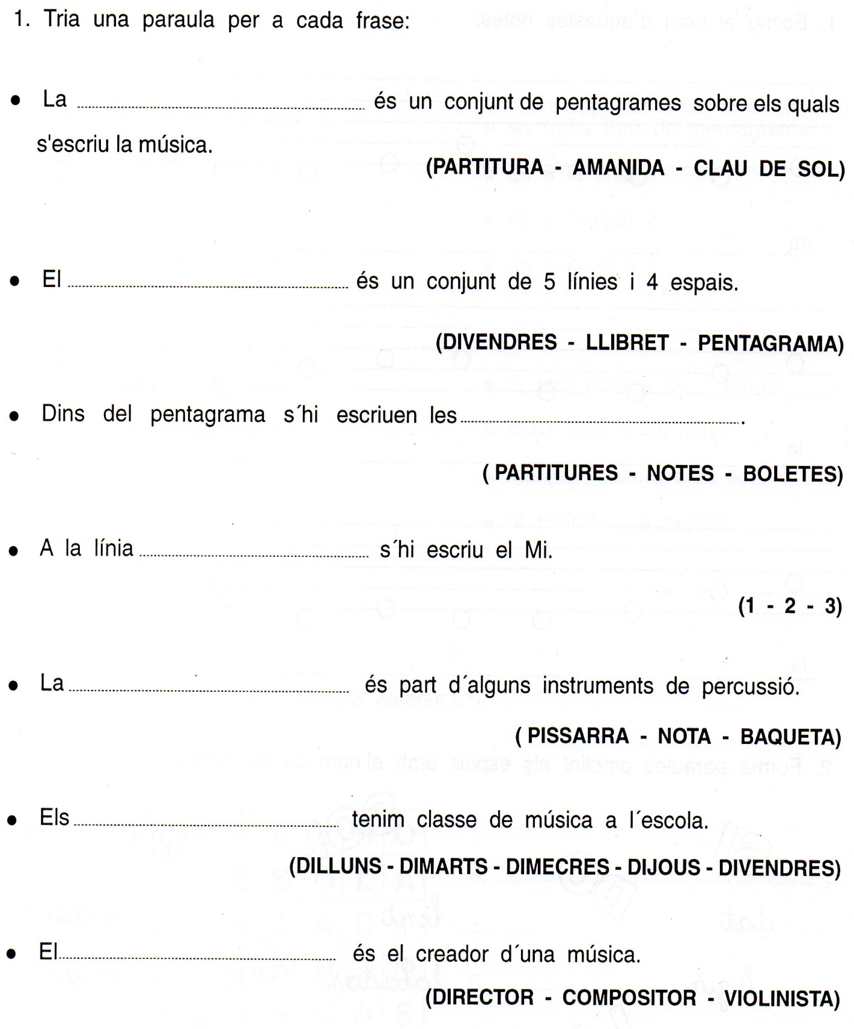
6è
NOM:

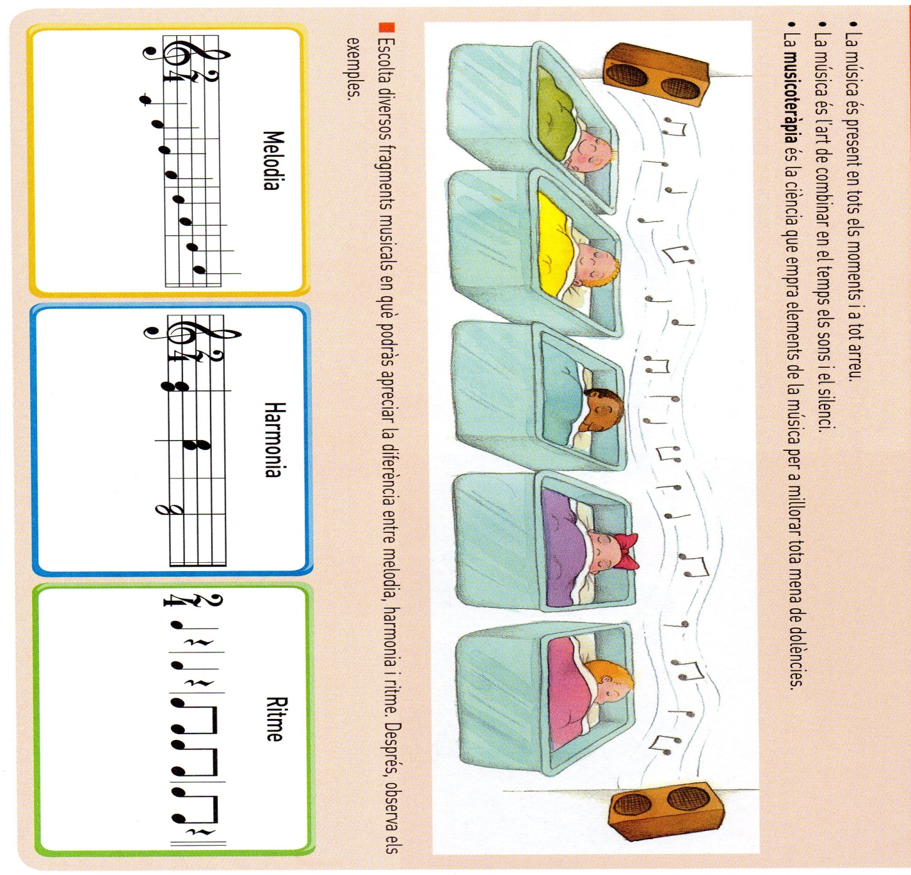
https://www.youtube.com/watch?v=xzy_gVVlRZg

