HELLO BOYS AND GIRLS!! THIS WEEK YOU WILL BE CHEFS!!

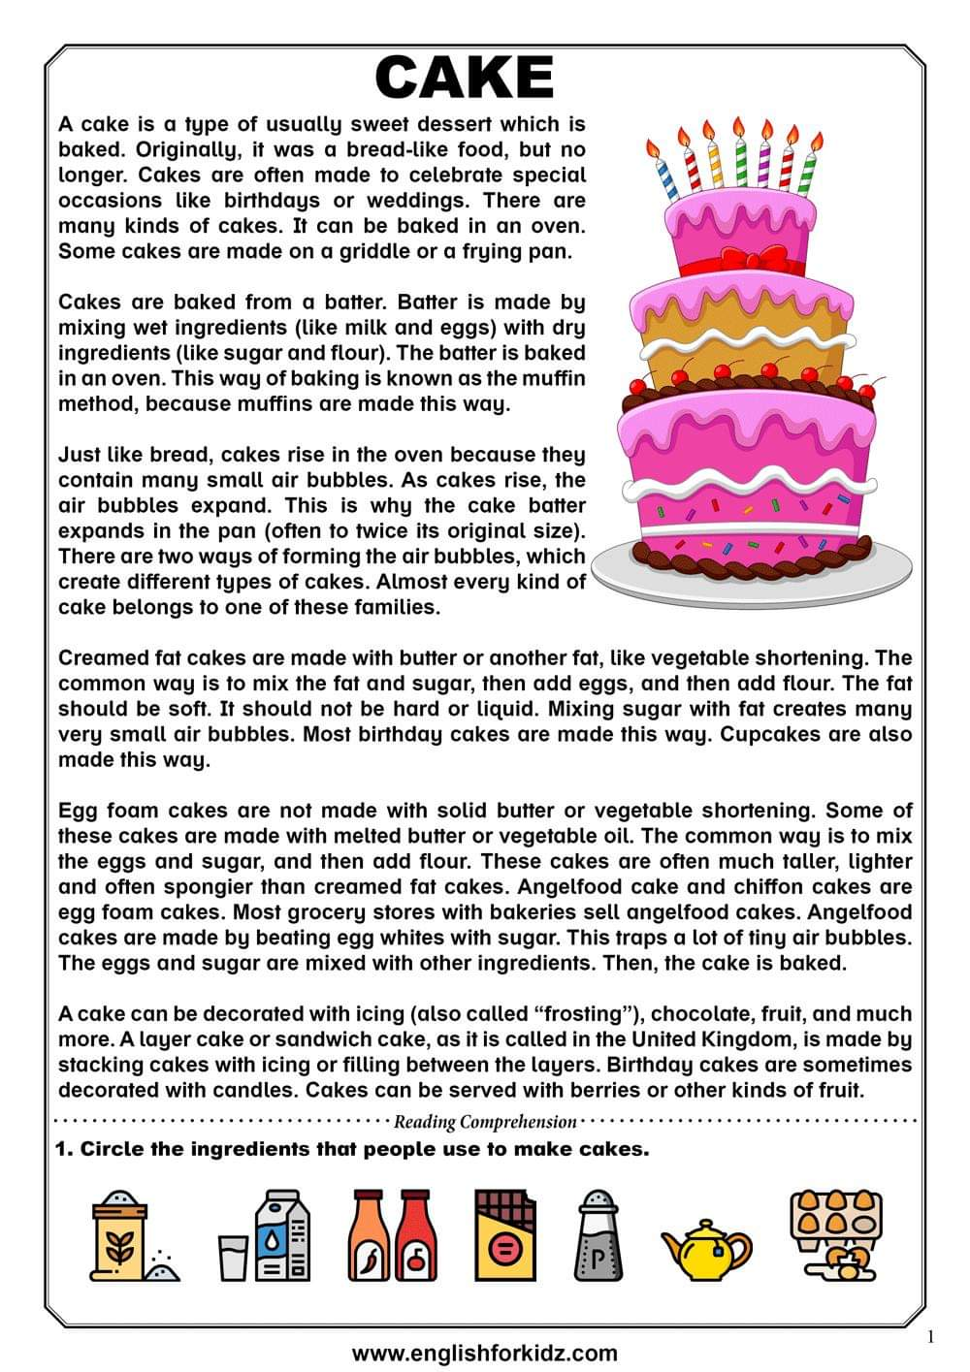
THIS IS SOME HELP!!! ;-)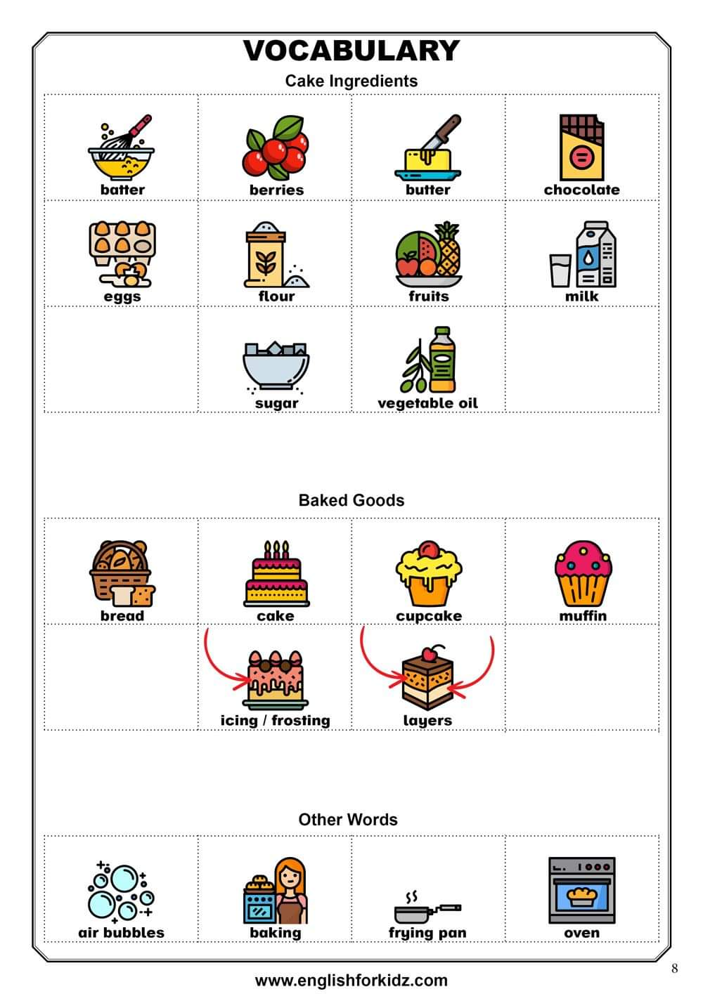
- EXERCISES