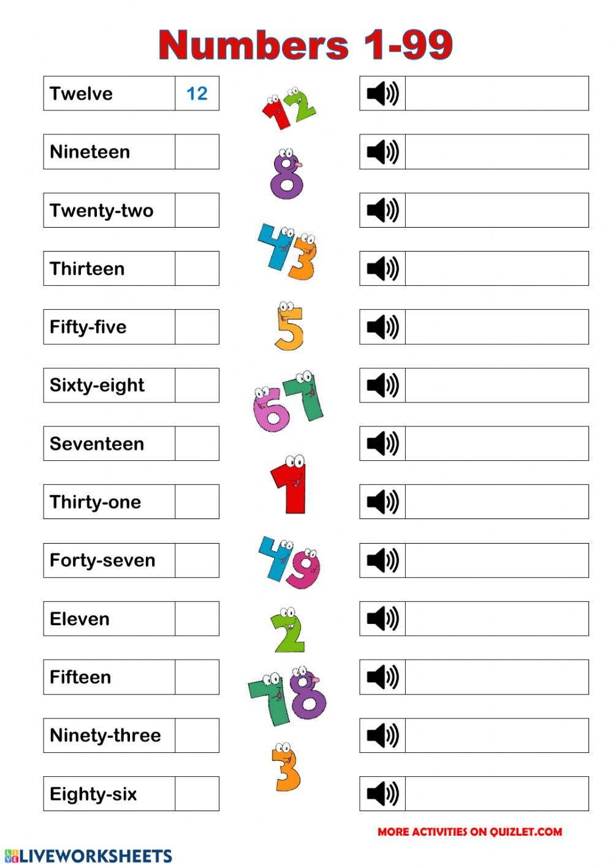
Hellooo!!! This week we are going to revise numbers, ordinal and cardinal numbers.

- WRITE THE NUMBERS ON THE CORRECT POSITION:

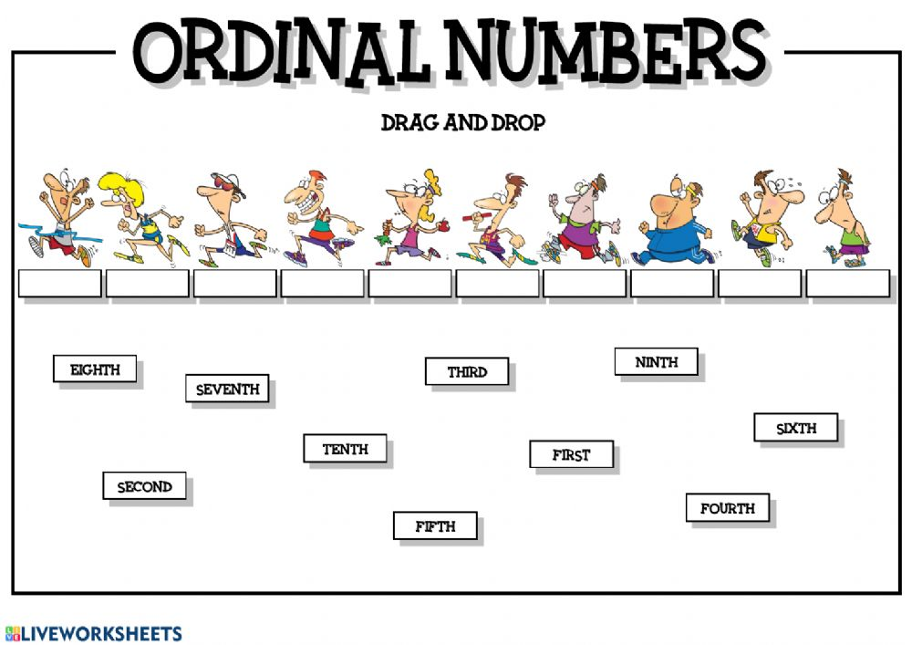

1st- FIRST
2nd- SECOND IRREGULAR
3rd- THIRD

4th- fourth
5th- fifth REGULAR
6th- sixth
7th- seventh
8th- eighth... etc

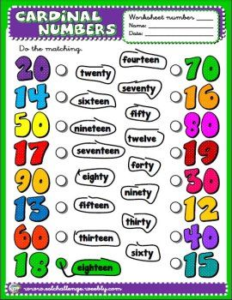
Li podeu enviar directament les tasques d’anglès a la Mònica a la seva adreça electrònica:
monicaperales@escolajoanmaragall.cat

