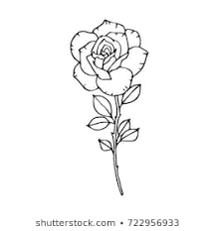
SAINT GEORGE

Order the words and draw.

STLECA- OSREH- CPINSRES- OKBO- RGANDO- ORSIREGTGAGNE

Hello boys and girls!!!
I hope all of you are OK.
Here you’ve got the activity related to Saint George in English, I hope you like it!!

If you can’t print it, you can draw it on a paper, it will be very nice!!

Li podeu enviar directament les tasques d’anglès a la Mònica a la seva adreça electrònica:
monicaperales@escolajoanmaragall.cat

