The Gruffalo - Comprehension questions

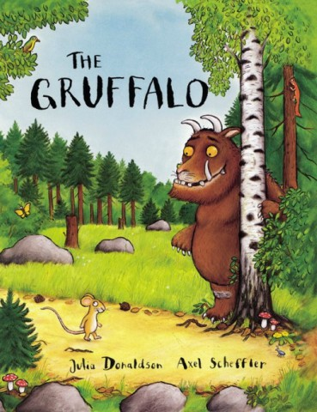
- Which animals does the mouse meet in the woods?

- What is the gruffalo’s favourite food?

- Who is telling the story?

- Describe the Gruffalo in 3 words:

------------------------------------
- What did the mouse tell the fox was the Gruffalo’s favourite food?

- What did the mouse tell the owl was the Gruffalo’s favourite food?

- What did the mouse tell the snake was the Gruffalo’s favourite food?

- Why did the Gruffalo run away in the end?

