Challenge 1:
Shortbread biscuits Recipe

Get together with your family and try making these easy, buttery shortbread biscuits recipe!
Send me a photo or a video preparing this shortbread biscuits! (CLASS EMAIL)

Useful Vocabulary:
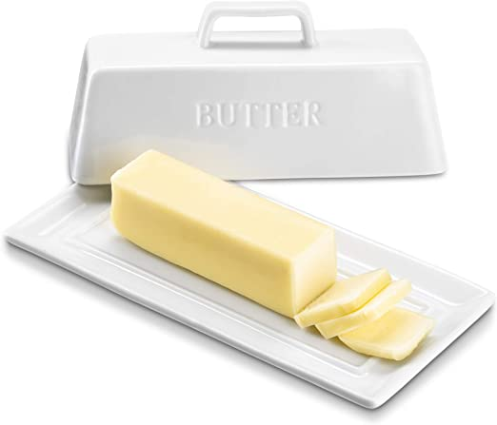 | 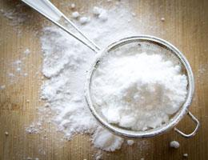 | 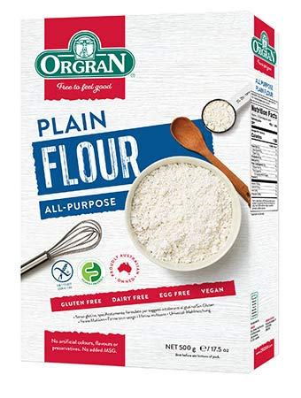
BUTTER | CASTER SUGAR | PLAIN FLOUR
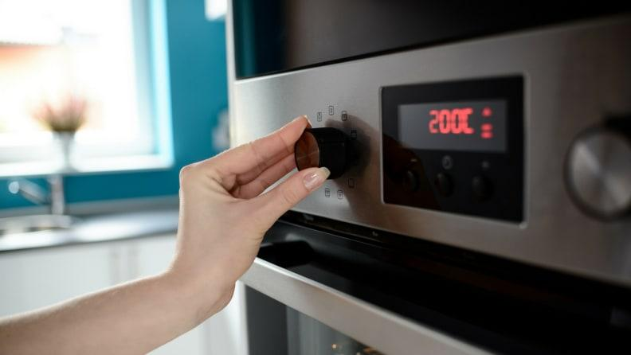 | 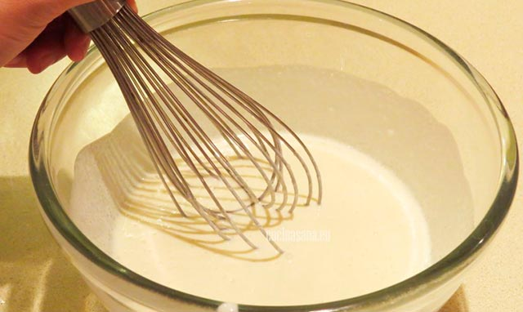 | 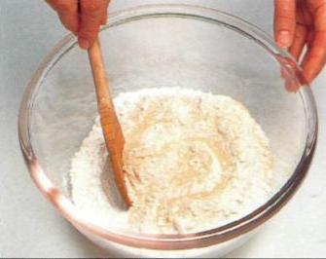
PREHEAT OVEN | BEAT | STIR
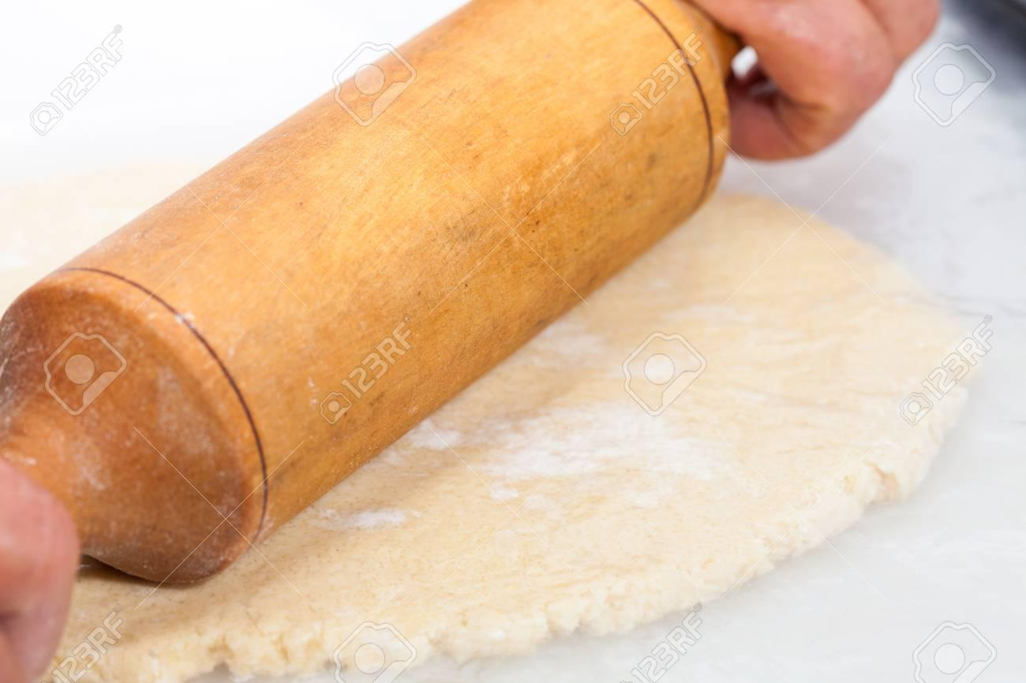 | 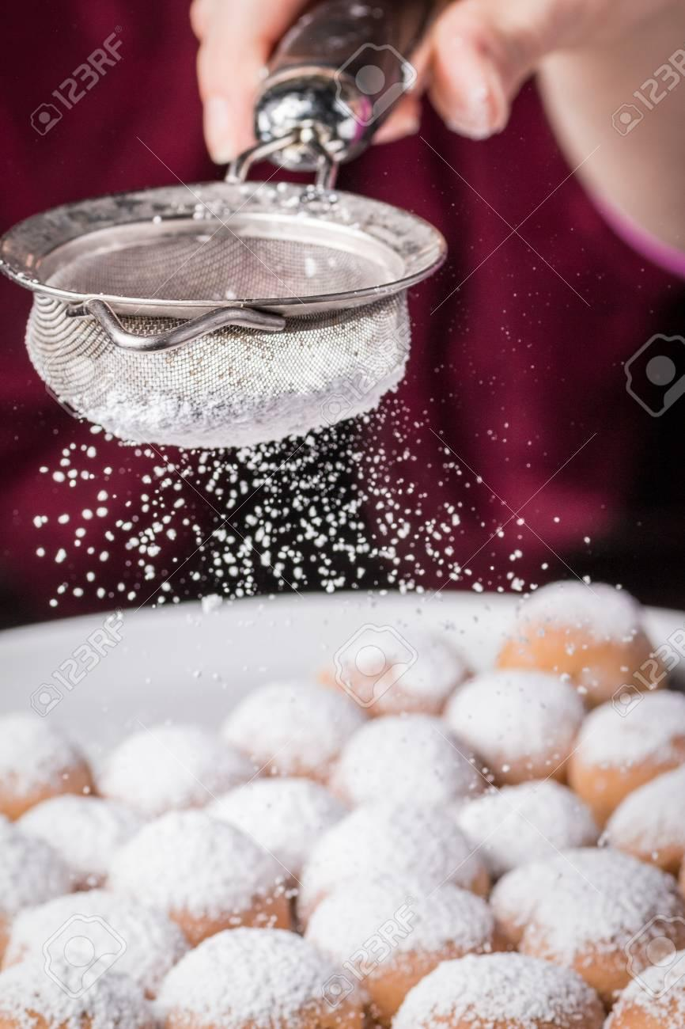 | 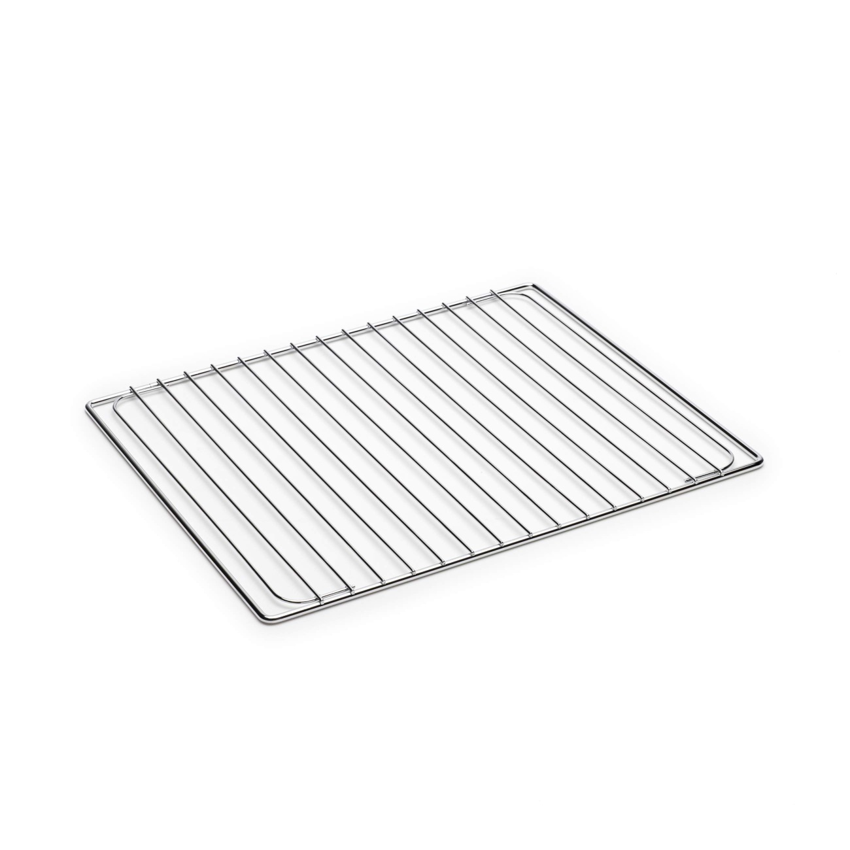
ROLL OUT | SPRINKLE | WIRE RACK

Would you like to share another recipe? Complete the recipe card and send it to me too!
