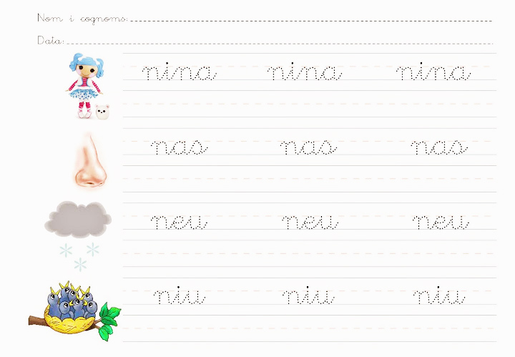

Dibuixa:

niu

núvol

nou

neu

nas

**Nom: ________________________________**

**Data: ________________________________**

|  |  |  |  |
| --- | --- | --- | --- |
| https://image.freepik.com/iconos-gratis/nube-contorno_318-32468.jpg | [Resultado de imagen de nariz](http://www.google.es/url?sa=i&rct=j&q=&esrc=s&source=images&cd=&cad=rja&uact=8&ved=0ahUKEwic4Oyb6KjQAhVFCBoKHV0DBa4QjRwIBw&url=http://www.imagui.com/a/imagen-para-colorear-de-nariz-cMdXonBRe&bvm=bv.138493631,d.d2s&psig=AFQjCNHyVNNrdi7oXAMQ7amxUC3Rlprebg&ust=1479232349668421) | http://2.bp.blogspot.com/-T3m872R56TU/Ulblyt8bs6I/AAAAAAAA1t0/5wUUHncTbko/s1600/Nido%2B(9).jpg | http://2.bp.blogspot.com/-TZwwOECQW0s/T-Yn-lIKJEI/AAAAAAAAHac/alkEbUif-q0/s320/052.jpg |
| ........vol | ........s | ........u | .............. |
| http://2.bp.blogspot.com/-TZwwOECQW0s/T-Yn-lIKJEI/AAAAAAAAHac/alkEbUif-q0/s320/052.jpg | **9** | https://s-media-cache-ak0.pinimg.com/736x/07/21/56/072156620d189280fbcb821bd3b896f3.jpg | http://static.ellahoy.es/ellahoy/fotogallery/1200X0/345173/fases-de-la-luna-para-colorear.jpg |
| ........n | ........u | ........u | llu........ |

na –- ne - ni - no - nu