NOM ______________________________________________________________

P
P P P P P P P
p p p p p p p
PA PE PI PO PU
pa pe pi po pu
AP EP IP OP UP
ap ep ip op up
PEU | POMA | PA | POU
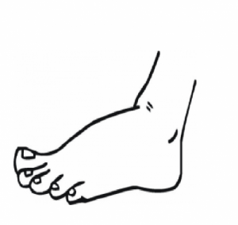

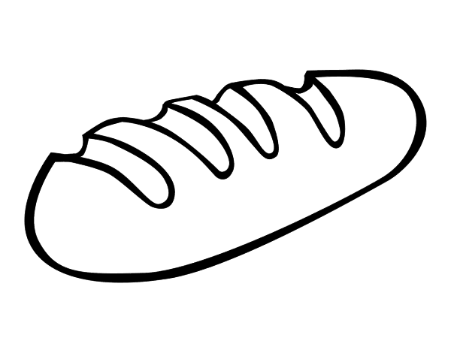
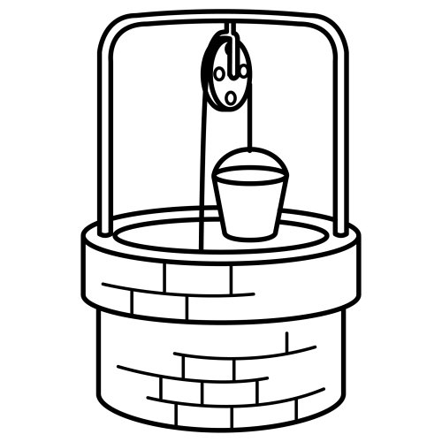

NOM ____________________________________________

