REPASSA I ESCRIU EL NOM DE LA FIGURA GEOMÈTRICA A SOTA
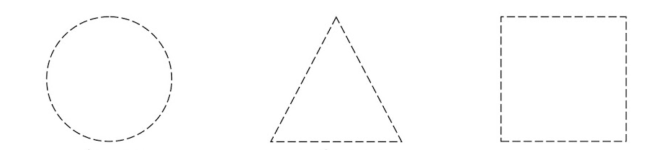

_____________________________________ ________________________________________ ______________________________________
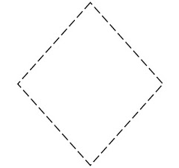
ROMBE
CERCLE
QUADRAT
TRIANGLE
RECTANGLE

___________________________________________ _________________________________________

