Name: ______________________ Date: _______________
NUMBERS IN ENGLISH (1-20)
1 ONE | 11 ELEVEN
2 TWO | 12 TWELVE
3 THREE | 13 THIRTEEN
4 FOUR | 14 FOURTEEN
5 FIVE | 15 FIFTEEN
6 SIX | 16 SIXTEEN
7 SEVEN | 17 SEVENTEEN
8 EIGHT | 18 EIGHTEEN
9 NINE | 19 NINETEEN
10 TEN | 20 TWENTY

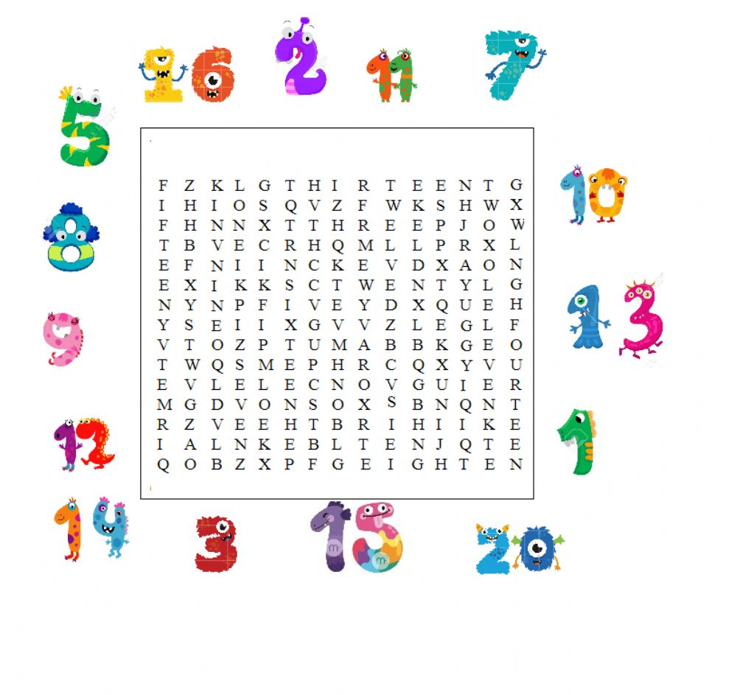
1) WORD SEARCH.

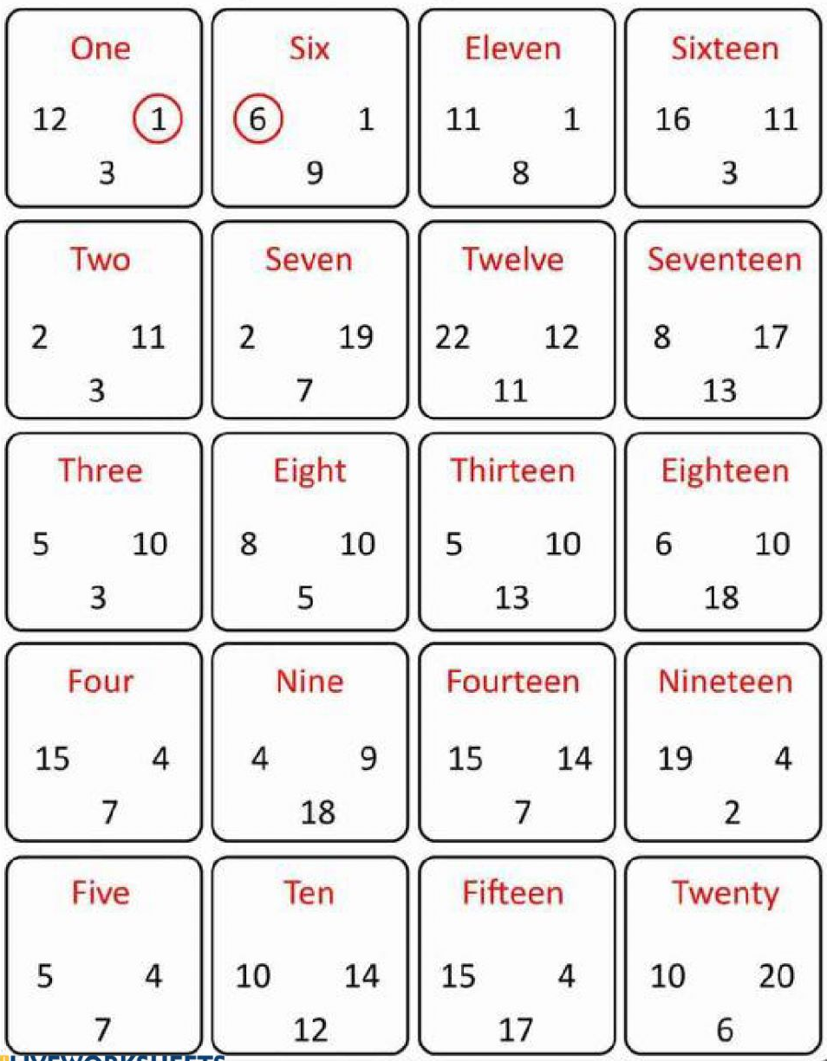
2) CIRCLE THE RIGHT NUMBER. LOOK AT THE EXAMPLE.
3) UNSCRAMBLE THE LETTERS.
F I F T E E N
T H R E E
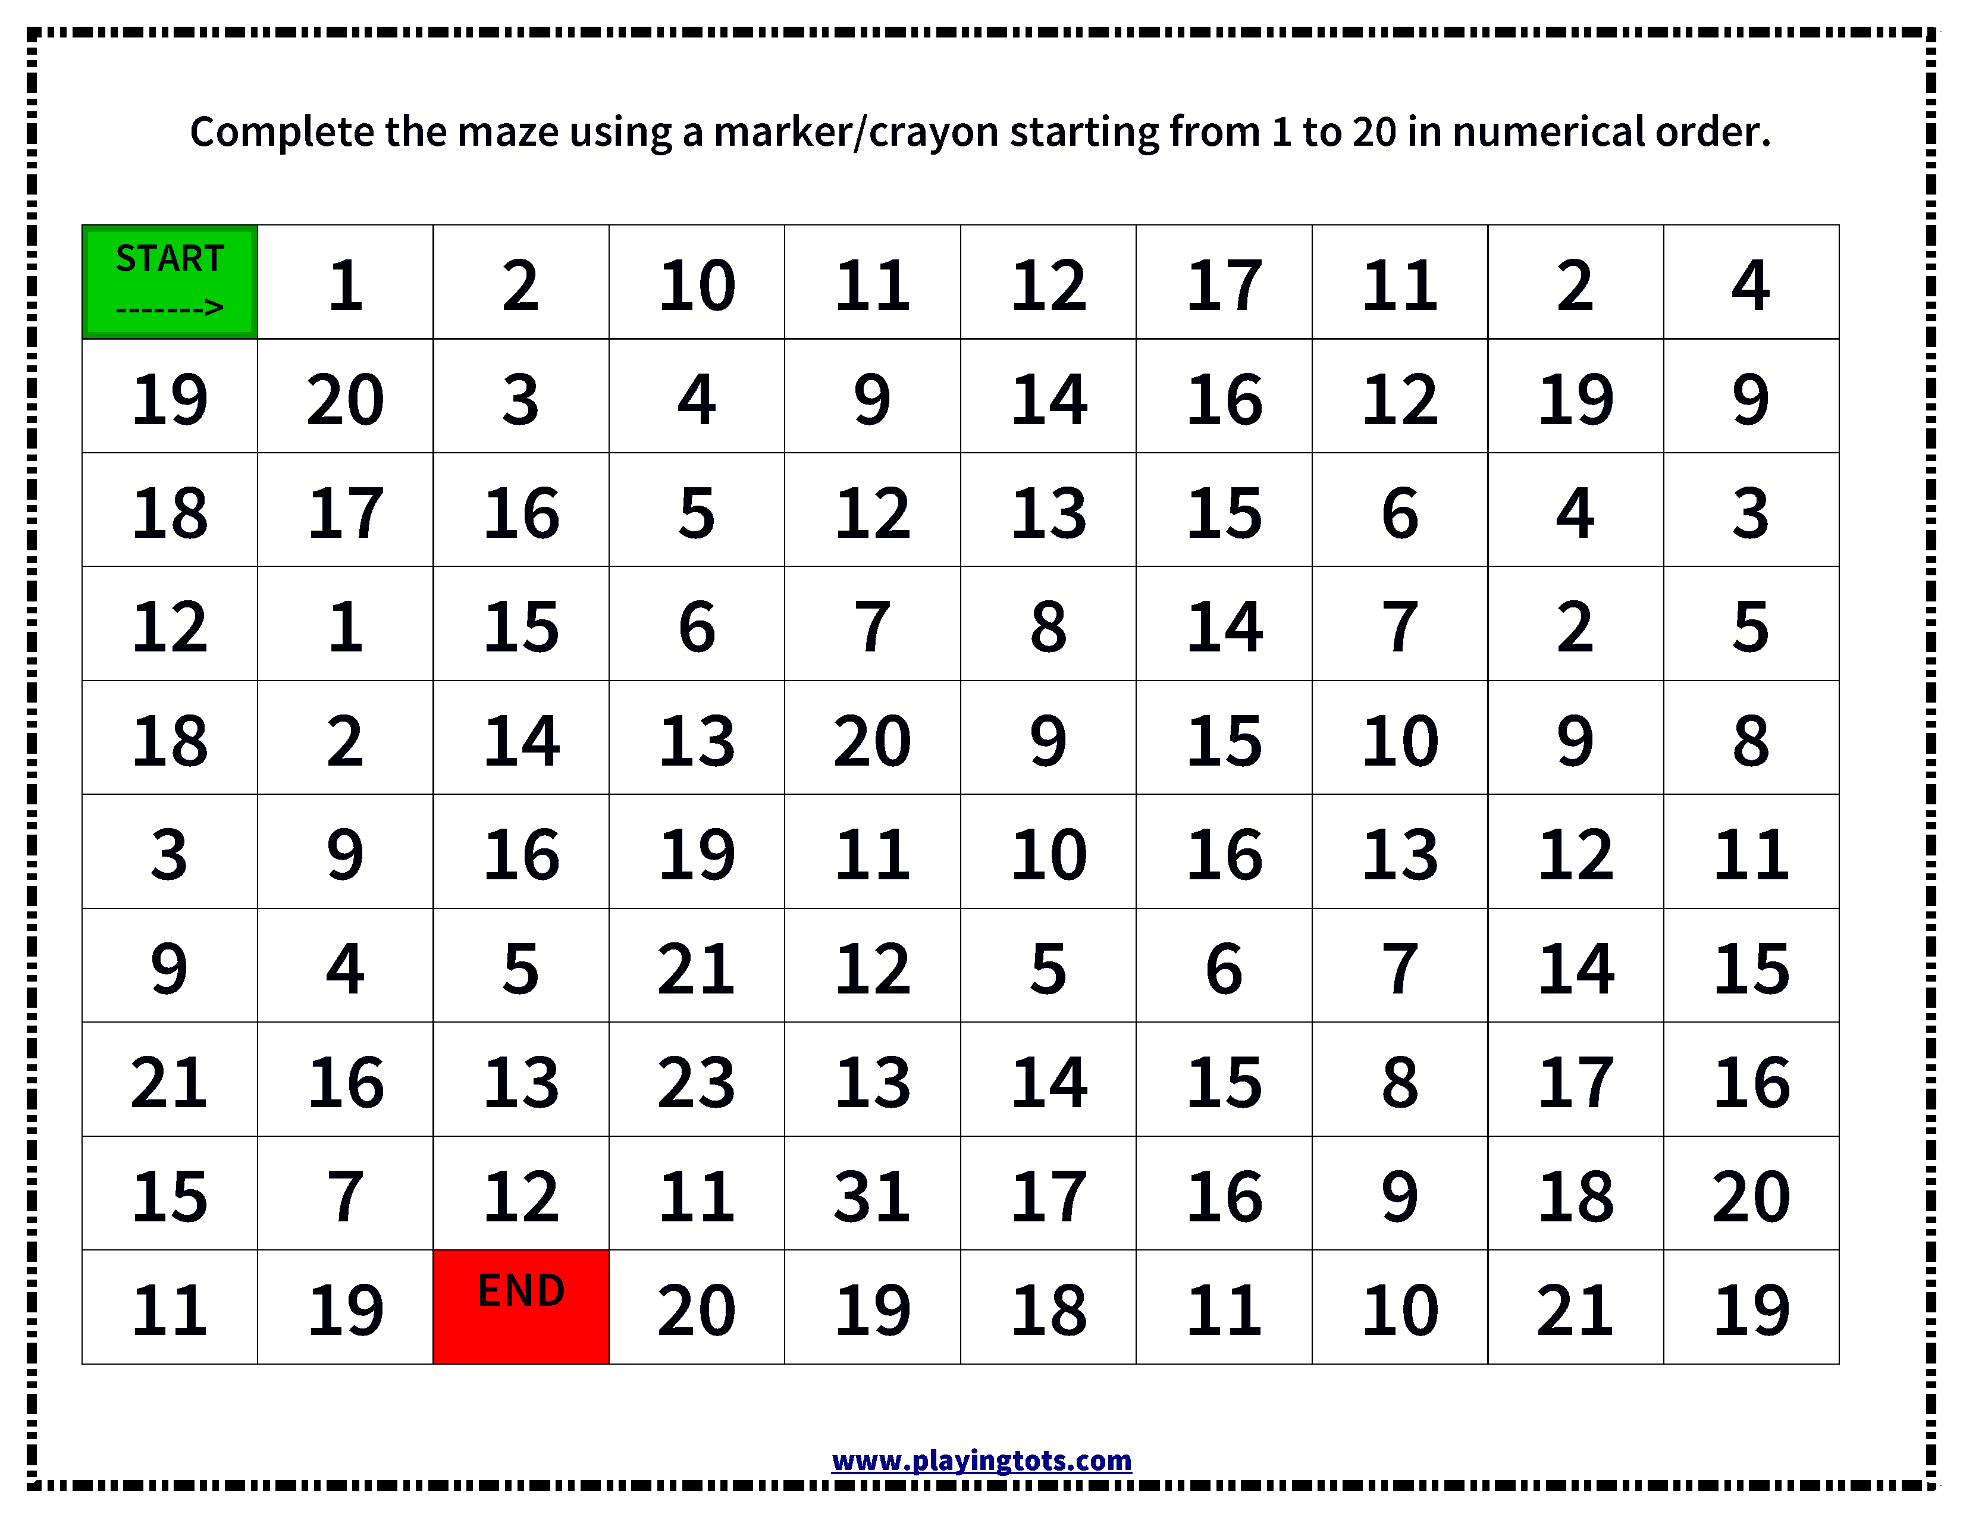
4) COMPLETE THE MAZE FROM 1-20 IN ORDER.

