THE HUNGRY DRAGON
(Activities)
1. WRITE:
DRAGON – TOMATO – RICE – HUNGRY – SAUSAGE – SWEETS – NOODLES – CHICKEN

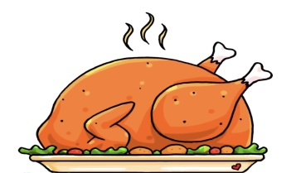 | 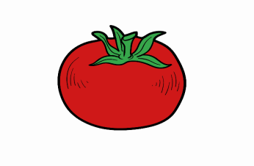 | 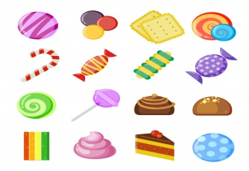
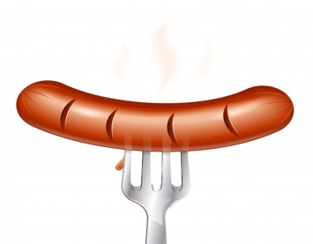 | 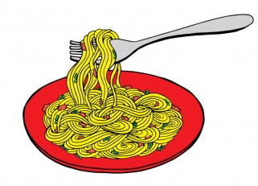 | 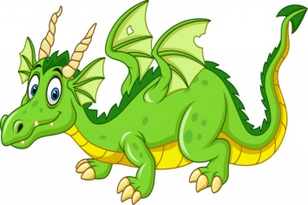 | 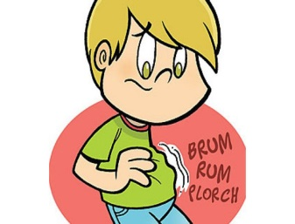

2. CHOOSE THE CORRECT OPTION:
1. THE DRAGON LIVED DEEP IN THE...
 |  | 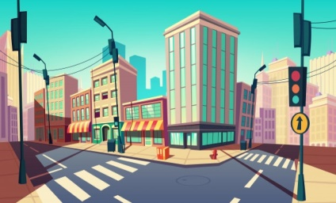
A) SEA | B) MOUNTAINS | C) CITY

2. THE DRAGON IS...
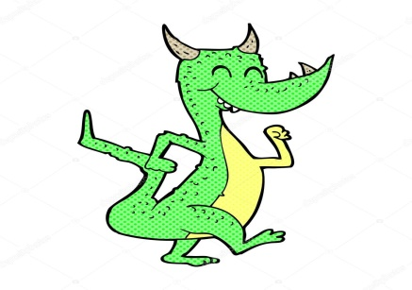 | 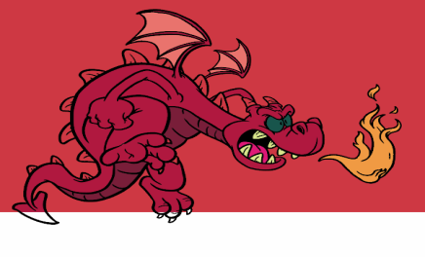 | 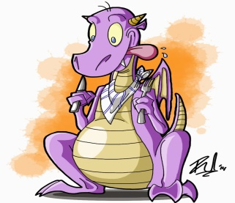
A) HAPPY | B) ANGRY | C) HUNGRY

3. HE WANTS SOME...
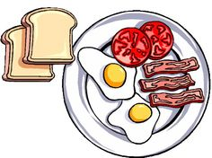 | 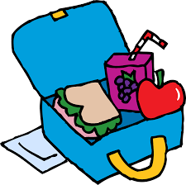 | 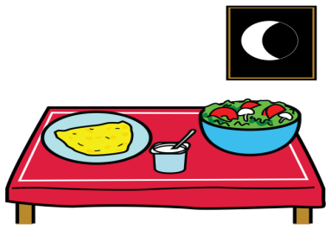
A) BREAKFAST | B) LUNCH | C) DINNER

4. HE ATE...
A) ONE | B) THREE | C) FIVE
…PLATES OF CHICKEN AND RICE. 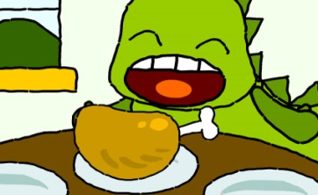

5. HE ATE...
A) TEN | B) SEVEN | C) FIVE
…SAUSAGES. 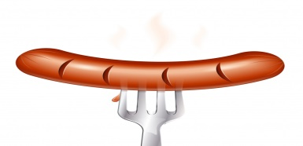

6. IN THE RESTAURANT THE DRAGON ATE…
 | 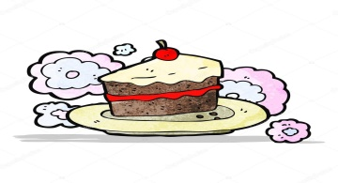 | 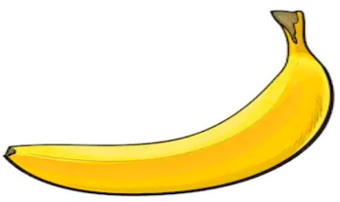
A) CHICKEN | B) CAKE | C) BANANA

7. IN THE SHOP THE DRAGON ATE…
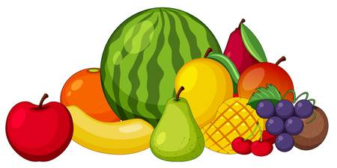 |  | 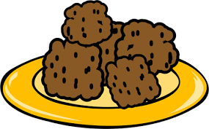
A) FRUITS | B) RICE | C) MEATBALLS

8. THE BOY GAVE HIM A…
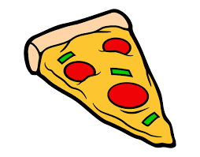 | 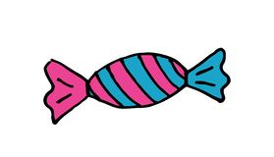
A) PIZZA | B) SWEET | C) CUPCAKE

