1. Read this text carefully and tick the correct answers:
A TYPICAL DAY IN AUSTRALIA
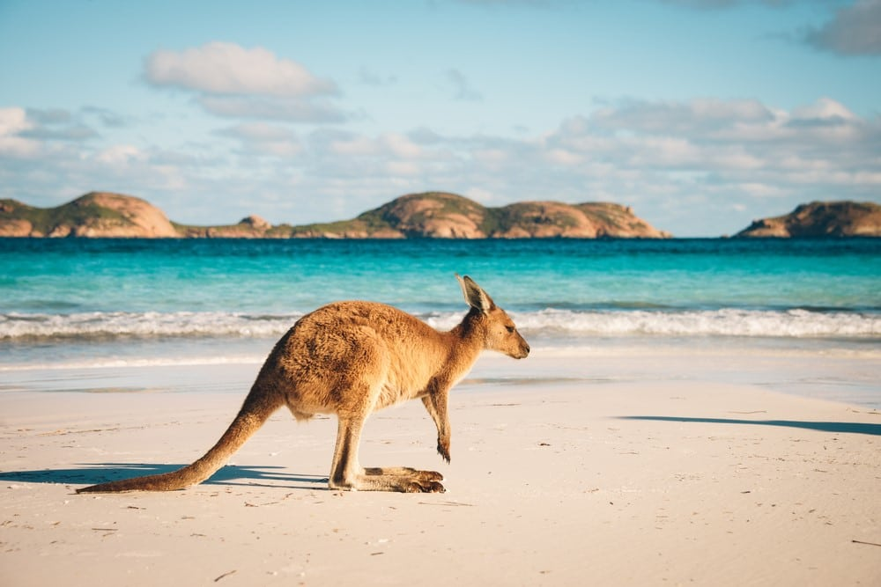
Hello! My name is John Logan. I am 12 years old. I live in Queensland with my little sister Pat and my parents, Paul and Anne.
At 6:20 a.m. I get up. My dad cooks us some fried eggs for breakfast and I make the toast. My mum helps me practise for my German test. Then, I feed the chickens, dogs and cat and I take a quick ride on my bike. My mum takes us to school in her car because she works there.
Today we had a test on History and German. German is a very difficult subject. I started German classes three years ago but I cannot pronounce a word correctly! At 10:30 a.m. we always have morning tea and 15 minutes for breaktime. At 11:30 a.m. we go outside for tennis lessons. We play for 45 minutes. At lunchtime I usually eat a chicken sandwich and some fruit salad. After lunch, I always play football with my friend Josh. In my afternoon class, we work with a partner to use the Internet. Today we looked for* an Aboriginal legend and printed it out.
I always leave school at 4:00 p.m., but today I finished classes at 2:45 p.m. because I had to** help my dad. He is a farmer. Work on the farm is hard but I love taking care of animals! I want to be a vet!
At 6:30 p.m. I get home and have a rest because I am very tired. After dinner I take a shower and I go to bed.
Adapted from http://www.timeforkids.com/destination/australia/day-in-life
JOHN’S DAILY PLANNER
6:20 a.m | Get up
7:45 a.m. | School starts
10:30 a.m. | Breaktime
11:30 a.m. | Tennis lessons
4 p.m. | School finishes (today 2:45 p.m.)
6:30 p.m. | Get Home
8 p.m. | Shower

Vocabulary:
* looked for: hem buscat
** had to: havia de

QUESTIONS:
1. John lives with…
a. his mum and older sister.
b. his mum and his dad.
c. his sister and his parents.
2. Which sentence is true?
a. Pat is older than John.
b. John is older than Pat.
c. John and Pat are the same age.
3. In the morning John and his dad…
a. prepare breakfast.
b. use the Internet.
c. play football.
4. Pat and John go to school…
a. by bus.
b. by car.
c. on foot.
5. John started learning German…
a. when he was six.
b. three years ago.
c. this school year.
6. What time does his tennis lesson start?
a. At 11:30 a.m.
b. At 11:45 a.m.
c. At 12:15 p.m.

7. What does John eat for lunch?
a. Only some fruit.
b. Some chicken salad.
c. A sandwich and some fruit.
8. School always finishes at…
a. 11:30 a.m.
b. 4 o’clock p.m.
c. 6:30 p.m.
9. Today John…
a. finished his lessons earlier.
b. didn’t go to school.
c. went home very late.
10. When John gets home he before he goes to bed.
a. works on the farm.
b. rides his bike.
c. takes a shower.
11. In the second paragraph: “At 6:20 a.m. (…) works there”, you find information about…
a. John’s favourite subjects.
b. what John eats for breakfast.
c. Queensland, John’s hometown.
12. This text is about...
a. the daily routine of an Australian boy.
b. Australian education.
c. the history of Queensland.

