C O L O U R S
1. LISTEN AND NUMBER:
1

LINK TO THE AUDIO: https://www.123listening.com/freeaudio/color-1.mp3

2. PUT THE LETTERS IN THE CORRECT ORDER:
 | E L L Y O W | YELLOW
 | E D R | R __ __
 | U B L E | B ___ ___ E
 | N K I P | P __ N ___

 | A K C L B | B __ __ __ K
 | I W T H E | W __ __ T __
 | R N E E G | G ___ E ___ ___
 | U R P L E P | P __ R ___ ___ E

3. CHOOSE TRUE OR FALSE:
1. THE DOG IS WHITE. |  | 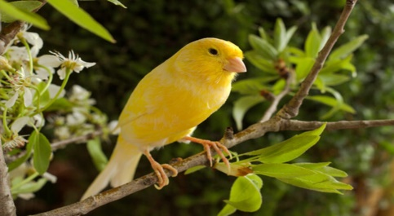  2. THE BIRD IS BLUE. |  |  | 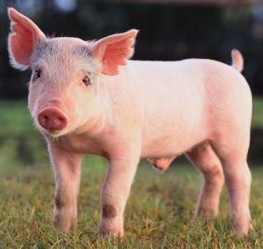  3. THE PIG IS PINK.
TRUE | FALSE | TRUE | FALSE |  | TRUE |  | FALSE
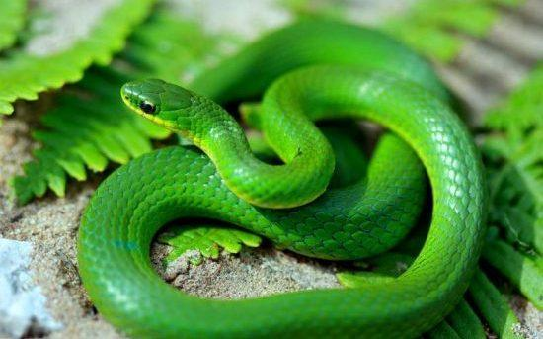  4. THE SNAKE IS GREEN. |  | 5. THE CAT IS PURPLE. |  |  | 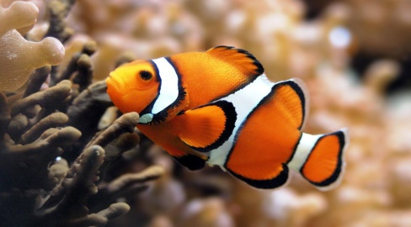  5. THE FISH IS ORANGE.
TRUE | FALSE | TRUE |  | FALSE | TRUE | FALSE

C O L O U R S and
N U M B E R S

1. PAINT:
EIGHT | THREE | ONE | TEN | SIX
TWO | FIVE | NINE | FOUR | SEVEN

1 BLUE 6 YELLOW
2 GREEN 7 RED
3 WHITE 8 ORANGE
4 PINK 9 BROWN
5 BLACK 10 GRAY

WELL DONE CASTELLERS AND CASTELLERES!!!

