C O L O U R S
1. LISTEN AND NUMBER:
1

LINK TO THE AUDIO: https://www.123listening.com/freeaudio/color-1.mp3

2. PUT THE LETTERS IN THE CORRECT ORDER:
 | E L L Y O W | YELLOW
 | E D R | R ___ ___
 | U B L E | B ___ ___ ___
 | N K I P | P ____ ____ ____

 | A K C L B | B ___ ___ ___ ___
 | I W T H E | W ___ ___ ___ ___
 | R N E E G | G ___ ___ ___ ___
 | U R P L E P | P ___ ___ ___ ___ ____

3. CHOOSE TRUE OR FALSE:
1. THE DOG IS WHITE. |  | 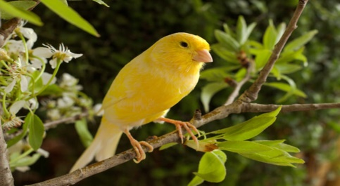  2. THE BIRD IS BLUE. |  |  | 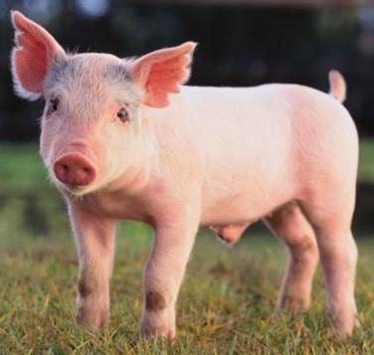  3. THE PIG IS PINK.
TRUE | FALSE | TRUE | FALSE |  | TRUE |  | FALSE
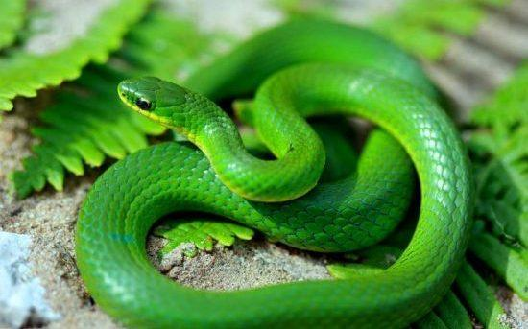  4. THE SNAKE IS GREEN. |  | 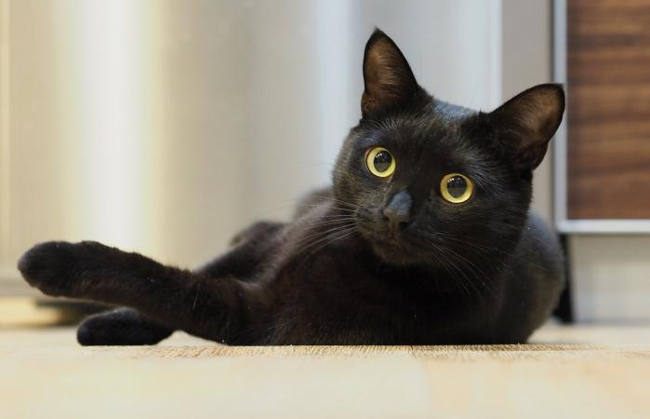  5. THE CAT IS PURPLE. |  |  | 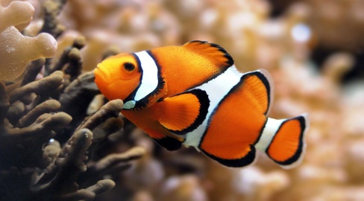  5. THE FISH IS ORANGE.
TRUE | FALSE | TRUE |  | FALSE | TRUE | FALSE

4. WRITE SENTENCES:
SINGULAR |  | PLURAL
IS  (ÉS) |  | ARE  (SÓN)

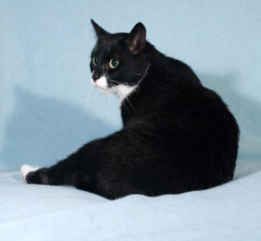 | 1. THE CAT IS BLACK. | 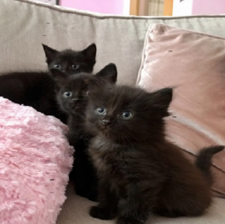 | 2. THE CATS ARE BLACK.
 |  | 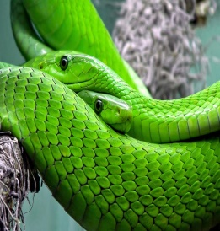
 |  | 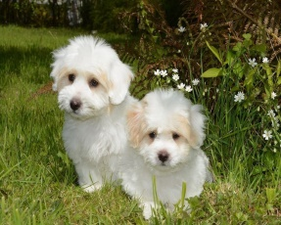
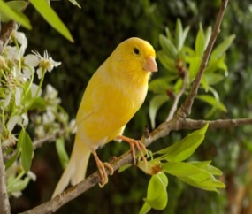 |  | 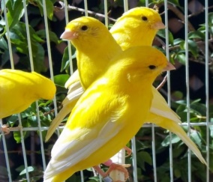
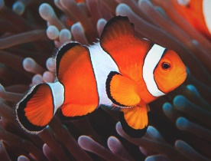 |  | 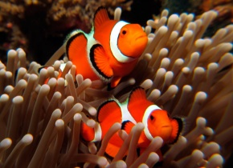
 |  | 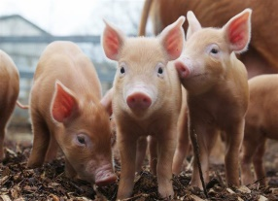
C O L O U R S and
N U M B E R S

1. PAINT (10-20):
EIGHTEEN | THIRTEEN | ELEVEN | TWENTY | SIXTEEN
TWELVE | FIFTEEN | NINETEEN | FOURTEEN | SEVENTEEN

11 BLUE 16 YELLOW
12 GREEN 17 RED
13 WHITE 18 ORANGE
14 PINK 19 BROWN
15 BLACK 20 GRAY

WELL DONE PIRATES!!

