Hola nois i noies!
Com esteu? Desitgem que estigueu bé, bonics i boniques.
Nosaltres som la Jessica i la Beth, estudiants de batxillerat. Estem fent un treball de recerca i necessitem que feu aquestes petites activitats per col·laborar una mica amb nosaltres, que ja ens han dit les mestres que sou molt treballadors, i ho volem comprovar...
Realment ens hagués agradat estar amb vosaltres i conèixer-vos una mica, però degut al COVID-19 no ha estat possible.
Gràcies per ajudar-nos, quan aquesta situació acabi anirem a conèixer-vos si és possible, una abraçada ben forta!

LISTENING ACTIVITY:
1. Listen and circle the correct option.( per poder escoltar l’audio haureu de clicar aquest link, només heu de escoltar l’audio i realitzar aquesta activitat).
https://www.liveworksheets.com/worksheets/en/English_as_a_Second_Language_(ESL)/Listening_comprehension/Leisure_activities_listening_qq19263fg

1. Sam likes riding a bike | True | False
2. Sam likes riding horses | True | False
3. Nick likes fishing with his dad | True | False
4. Jill loves playing the guitar | True | False
5. Jill hates going to school | True | False
6. Kim likes eating cakes | True | False
7. Sam likes his toy tiger | True | False
8. Lucy likes reading | True | False
9. Tom likes swimming | True | False
10. Tom likes ice-cream | True | False

VOCABULARY AND GRAMMAR ACTIVITIES:
1. Put the letters in order and then, match the word with the correct picture.

1  LOGF | 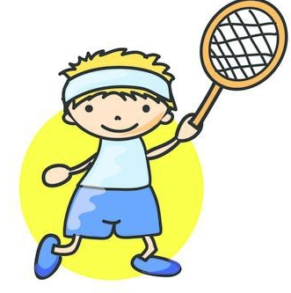
2  MMWSIGIN | 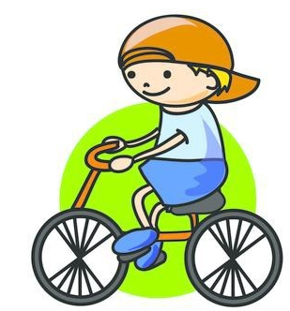
3  NNTESI | 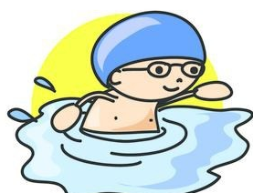
4  CILYCGN | 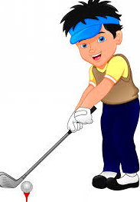
5  ASKITNG | 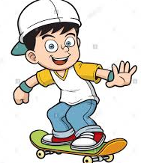

2. Match the words to their definitions..

Football Volleyball Skiing Badminton Dancing

1. Is a sport that we usually do it in winter, snow is necessary →
2. Is a sport played by two or four players, that we need a racket and we must to pass the steering wheel over the net→
3. Is a sport played by two teams and players kick the ball to each other and try to score goals →
4. We move all the body with the rhythm of the music→
5. This is sport it can be played in the beach or in a pavilion, we must to pass the ball over the net→

3. Put the name of the sport in each image and then make a sentence with each sport.

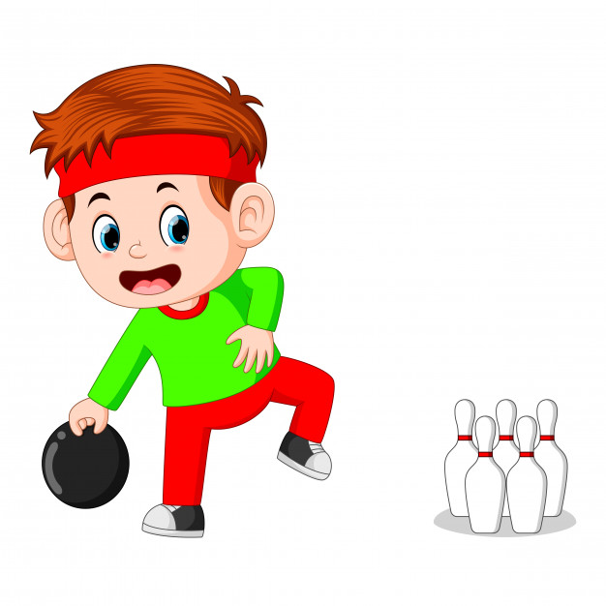  ------------------------------------ | 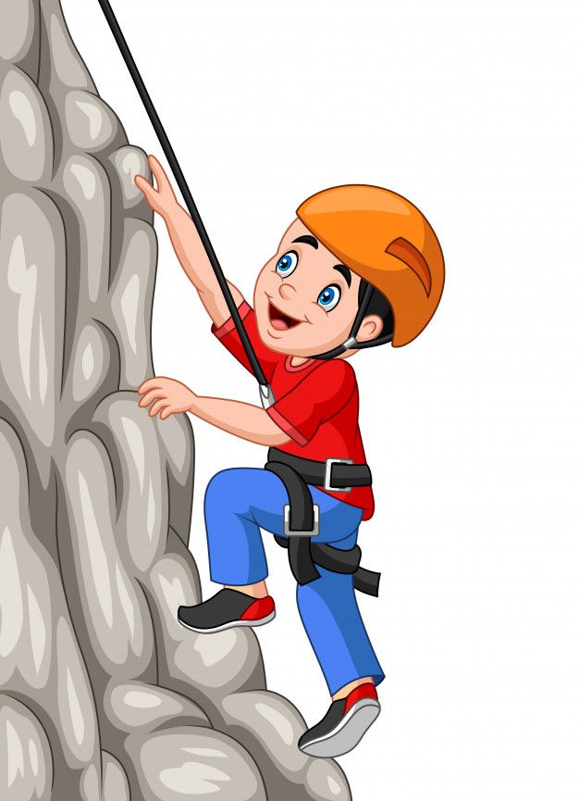  ------------------------------------ | 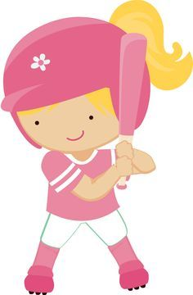  ------------------------------------
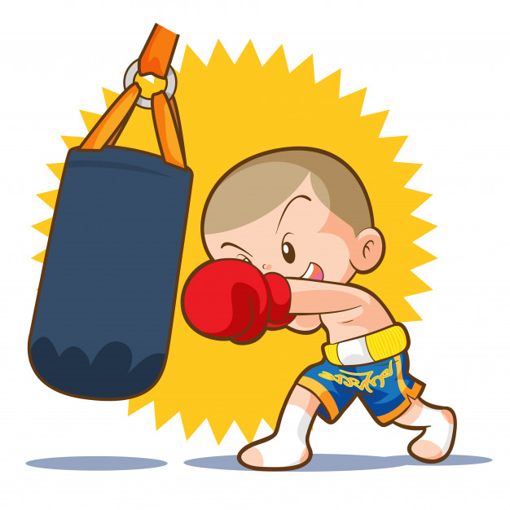  ------------------------------------ | 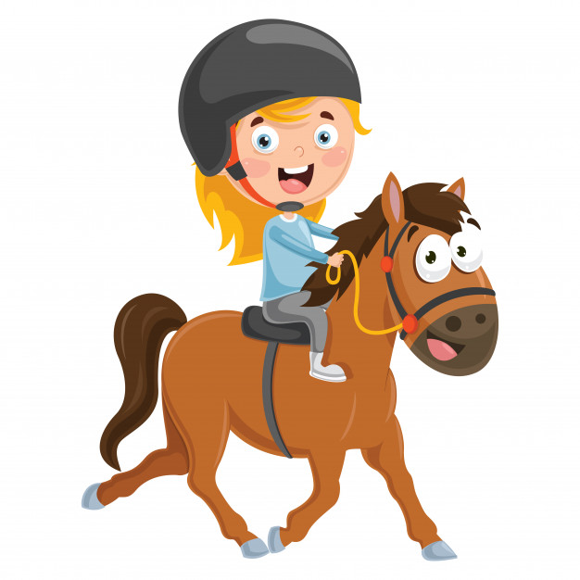  ------------------------------------ | 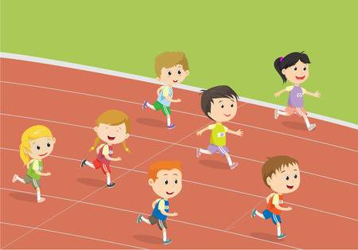  ------------------------------------

READING ACTIVITIES:
1.Read and answer the questions.

- How old is May?
- How is her hair?
- What is the color of her eyes?
- What activities does she do? What activity she doesn’t do?
- What and how is her favorite toy?

WRITING ACTIVITY:
2. Now it is your turn, write about yourself, like May did. (5 lines)

I am… (your name) and I am … (your age) years old. I am… (height) and (weight). I have got (long/medium/short) hair. I have got (colour) eyes.
In my free time, I like + ing … (activitat que t’agradi fer). My favourite toys are ... (joguines)

