What’s wrong?
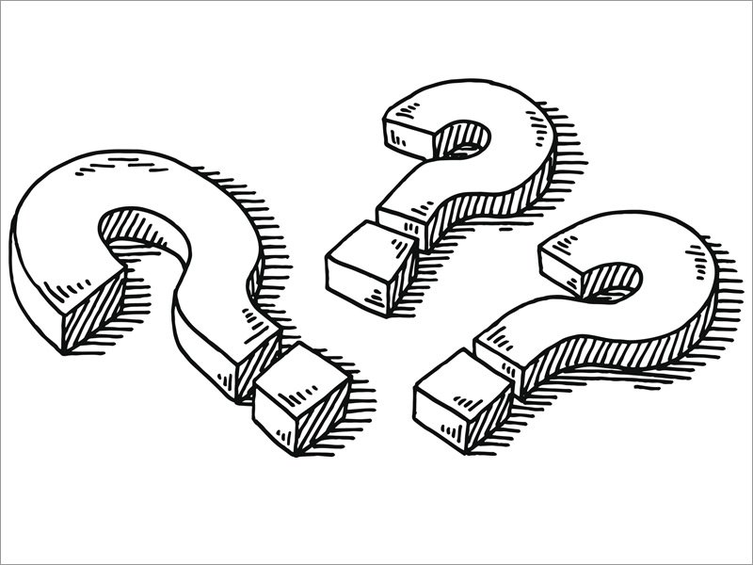
 | Wrong |  | Correct
1 | I likes chocolate |  | I like chocolate
2 | Do she like pizza?
3 | Does I like strawberries?
4 | He like spinach.
5 | I doesn’t like tomatoe.
6 | She don’t like rice.
7 | Yes, I does
8 | Yes, she do
9 | No, I doesn‘t
10 | No, he don‘t

