Who is it?
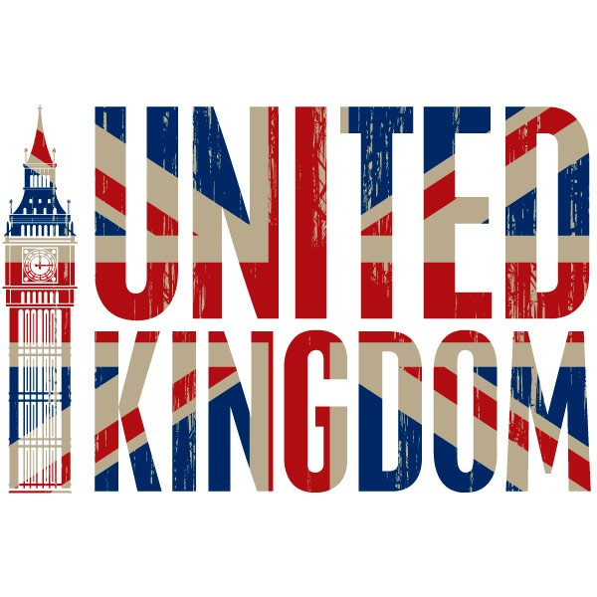
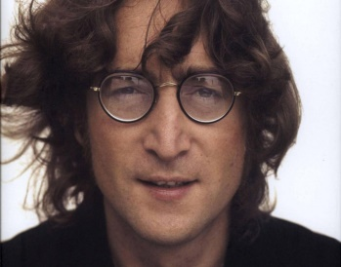 | 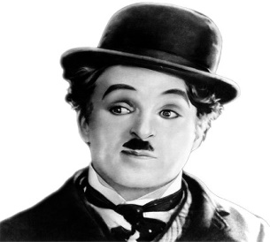 | 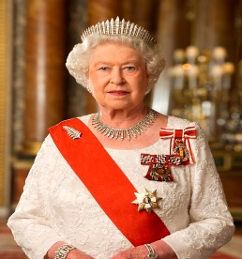 | 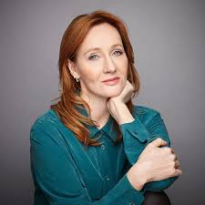 | 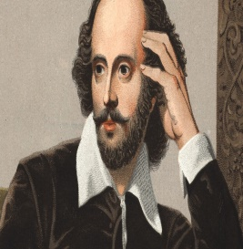
John Lennon | Charles Chaplin | Elizabeth II | J.K. Rowling | William Shakespeare
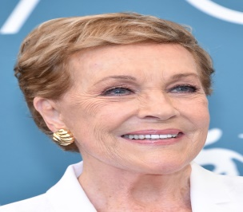 | 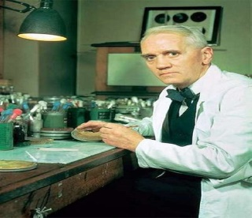 |  | 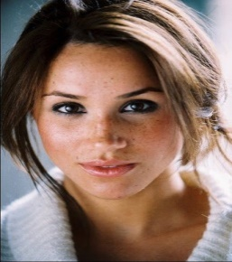 | 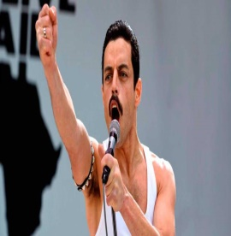
Julie Andrews | Alexander Fleming | Catherine Zeta-Jones | Meghan Markle | Freddie Mercury

Description | Who is it?
1. He was a singer. He has got moustache. He has got short dark hair. | Freddie Mercury
2. She has got long straight brown hair. She has got brown eyes. She hasn’t got glasses.
3. She has got long straight red hair. She is the author of Harry Potter.
4. She has got short straight fair hair. She has got blue eyes.
5. He has got glasses.
6. He hasn’t got glasses. He has got short straight white hair.
7. She is old. She has got curly white hair. She is Queen of the United Kingdom.
8. She has got long straight dark hair. She has got freckles.
9. He is wearing a hat. He has got moustache. He has got dark hair.
10. He has got moustache and beard. He has got curly brown hair.

