**THE VERY HUNGRY CATERPILLAR**

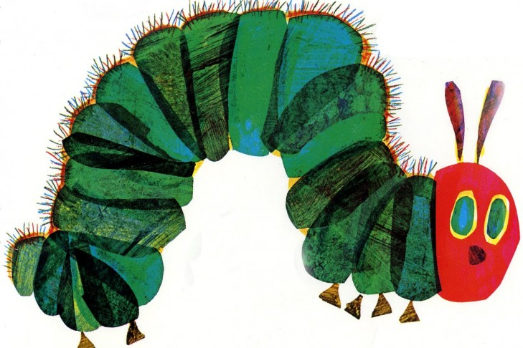

1. READ AND NUMBER:

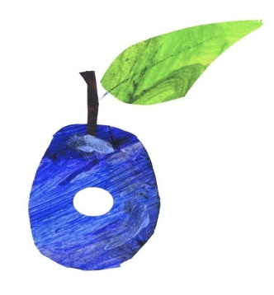

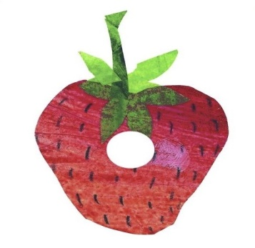

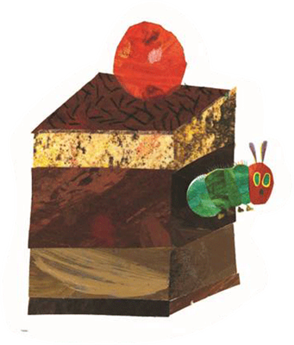

1. ICE-CREAM

2. PLUM

3. APPLE

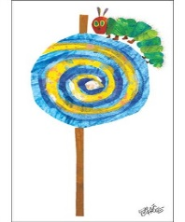

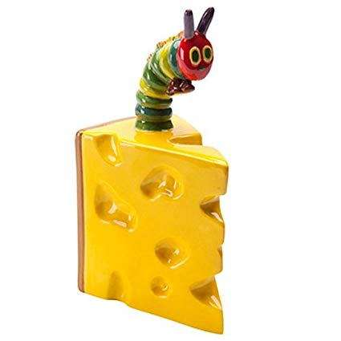

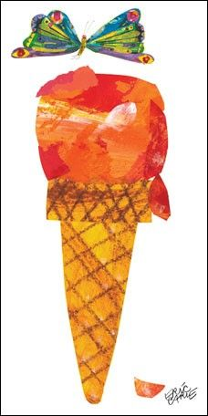

4. CUPCAKE

5. STRAWBERRY

6. CHEESE

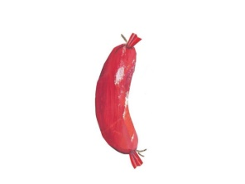

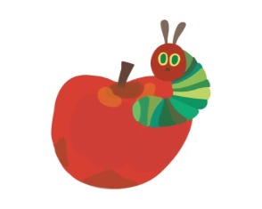

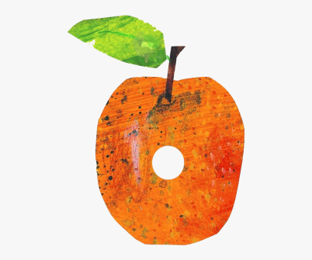

7. ORANGE

8. SAUSAGE

9. CAKE

**2. WHAT’S NEXT?**

|  |  |  |  |  |  |
| --- | --- | --- | --- | --- | --- |
| LOS PINGÜINOS: THE VERY HUNGRY CATERPILLAR | 2f55618834 wholesale dealer timeless design the very hungry ... | hungry caterpillar + moon - Google Search | Hungry Caterpillar Sun Clipart | Amazon.com: The Very Hungry Caterpillar (9780399226908): Carle ... | Hungry Caterpillar Cocoon Clipart |
| CATERPILLAR | BUTTERFLY | MOON | SUN | LEAF | COCOON |

|  |  |  |  |  |  |  |  |  |
| --- | --- | --- | --- | --- | --- | --- | --- | --- |
| LOS PINGÜINOS: THE VERY HUNGRY CATERPILLAR | 2f55618834 wholesale dealer timeless design the very hungry ... | 2f55618834 wholesale dealer timeless design the very hungry ... | LOS PINGÜINOS: THE VERY HUNGRY CATERPILLAR | 2f55618834 wholesale dealer timeless design the very hungry ... | 2f55618834 wholesale dealer timeless design the very hungry ... | LOS PINGÜINOS: THE VERY HUNGRY CATERPILLAR | 2f55618834 wholesale dealer timeless design the very hungry ... | B U T T E R F L Y |
| Hungry Caterpillar Sun Clipart | hungry caterpillar + moon - Google Search | hungry caterpillar + moon - Google Search | Amazon.com: The Very Hungry Caterpillar (9780399226908): Carle ... | Hungry Caterpillar Sun Clipart | hungry caterpillar + moon - Google Search | hungry caterpillar + moon - Google Search | Amazon.com: The Very Hungry Caterpillar (9780399226908): Carle ... | ______ _____ _____ |
| Amazon.com: The Very Hungry Caterpillar (9780399226908): Carle ... | Hungry Caterpillar Cocoon Clipart | Amazon.com: The Very Hungry Caterpillar (9780399226908): Carle ... | Hungry Caterpillar Cocoon Clipart | Amazon.com: The Very Hungry Caterpillar (9780399226908): Carle ... | Hungry Caterpillar Cocoon Clipart | Amazon.com: The Very Hungry Caterpillar (9780399226908): Carle ... | Hungry Caterpillar Cocoon Clipart | ___ ___ ___ ___ |
| LOS PINGÜINOS: THE VERY HUNGRY CATERPILLAR | 2f55618834 wholesale dealer timeless design the very hungry ... | hungry caterpillar + moon - Google Search | LOS PINGÜINOS: THE VERY HUNGRY CATERPILLAR | 2f55618834 wholesale dealer timeless design the very hungry ... | hungry caterpillar + moon - Google Search | LOS PINGÜINOS: THE VERY HUNGRY CATERPILLAR | 2f55618834 wholesale dealer timeless design the very hungry ... | ___ ___ ___ ___ |
| Hungry Caterpillar Cocoon Clipart | Hungry Caterpillar Sun Clipart | Hungry Caterpillar Sun Clipart | Amazon.com: The Very Hungry Caterpillar (9780399226908): Carle ... | Hungry Caterpillar Cocoon Clipart | Hungry Caterpillar Sun Clipart | Hungry Caterpillar Sun Clipart | Amazon.com: The Very Hungry Caterpillar (9780399226908): Carle ... | __ __ __ __ __ __ |

**WELL DONE CASTELLERES AND CASTELLERS!**

