ROCK BAND SUMMER CAMP
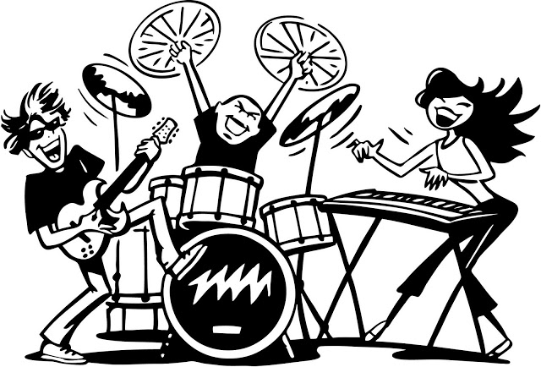
Are you a music lover? Is Rock a part of your life? Do you sing or play any instrument? Are you between 11 and 18 years old? If the answer to these questions is YES and you want to live the most amazing experience of your life, spend your holiday at ROCK BAND SUMMER CAMP.
ACTIVITIES
Mornings are full of music at the camp. Professional musicians and professors will teach you everything about musical theory, harmony, song writing, vocal training and the practicing of the instrument you choose (electric guitar, acoustic guitar, keyboards, bass guitar or drums).
In the afternoon, you will participate in different activities (excursions, outdoor* sports and nature-related activities), again supervised by professional instructors and arranged depending on your age.
THE FINAL SHOW
Your stay** at the camp will end with a final concert for family and friends. You will also get a CD of the songs you record in our professional studio.
CALENDAR AND PRICES FOR A TWO-WEEK STAY**
(One-week stay costs 60% of the two-week stay price)
CALENDAR | PRICE  Every day from 8:30 a.m. to 4 p.m.
JULY Monday 1st to Sunday 14th | £400
JULY Monday 15th to Sunday 28th | £450
AUGUST Thursday 1st to Wednesday 14th | £470
AUGUST Thursday 15th to Wednesday 28th | £400
Places limited to 15 students per week

REGISTRATION AND FURTHER INFORMATION
If you want to come to the summer camp, fill in the Registration form on our website www.rockbandsummercamp.com. There you will also find more information about the camp, a picture gallery and some of the last year’s concert videos.
LOCATION
The camp site is located on the East coast of Cornwall County, 25 km away from the city of Penzance, England.
Vocabulary:
* outdoor: a l’aire lliure
** stay: estada

