ABOUT MY FAMILY
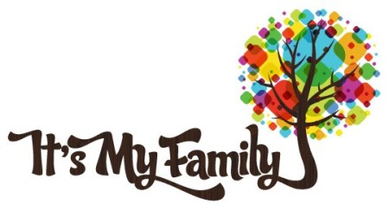
Dear Marta,
I’m going to tell you about my family. I live with my little sister, mum, and dad. We live in London, although I grew up in Lancaster, a beautiful city in the North of England.
My dad’s name is Pierre. He’s from France, and he speaks English and French. When he was young, my mother went to France on a student exchange, and they met there. A few years later, my dad moved to England and married my mum. He works as a French teacher. He’s very tall –much taller than my mum– and athletic. He’s got short blonde hair and blue eyes.
My mum’s name is Anna. She’s English. She’s quite short, and she’s got long curly brown hair and brown eyes. She works at a chemist’s opposite our home. She can speak French too!
My sister Julia is 18 years old, and she’s got the same color of hair and eyes as my father. She loves playing the piano and dancing. She’s very talented, and she would like to be a professional musician.
I’ve got short blonde hair like my dad, but brown eyes like my mom. We all love playing board games together on Friday evenings and we always order pizza. Our favourite game is Monopoly. Oh, I almost forgot…we’ve also got a pet cat, Snowball. She’s all white and has got a lot of fur. She likes sleeping on me.
Write back soon. Please, tell me about your family too.
Love
Jonathan

Questions:
1. Jonathan was born in London:
a) True
b) False
2. His parents both speak more than one language:
a) True
b) False

3. They got married in France.
a) True
b) False
4. Jonathan’s mother is a lot shorter than his father.
a) True
b) False
5. She doesn’t work far from home.
a) True
b) False
6. Jonathan’s sister has got blue eyes.
a) True
b) False
7. She works as a musician.
a) True
b) False
8. Jonathan’s hair is the same colour as his mother.
a) True
b) False
9. On Fridays, they always eat the same thing.
a) True
b) False
10. Write 5 new words that you have learned in this text and their translation in Catalan:
ENGLISH | CATALAN

