ORAL COMPREHENSION. LISTENING 1
You’ll hear listening 1 three times. Listen carefully and tick the best option for every question. Now look at the questions for this part.
1. Susan wants to eat something because she is…  a. hungry  b. thirsty  c. bored | 2. Where are they?  a. In the kitchen.  b. In the bedroom.  c. In the living room.
3. Susan wants to make…  a) Salad  b) Pizza  c) Hamburger | 4. Tick FOUR of the ingredients they use:  a. chicken, fish, lettuce, ham  b. eggs, bacon, ketchup, oil  c. tomato, lettuce, ketchup, onion
5. They have…

a) b) c)
6. First Susan has to…  a. grate the cheese  b. fry the hamburger  c. cut the bread | 7. At the end Susan is…  a. happy  b. sad  c. afraid

ORAL COMPREHENSION. LISTENING 2
You’ll hear listening 2 three times. Listen carefully and tick the best option for every question. Now look at the questions for this part.
1. What day is it?
a) b) c)

2. Trafalgar School is celebrating…?

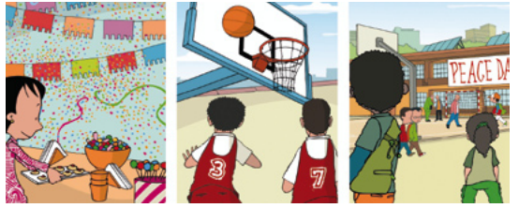
a) b) c)

3. What’s the weather like?

a) b) c)

4. The activities start at…
a) b) c)

5. The competitions are in…
a) b) c)
6. The winners get…

a) b) c)
7. After the competition, there will be…
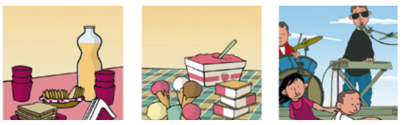
a) b) c)

Universe, Tsunami and Marina’s Class!

