PREPOSITIONS OF PLACE
Where is the ball?
The ball is_______________ the box.
1. What does it mean each preposition? (Vocabulary Review)

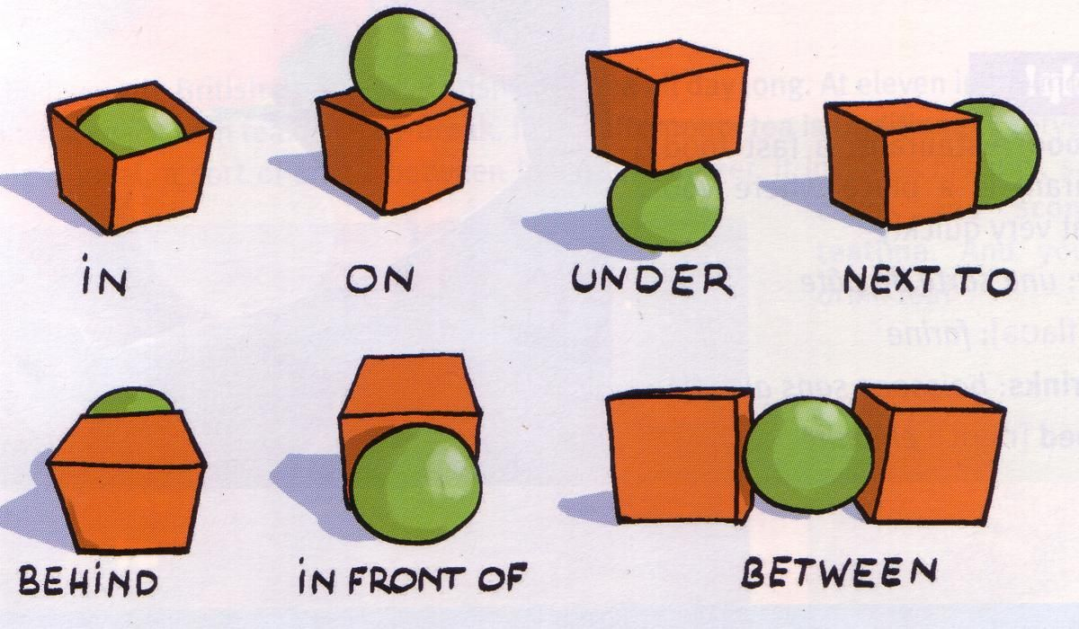

ENGLISH | CATALAN
UNDER | SOTA
 | DAMUNT
 | AL COSTAT DE
 | DINS
 | DARRERE
 | ENMIG DE
 | ENFRONT DE

2. Choose True or False (Reading):
1. The dog is under the sofa. |  | 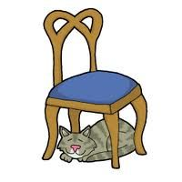  2. The cat is under the chair. |  |  |  | 3. The rabbit is in the hat.
TRUE | FALSE | TRUE | FALSE |  |  | TRUE |  | FALSE
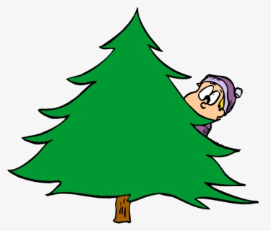  4. The man is behind the tree. |  | 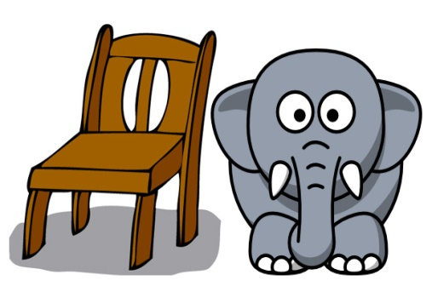  5. The elephant is on the chair. |  |  |  | 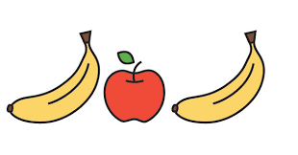  6. The apple is between the bananas.
TRUE | FALSE | TRUE |  | FALSE |  | TRUE | FALSE
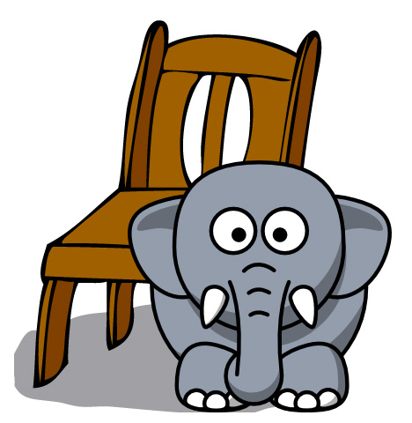  7. The elephant is in front of the chair. |  | 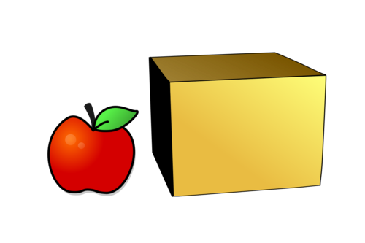  8. The apple is next to the box. |  |  |  | 9. The apple is under the book.
TRUE | FALSE | TRUE |  |  | FALSE | TRUE |  |  | FALSE

3. Write sentences using the correct preposition (Writing):
 | 1. The monkey is on the box. | 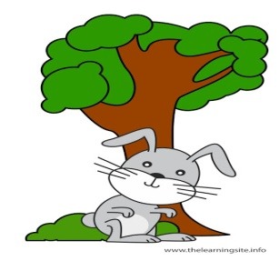 | 2.
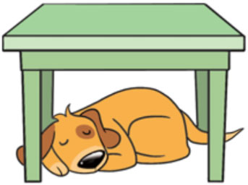 | 3. | 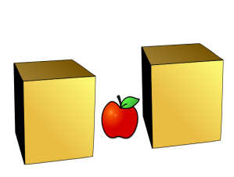 | 4.
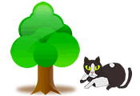 | 5. | 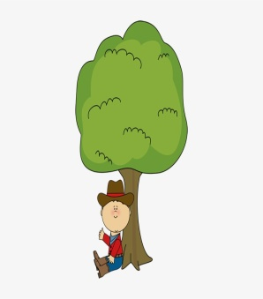 | 6.
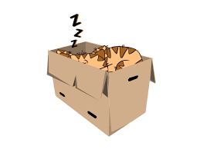 | 7. | 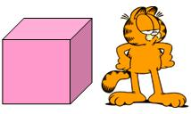 | 8.

4. Look at the picture. Write 4 sentences using prepositions (Writing):
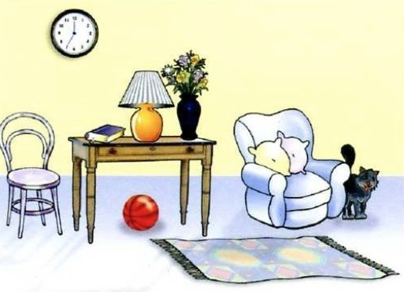 | 1. The cat is next to the armchair.  2.  3.  4.  5.
5. Listen (audio 1) and choose or write the correct option (Listening):
1. The ball is under / in the box.
2. The ball is on/ in the box.
3. The ball is __________________ the box.
4. The ball in behind / under the box.
5. The ball is in/ by the box.
6. The rabbit is _________________ the box.
7. The rabbit is over/ on the box.
8. The rabbit is __________________ the box.
9. The rabbit is __________________ the box.
10. The rabbit is _________________ the box.

(A vegades heu de seleccionar la resposta correcta i altres escriure-la directament).

TURÓ DE L’HOME!

