**MEANS OF TRANSPORT**



1. READ AND NUMBER:

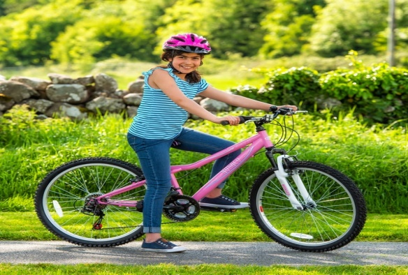

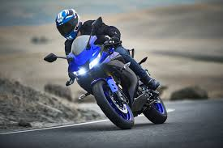

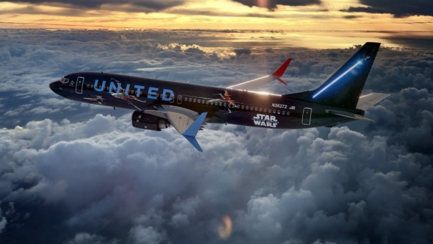

1. CAR

2. BIKE

3. PLANE

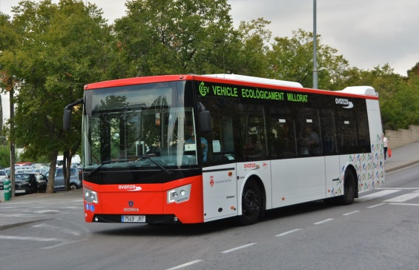

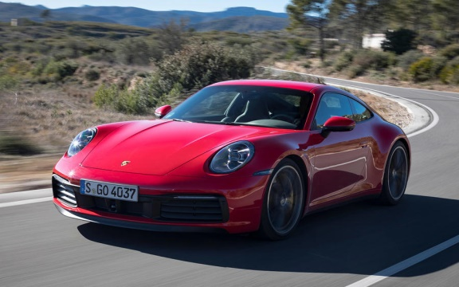

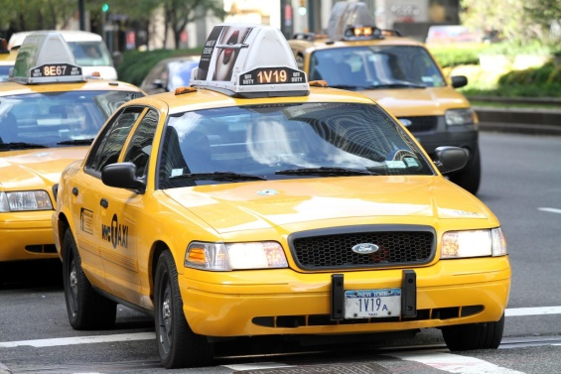

4. MOTORBIKE

5. BUS

6. TAXI

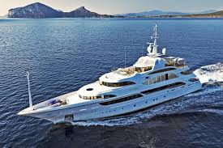

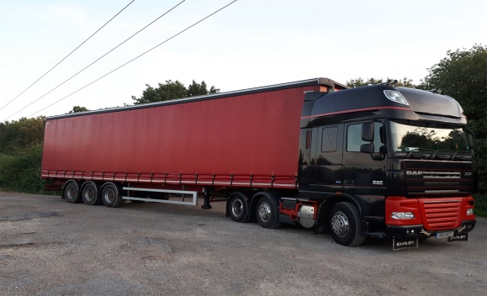

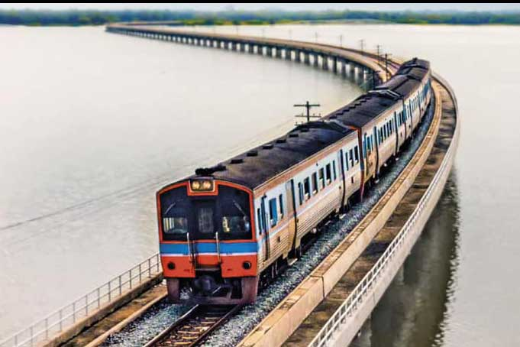

7. LORRY

8. BOAT

9. TRAIN

**2. WHAT’S NEXT?**

|  |  |  |
| --- | --- | --- |
| Untitled - Screen 7 on FlowVella - Presentation Software for Mac ... | Clarence Town, NSW 2321 Sold Land Prices & Auction Results ... | Indoor Air Quality - Razor Heating |
| WATER | LAND | AIR |

|  |  |  |  |  |  |  |  |  |  |
| --- | --- | --- | --- | --- | --- | --- | --- | --- | --- |
| 1 | Clarence Town, NSW 2321 Sold Land Prices & Auction Results ... | Untitled - Screen 7 on FlowVella - Presentation Software for Mac ... | Indoor Air Quality - Razor Heating | Clarence Town, NSW 2321 Sold Land Prices & Auction Results ... | Untitled - Screen 7 on FlowVella - Presentation Software for Mac ... | Indoor Air Quality - Razor Heating | Clarence Town, NSW 2321 Sold Land Prices & Auction Results ... | Untitled - Screen 7 on FlowVella - Presentation Software for Mac ... | LAND |
| 2 | Indoor Air Quality - Razor Heating | Indoor Air Quality - Razor Heating | Clarence Town, NSW 2321 Sold Land Prices & Auction Results ... | Untitled - Screen 7 on FlowVella - Presentation Software for Mac ... | Indoor Air Quality - Razor Heating | Indoor Air Quality - Razor Heating | Clarence Town, NSW 2321 Sold Land Prices & Auction Results ... | Untitled - Screen 7 on FlowVella - Presentation Software for Mac ... |  |
| 3 | Untitled - Screen 7 on FlowVella - Presentation Software for Mac ... | Untitled - Screen 7 on FlowVella - Presentation Software for Mac ... | Clarence Town, NSW 2321 Sold Land Prices & Auction Results ... | Untitled - Screen 7 on FlowVella - Presentation Software for Mac ... | Untitled - Screen 7 on FlowVella - Presentation Software for Mac ... | Clarence Town, NSW 2321 Sold Land Prices & Auction Results ... | Untitled - Screen 7 on FlowVella - Presentation Software for Mac ... | Untitled - Screen 7 on FlowVella - Presentation Software for Mac ... |  |
| 4 | Indoor Air Quality - Razor Heating | Untitled - Screen 7 on FlowVella - Presentation Software for Mac ... | Indoor Air Quality - Razor Heating | Untitled - Screen 7 on FlowVella - Presentation Software for Mac ... | Indoor Air Quality - Razor Heating | Untitled - Screen 7 on FlowVella - Presentation Software for Mac ... | Indoor Air Quality - Razor Heating | Untitled - Screen 7 on FlowVella - Presentation Software for Mac ... |  |
| 5 | Clarence Town, NSW 2321 Sold Land Prices & Auction Results ... | Clarence Town, NSW 2321 Sold Land Prices & Auction Results ... | Untitled - Screen 7 on FlowVella - Presentation Software for Mac ... | Untitled - Screen 7 on FlowVella - Presentation Software for Mac ... | Clarence Town, NSW 2321 Sold Land Prices & Auction Results ... | Clarence Town, NSW 2321 Sold Land Prices & Auction Results ... | Untitled - Screen 7 on FlowVella - Presentation Software for Mac ... | Untitled - Screen 7 on FlowVella - Presentation Software for Mac ... |  |

**3. IDENTIFY THE MODE OF TRANSPORT:**

|  |  |
| --- | --- |
| Resultat d'imatges de bike | LAND TRANSPORT |
| WATER TRANSPORT |
| AIR TRANSPORT |

|  |  |
| --- | --- |
| Resultat d'imatges de autobus rubi | LAND TRANSPORT |
| WATER TRANSPORT |
| AIR TRANSPORT |

|  |  |
| --- | --- |
| Imatge relacionada | LAND TRANSPORT |
| WATER TRANSPORT |
| AIR TRANSPORT |

|  |  |
| --- | --- |
| Resultat d'imatges de TRAIN | LAND TRANSPORT |
| WATER TRANSPORT |
| AIR TRANSPORT |

|  |  |
| --- | --- |
| Resultat d'imatges de plane | LAND TRANSPORT |
| WATER TRANSPORT |
| AIR TRANSPORT |

|  |  |
| --- | --- |
| Resultat d'imatges de boat | LAND TRANSPORT |
| WATER TRANSPORT |
| AIR TRANSPORT |

**WELL DONE PIRATES!**

