WHAT’S THE WEATHER LIKE TODAY?
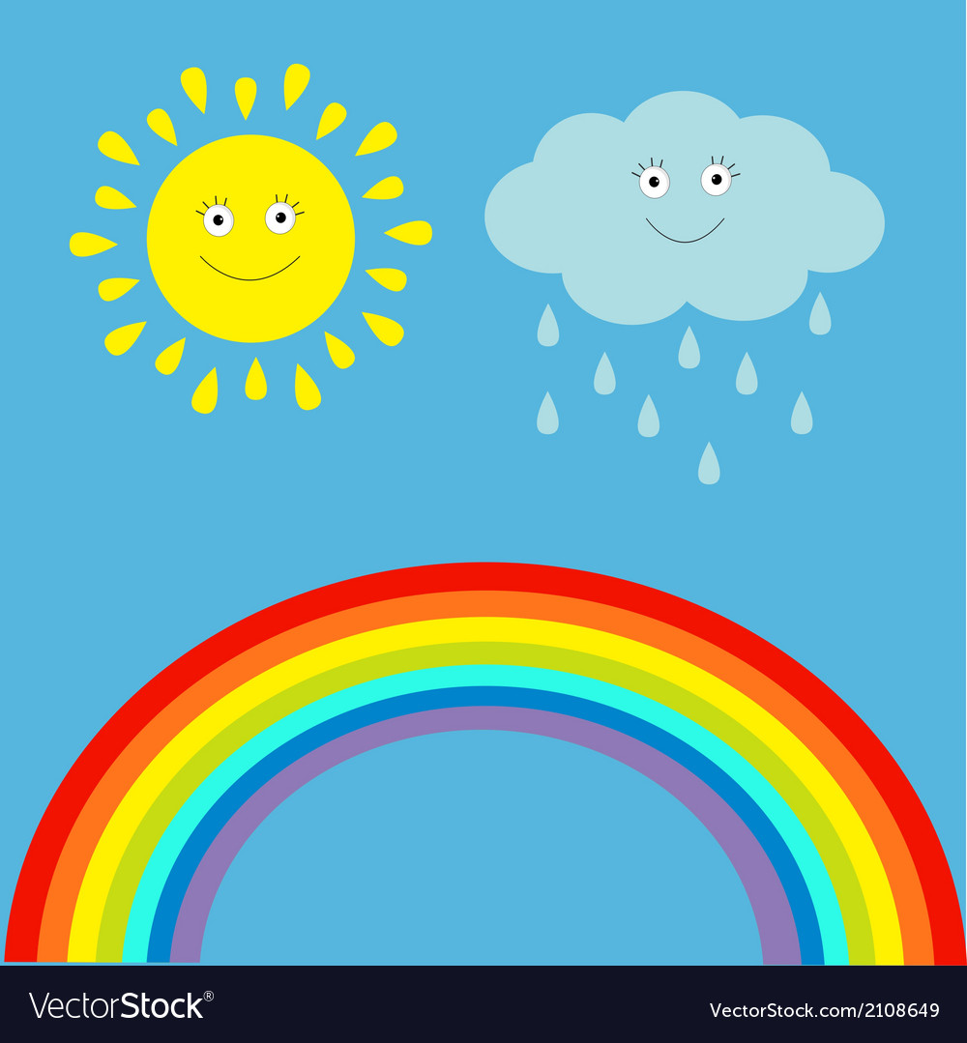

MONDAY | TUESDAY | WEDNESDAY |  | THURSDAY | FRIDAY | SATURDAY | SUNDAY

TODAY IS...
 |  | 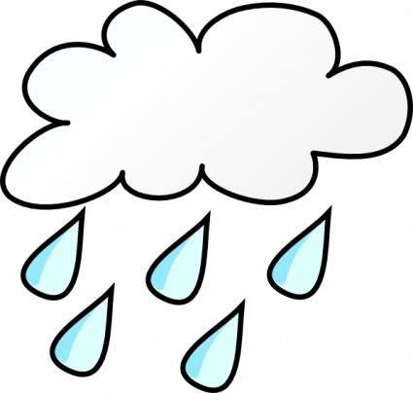 | 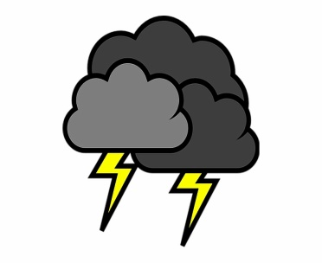 | 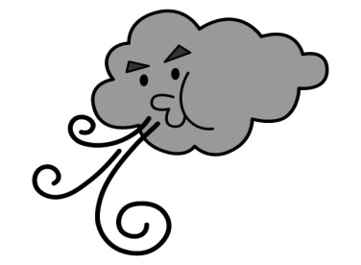 | 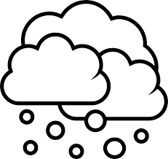
SUNNY | CLOUDY | RAINY | STORMY | WINDY | SNOWY

