**HOW DO YOU FEEL TODAY?**

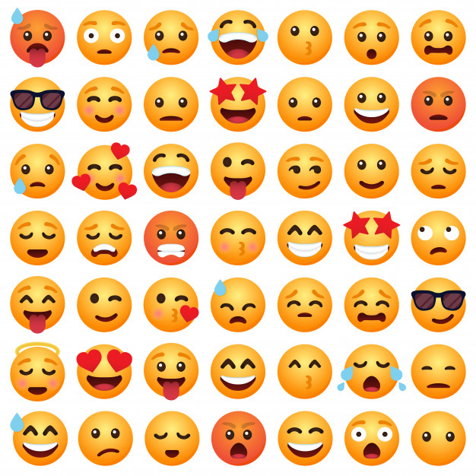

|  |  |  |  |  |  |  |  |
| --- | --- | --- | --- | --- | --- | --- | --- |
| MONDAY | TUESDAY | WEDNESDAY | | THURSDAY | FRIDAY | SATURDAY | SUNDAY |
|  |  | |  |  |  |  |  |

**TODAY I FEEL...**

|  |  |  |  |  |  |  |
| --- | --- | --- | --- | --- | --- | --- |
| Emoticon Smile Emoji - Free image on Pixabay | 😞 Sad Emoji Meaning with Pictures: from A to Z | Download Very Angry Emoji | Emoji Island | Emoji Request - ExcitedEmoji | Sleeping Emoji [Free Download IOS Emojis] | Emoji Island | Face With Thermometer Emoji | Emojis emoticonos, Emojis para ... | Framed Emoji Print - Worried with Sweat Face (Picture Poster ... |
| **HAPPY** | **SAD** | **ANGRY** | **EXCITED** | **SLEEPY** | **ILL** | **WORRIED** |