
LES NOSTRES CANÇONS

BON DIA- DÀMARIS GELABERT
https://www.youtube.com/watch?v=BF7w-xJUlwM
DIES DE LA SETMANA- DÀMARIS GELABERT
https://www.youtube.com/watch?v=4atoVE3t-yo
QUIN DIA FA- DÀMARIS GELABERT
https://www.youtube.com/watch?v=x8_lP3-698w
SAMBA DO BRASIL
https://www.youtube.com/watch?v=hipkOqYbleo&list=RDhipkOqYbleo&start_radio=1
EL MÓN SERIA MÉS FELIÇ
https://www.youtube.com/watch?v=_SPlkGmHIQA&list=RD_SPlkGmHIQA&start_radio=1
CANÇONS NINA SIMONE
https://www.youtube.com/watch?v=D5Y11hwjMNs&list=RDEMnsaONZZ-LNB1Q4ED8ENRiw&start_radio=1

ABECEDARI
https://www.youtube.com/watch?v=T-AKoOvcKX8
https://www.youtube.com/watch?v=ITUmXHq7Y-A
LES VOCALS
https://www.youtube.com/watch?v=ITUmXHq7Y-A
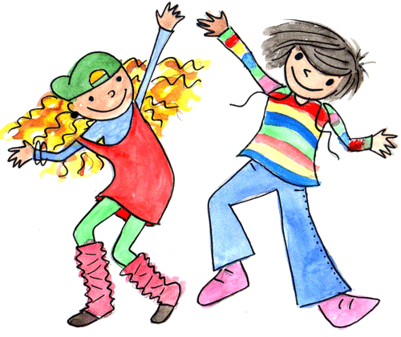
ENGLISH SONGS:
ROUTINE SONGS:
Hello, hello! Can you clap your hands: https://www.youtube.com/watch?v=fN1Cyr0ZK9M
How is the wheather: https://www.youtube.com/watch?v=rD6FRDd9Hew
How’s the weather (another song)
https://www.youtube.com/watch?v=I8GeA3anPdo
Days of the week: https://www.youtube.com/watch?v=loINl3Ln6Ck
If you are happy: https://www.youtube.com/watch?v=l4WNrvVjiTw
ANIMALS
Walking in the jungle: https://www.youtube.com/watch?v=GoSq-yZcJ-4
JOBS AND OCCUPATIONS
What do you want to be: https://www.youtube.com/watch?v=wKfrbnRRD-k&t=37s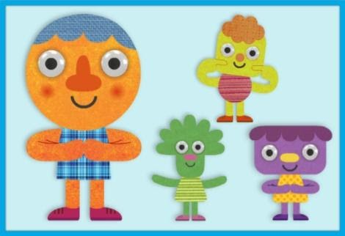
FAMILY
Rain Rain go away: https://www.youtube.com/watch?v=LFrKYjrIDs8
Finger Family: https://www.youtube.com/watch?v=gI3_gdUY41U

El cervató (Mic)
https://www.youtube.com/watch?v=oh-GyAUCIu4

ANYS I ANYS...PER MOLTS ANYS
https://www.youtube.com/watch?v=VyMLSJwehyI
HAPPY BIRTHDAY TO YOU!
https://www.youtube.com/watch?v=qCJSNMqub8g

