Nom:
SUMES SENSE PORTAR

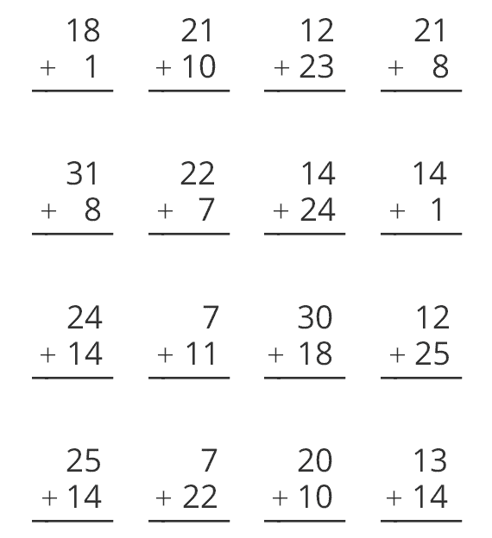

Nom:
SUMES SENSE PORTAR
