TRY TO SOLVE THESE GENIUS PUZZLES!!!

- Laptop charge setup puzzle

How many laptops can be charged from the below puzzle setup?

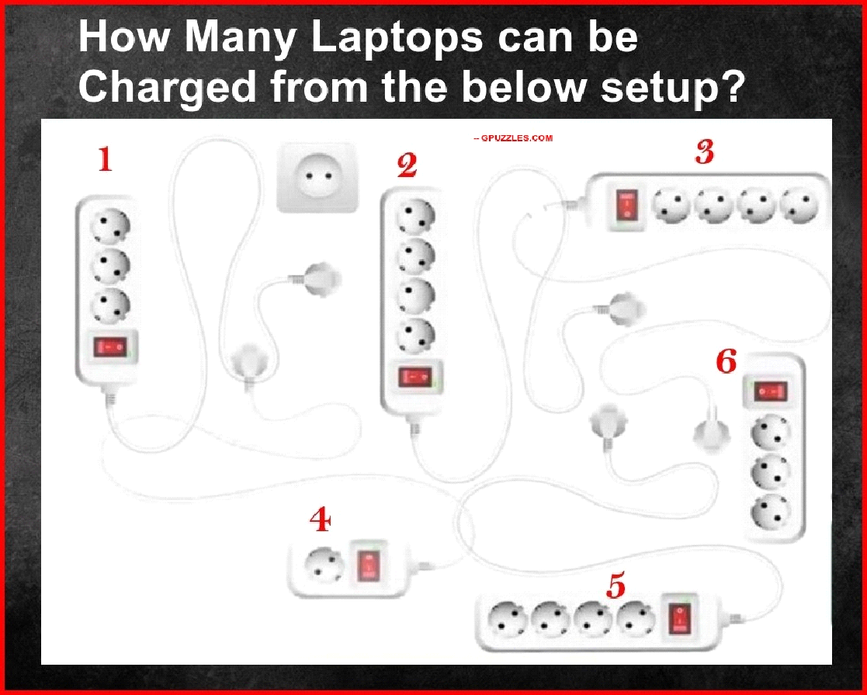

- Which Tank Will Fill Up First?

If the water starts running into tank A, which tank will fill up first?



- The COVID19 Patient Riddle

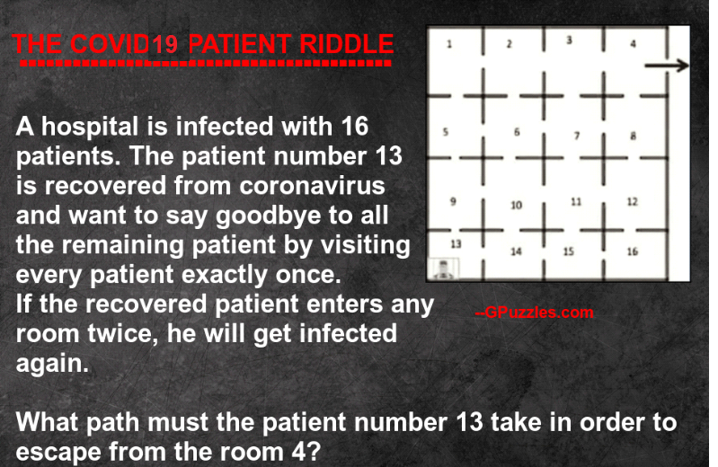

- Pool Balls – Sum of 30
You have 8 balls numbered 1, 3, 5, 7, 9, 11, 13 and 15. Select 3 balls and put them into the circles such that the sum of the numbers on them add up to 30.

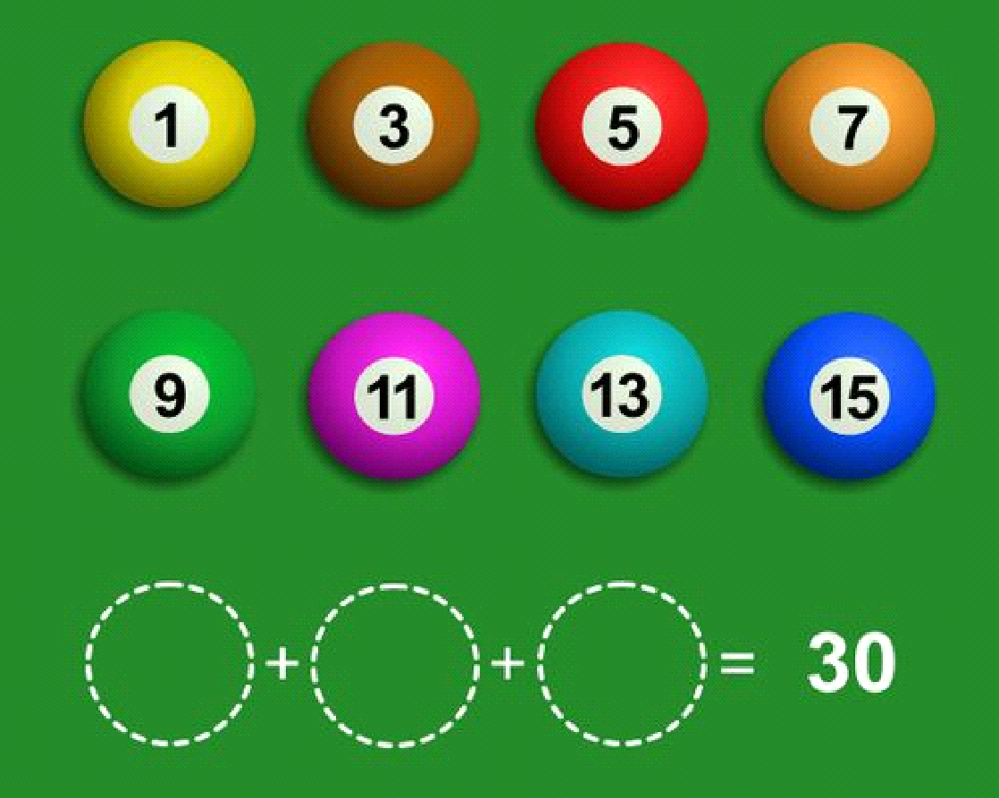

- Man and Dog
A man stands on one side of a river, his dog on the other. The man calls his dog, who immediately crosses the river without getting wet and without using a bridge or a boat. How did the dog do it?

- 12 Fishes
If there are 12 fish and half of them drown, how many are there?

- Taxi Driver
A taxi driver is going the wrong way down a one-way street. He passes four police officers, yet none of them stop him. Why?

- The donkey
A donkey travels the exact same distance daily,
strangely 2 of his legs travels 40 kilometers and the remaining two travels 41 kilometers.
Obviously 2 donkey legs cannot be a 1km ahead of the other 2.
The donkey is perfectly normal. So how come this be true ?


- Hello, Father
A women and daughter walked into a restaurant. A man walked past and the women both said, “Hello, Father”. How is this possible?

- River Boat
In my neighbourhood lives a man who weighs 200 pounds. He has two sons. They both weigh 100 pounds each. On a festival day they decide to go across the river on a boat to visit some relations. But the boat could carry a maximum load of only 200 pounds.
Yet they managed to get across the river by boat. How did they?

- How Did the Woman Die?
British Police inspects a room where there are no windows, no doors, no tables and is almost empty expect there is just a puddle of water. They found a dead woman who obviously hung herself from the ceiling, but they are not able to figure out how this had happened.
Sherlock and John Watson entered the crime scene and easily able to solve the case.
How did the woman die?


