RECYCLING AND HELPING THE ENVIRONMENT
This week you are going to play this game. You’ll have to place each object in its corresponding recycling bin. After that you are going to complete the table with at least four object in each category. Four objects for glass, four objects for plastic, four objects for paper and four objects for compost.
https://learnenglishkids.britishcouncil.org/games/clean-and-green

Glass | Plastic and Metal | Paper | Compost

KAHOOT: A GUIDE DOG
This week you are going to do a kahoot from watching the video “A guide dog”. Before answering the questions remember to watch the video that is in the first slide.
https://youtu.be/07d2dXHYb94
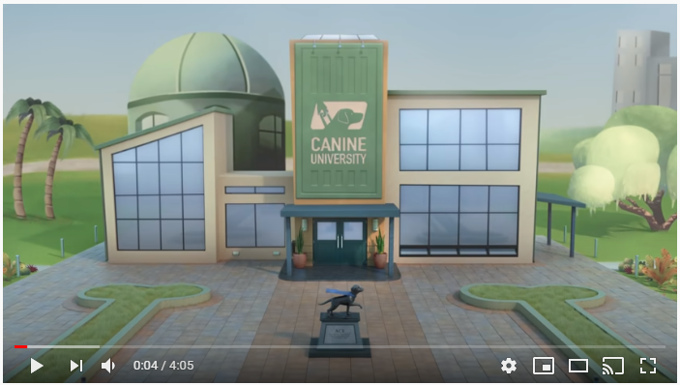
I hope you’ll be fun with this activity.
Click here: Kahoot: A guide dog

