HENRY AND THE SUGAR BUGS
Watch the video of “Henry and the Sugar bugs” and complete the task below.
https://www.abcya.com/games/henry_and_the_sugarbugs

CARE YOUR TEETH

Write the right food in each column. Apart from writing the food words, you can draw them.
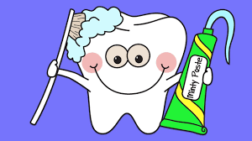  GOOD FOR YOUR TEETH | 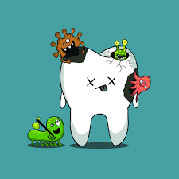  NOT GOOD FOR YOUR TEETH

