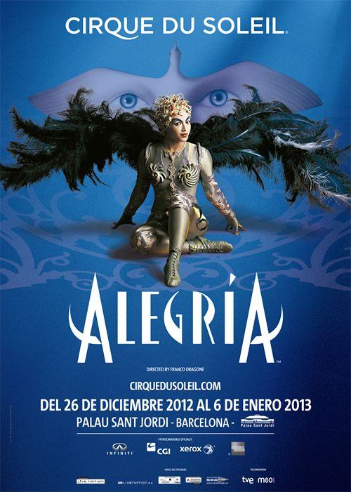
COMPRENSIÓ LECTORA
EL DISSABTE 4 DE GENER VAIG ANAR AL CIRC AMB LA MEVA FAMÍLIA.
VAM VEURE UN ESPECTACLE MOLT BONIC I EMOCIONANT, ELS ARTISTES SÓN FANTÀSTICS.
EL QUE MÉS ENS VA AGRADAR VA SER LA MÚSICA QUE ACOMPANYA L’ESPECTACLE.
ENS HO HEM PASSAT MOLT BÉ.

COM ES DIU EL CIRC ON HE ANAT?

QUIN DIA VAM ANAR AL CIRC?

COM ES DIU L’ESPECTACLE?

QUÈ ÉS EL QUE MÉS ENS VA AGRADAR DE L’ESPECTACLE?

ON FAN L ‘ESPECTACLE DEL CIRQUE DE SOLEIL? A QUINA CIUTAT?

DE QUIN DIA A QUIN DIA ES POT GAUDIR D’AQUEST ESPECTACLE A BARCELONA?

EL JOC DE LES FRASES I LA PARAULA INTRUSA
- Mira el dibuix i ordena les paraules per formar una frase.
- Pinta la paraula intrusa (la que t’ha sobrat).
- Escriu la frase sobre la línia.
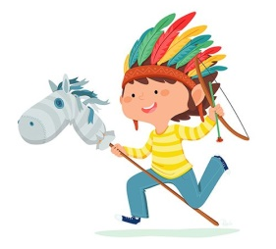 | a |  | nen |  |  |  |  |  | indis. |  |  |  | juga |  |  |  | balla |  |  |  | El
 | __________________________________________________
 | està |  | L’hipopòtam |  |  |  |  |  | a |  |  |  | sabó |  |  |  | la |  |  |  | banyera.
 | __________________________________________________
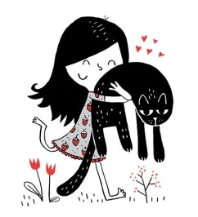 | La |  |  | nen |  |  | al |  |  |  | nena |  |  |  | gat. |  |  |  |  | abraça
 | __________________________________________________
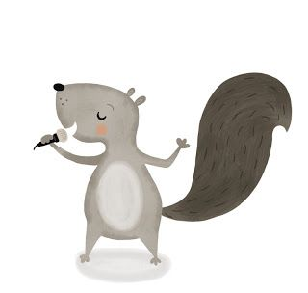 | canta |  |  | una |  |  | salta |  |  |  | cançó. |  |  |  | L’esquirol
 | ___________________________________________________
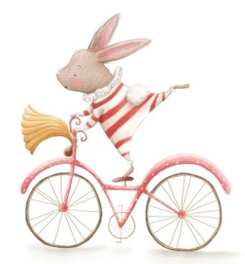 | en |  |  |  | El |  |  | va |  |  |  | patinet |  |  |  | conill |  |  | bicicleta.
 | ___________________________________________________
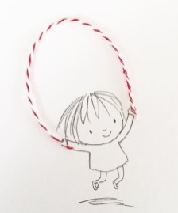 | La | salta |  |  |  | no |  |  |  | Carla |  |  |  | la |  |  |  | a |  |  |  | corda.
 | ___________________________________________________
ORTOGRAFIA
CA CO CU QUE QUI

Escriu les següents paraules tenint en compte aquest requadre.
