What will I be when I grow up?

What’s the word?
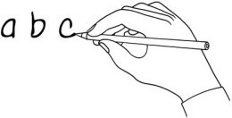
Write the word under the pictures.

brother | vet | snake | eggs | leg | father
bird | mother | dog | sister | dolphin | sing

 | 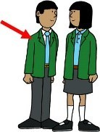 | 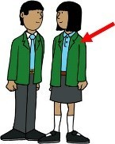 | 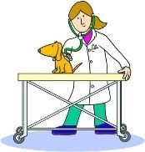 | 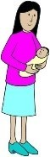 | 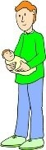
 | brother
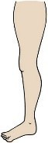 | 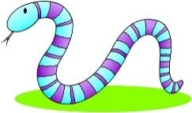 | 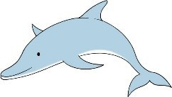 | 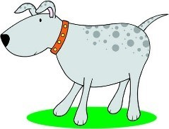 | 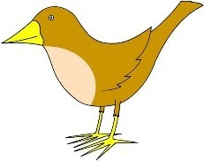 | 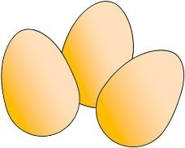

Fill it in!
Watch the story. Write the missing words in the sentences.
- My brother is a special vet .
- He looks after scary , some just out of eggs.

- My father is a . He works to save rare birds.

- Some are really clever and can even say some .

- My mother is a groomer. She loves dogs big or small.

- Once she styled a poodle. It looked just like a .

- My sister, she trains . They practise in the pool.

- She hears the dolphins talk and . That sounds really cool!
www.britishcouncil.org/learnenglishkids
© British Council, 2017 The United Kingdom’s international organisation for educational opportunities and cultural relations. We are registered in England as a charity.

Write sentences!
Write sentences about people in your family and their jobs.

- My is a .
He/She

- My is a .
He/She

- My is a .
He/She

- My is a .
He/She

- My is a .
He/She

Write and draw!
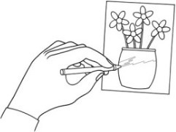
What will you be when you grow up? Write about it and draw a picture!

..................................................................................................................................

..................................................................................................................................

..................................................................................................................................

..................................................................................................................................

..................................................................................................................................
www.britishcouncil.org/learnenglishkids
© British Council, 2017 The United Kingdom’s international organisation for educational opportunities and cultural relations. We are registered in England as a charity.

