# **Look and write.**



**4 Extension Worksheet 2**

**Name:**

**Class:**



**W**

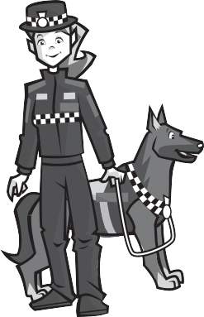

 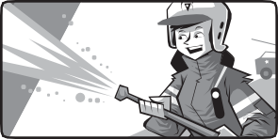 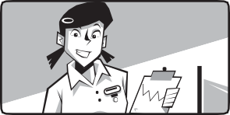

**vet**



**1**



**4**



**5**



**6**



**2**



**3**

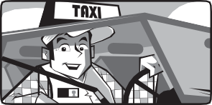

# **Read, look and match.**

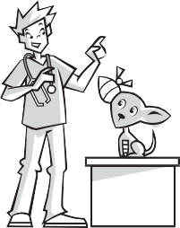

**a**



**b**



**c**



**d**

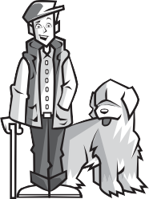

**e**

He wears a uniform. He helps people. He works in a hospital. He wears a uniform. He helps people. He drives a police car.

He works with animals. He doesn’t wear a uniform. He works on a farm. He works with animals. He doesn’t wear a uniform.



**1**

**c**



**2**



**3**



**4**

He doesn’t wear a uniform. He doesn’t work with animals. He sings.



**5**

# **Look and write.**

police officer

work / police station

wear / uniform

drive / police car

help / people

work / dog called Boe

_**T**_**his is Josie. She’s a**

© Macmillan Publishers Limited 2018