Look and match.
4 Extension Worksheet 1
pop star
2
7
shop assistant
3
8
fashion designer

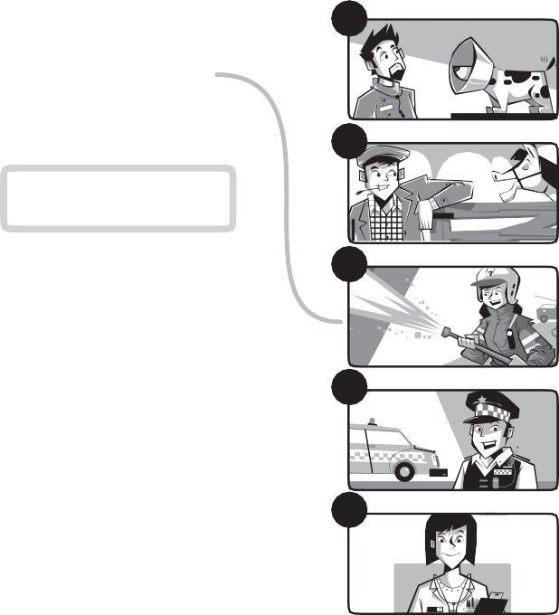
1
a
b
police officer
c
vet
d
doctor
e
farmer
firefighter
6

Read and circle.
4
9
nurse
5
10
taxi driver

A firefighter works in a hospital. True /
1
False

A firefighter wears a helmet. True / False A firefighter helps people. True / False A firefighter wears a uniform. True / False A firefighter drives a taxi. True / False A firefighter fights flames. True / False
2
3
4
5
6
Name:
Class:
W

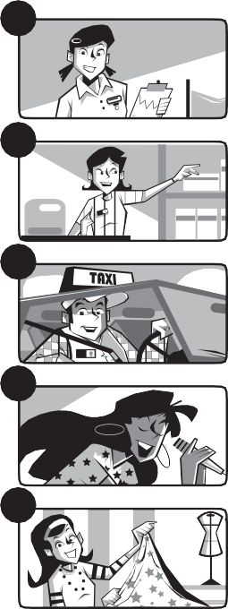
f
g
h
i
j

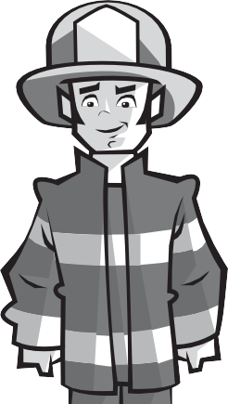

Look and write.
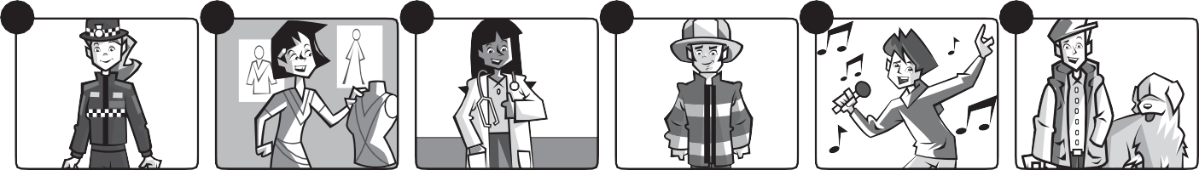
1
2
3
4
5
6

_She’s a police officer.
1
4
2
5

3
6

© Macmillan Publishers Limited 2018

