- Read and complete.
helps
hasn’t got
wears

She wears a uniform.
1
She doesn’t drive a . She in a shop.
2
3
5
6

- Order and write.
Name:
Class:
W
4 Basics Writing Practice Worksheet
doesn’t work

fire station
police car
She people. She works in a . She a dog.
She’s a firefighter.
4

work in / Does she / a library?
1

_Does she work in a library?
work / with animals? / Does she
2

Is / a pop star? / she
3

- Read the notes and write your project.

My Notes

Jobs and routines

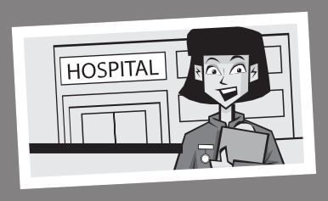
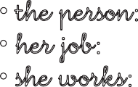
  - the person: My mother
  - her job: a nurse
  - she works: in a hospital
  - she wears: a uniform
  - What does she do? helps people
  - When does she work? Monday - Friday
My
She works She wears She
She works from to
© Macmillan Publishers Limited 2018 PHOTO

Use technology and the internet with an adult to extend your project.
is a .
.
.
.

.

